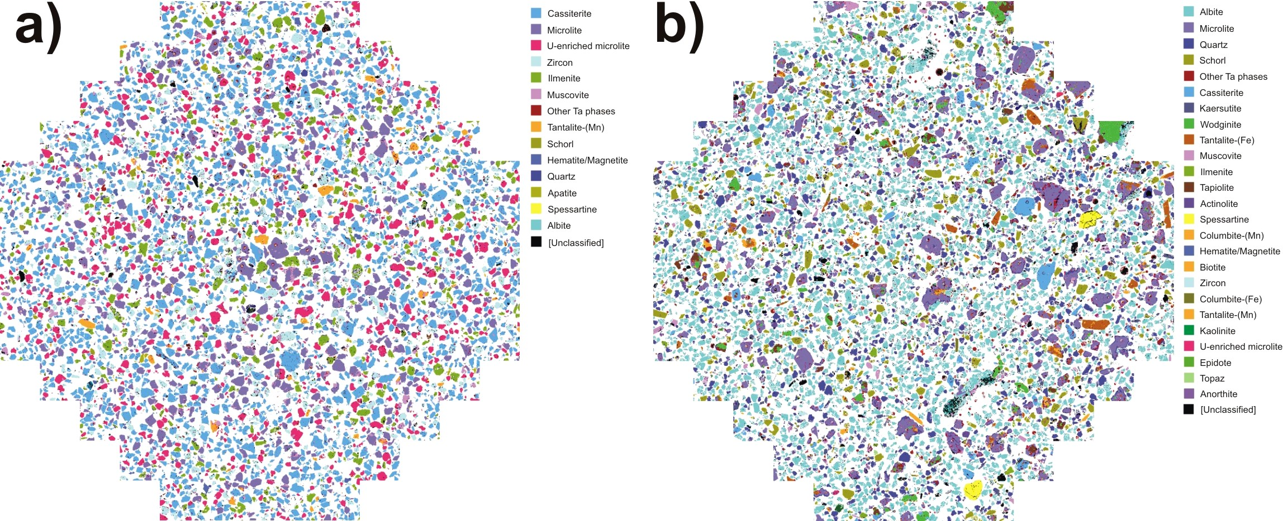
Electronic supplementum for paper Loun et al (2018): The Canadian Mineralogist 56(2), 18 pp.
Fig. 2. Automated Mineralogy images of the studied samples. a – Mungwe mine. b – Misumari II mine.

