Supporting information
Brief descriptions and pictures of the amazonite samples discussed in the text.

Sample Eghei Zuma A

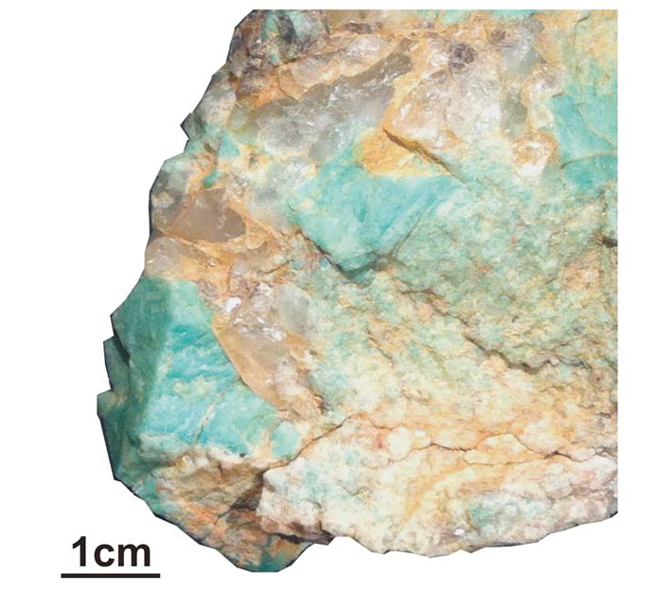

Amazonite crystals from the pegmatite intruded into the granite at Eghei Zuma, Tibesti massif (southern Libya).
Sample Eghei Zuma B

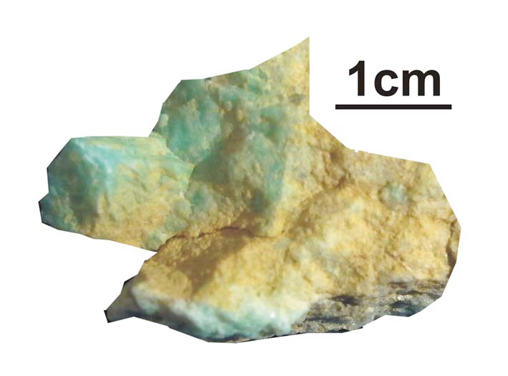

Amazonite crystals from the pegmatite intruded into the granite at Eghei Zuma, Tibesti massif (southern Libya).

Sample Eghei Zuma C

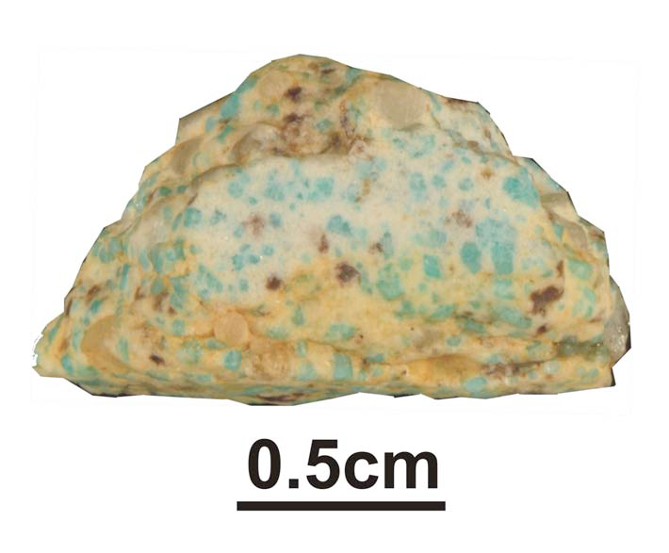

Amazonitic granite sampled in the vicinity of the pegmatite at Eghei Zuma, Tibesti massif (southern Libya).

Sample Eghei Zuma D

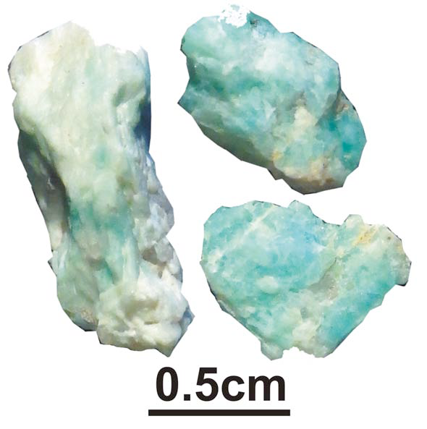

Small fragments of amazonite crystals from the pegmatite intruded into the granite at Eghei Zuma, Tibesti massif (southern Libya).
Sample Talat Umm Jaraf

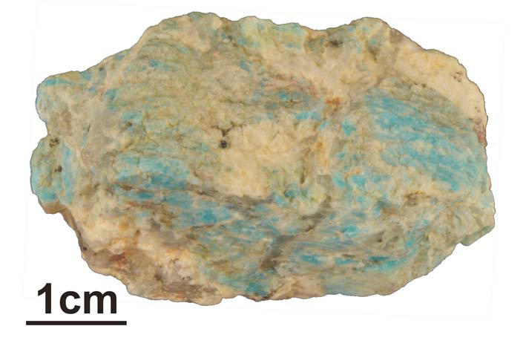

Amazonite crystals from the pegmatite at Talat Umm Jaraf, south-eastern Egypt.

Sample Jebel Hafafit

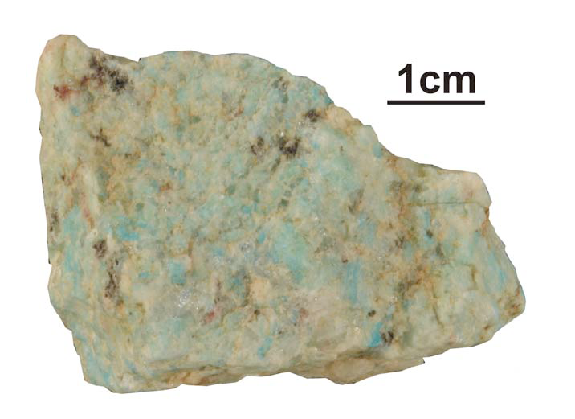

Amazonite crystals from the pegmatite intruded into the gneiss at Jebel Hafafit, south-eastern Egypt.

Sample Jebel Migif

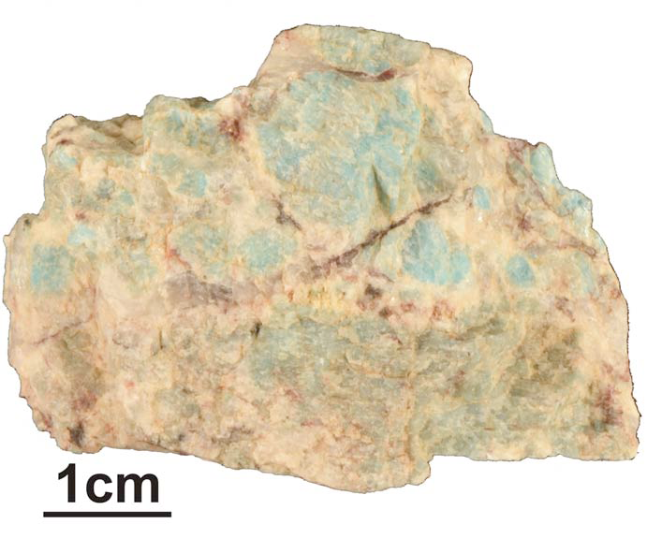

Amazonite crystals from the pegmatite intruded into the gneiss at Jebel Migif, south-eastern Egypt.

Sample MZQ1

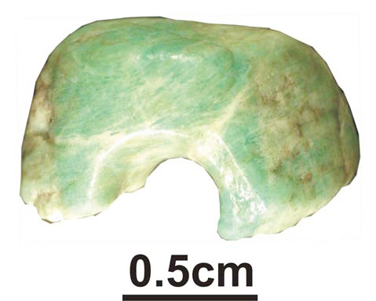

Fragment of bead found at the easternmost fringe of the Edeyen of Murzuq (SW Libya) in correspondence of a rich open-air Late or Final Pastoral Neolithic archaeological site.

Sample MZQ2

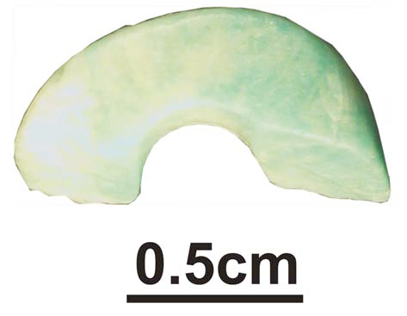

Fragment of bead found in an archaeological site at the easternmost fringe of the Edeyen of Murzuq (SW Libya), along the outer alignment of dunes in facing the city of Murzuq; the site consisted of a small number of hearths and fragments of pottery dating to the Garamantian phase.

Sample Tebu bead

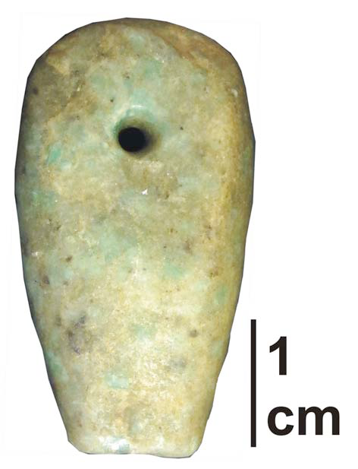

Amazonite pendant retrieved in the traditional market of Omdurman (Sudan) in 2011. It was traded, along with other beads, by a Tebu merchant that confirmed that was part of a Tebu necklace and that it was bought from nomads living in northern Chad (Tibesti region).

Sample Mauritania

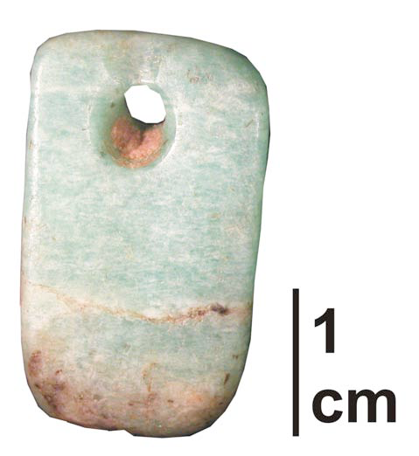

Amazonite pendant belonging to a private collection and found in an old market of Nouakchott (Mauritania); it was traded by a Tuareg seller.

Sample Mali A

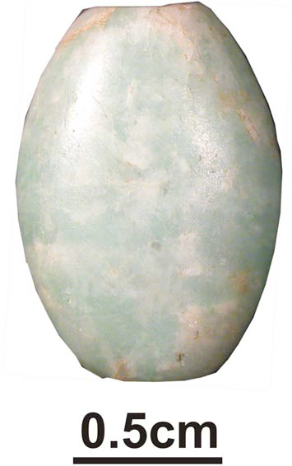

Amazonite bead part of an amazonite necklace, belonging to a private collection; it was collected in northern Mali in the ‘80s.
Sample Mali B

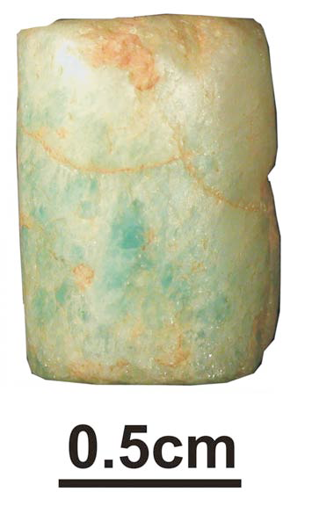

Amazonite bead part of an amazonite necklace, belonging to a private collection; it was collected in northern Mali in the ‘80s.

Sample Mali C

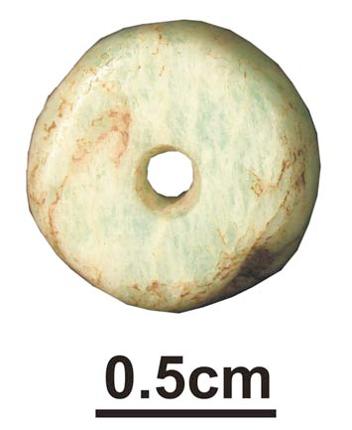

Amazonite bead part of an amazonite necklace, belonging to a private collection; it was collected in northern Mali in the ‘80s.

Sample Mali D

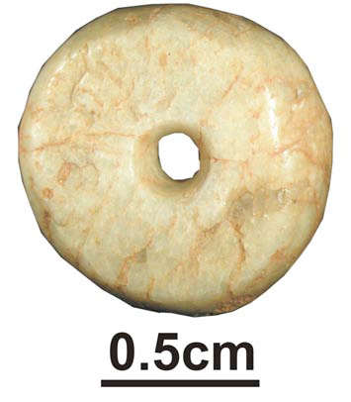

Amazonite bead part of an amazonite necklace, belonging to a private collection; it was collected in northern Mali in the ‘80s.

