Appendix A
Methods – Reproducibility of MLA data
Quantification of the reproducibility and statistical significance of the analyses was performed through (1) analyzing a thin section twice in the same analytical run (in-run duplication), and (2) by re-polishing of the sample to analyze a second surface of the same sample. Results are displayed in Figure A1. In-run analysis displays a relative standard deviation (2σ) for total area%^{PGM} of 5 % for sample ZK149-LG-6 and 4 % for sample ZK136D-LG-6A, while total area%^{BMS} and wt%^{Modal} show 2σ values below 2 % and 0.5 % for both samples, respectively. The combined in-run duplicates of surface A with surface B, 2SDs are 32 % in sample ZK149 and 15 % in sample ZK136D-LG-6A for total area%^{PGM}, while total area%^{BMS} and total area%^{Gangue} show 2σ values below 2 % and 3 % for both samples, respectively.
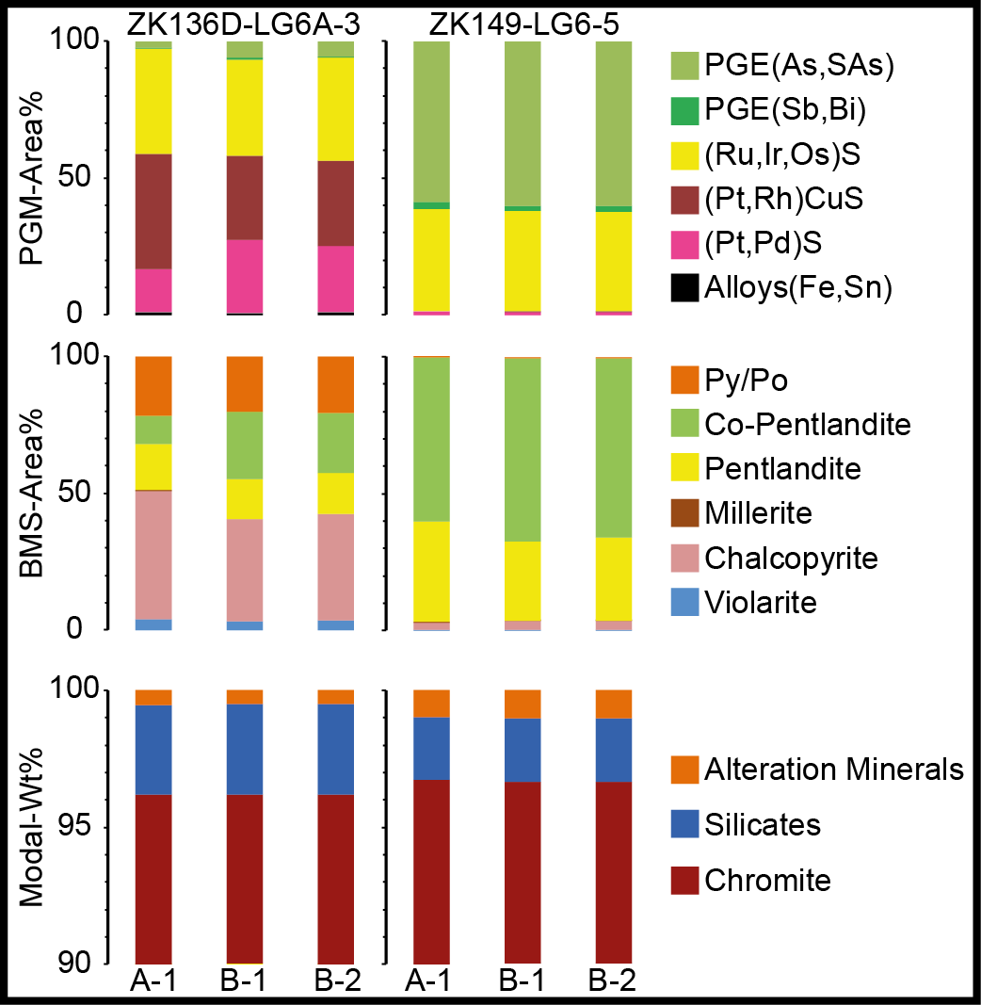
Figure A1 Stacked histograms showing the proportions of PGM species (in terms of area%^{PGM}), base metal sulfides (in terms of area%^{BMS}), and the modal mineralogy in wt% for samples ZK136D-LG-6A-3 and ZK149-LG-6-5. A-1: surface A; B-1: surface B-1; B-2: in-run duplicate of surface B-1.

Methods - Electron probe microanalysis (EPMA)
Quantitative analyses were also performed for amphibole, chromite, clinopyroxene, feldspar, olivine, orthopyroxene, serpentine and talc. Concentrations of Na, Mg, Al (all TAP); Si, K, Ca (all PETJ); Cr, V, Ti (all PETL); Zn, Ni, Co, Fe, Mn (all LIFH) were measured using K_{α} – lines. Certified reference materials provided by ASTIMEX Standards Ltd. were used for calibration. An electron beam diameter of 5 µm was set at 20kV/ 12 nA and the ZAF approach was used for matrix correction (atomic number–absorption–fluorescence; Philibert, 1963; Reed, 1965; Philibert & Tixier, 1968). Dwell times were set to 15s (Na), 20s (Si, Cr, Ni), and 30s (K, Ca, Fe, Mn), 40s (Mg, Al, V, Ti, Zn, Co). Offline overlap corrections were performed for Zn L_{β1} on Na K_{α1,2}; Mn K_{α1}, Ti K_{α1}, Cr K_{β1,3} on Al K_{α1,2}; Ni K_{α1} on Ca K_{α1}; V K_{β1,3} on Cr K_{α1}; Ti K_{β1,3} on V K_{α1}; Mn K_{β1,3} on Fe K_{α1}; and Cr K_{β1,3} on Mn K_{α1} as explained in Osbahr et al. (2015).
Finally, EPMA results were used to generate mineral standard spectra with a known composition for MLA measurements. Therefore, mineral standards were taken close to EPMA measurements. This approach allows a detailed differentiation of silicates, such as different feldspar compositions, amphiboles, pyroxenes and alteration silicates.
Results - Geochemistry
5PGE+Au (Pt,Pd,Rh,Ir,Ru,Au) contents are around 1 ppm for LG-6 samples and 1.5 ppm for the LG-6A. In general, the total sulfur content ranges between 100 – 200 ppm (<250 ppm), except intersection ZK144-LG-6, which contains only around 70 ppm. Detailed information are provided with the electronic supplementary material.
Figure A2 displays detailed geochemical assays of two selected drill core intersections of the LG-6 (ZK149-LG-6 and ZK144-LG-6). The profiles display a rather stable Cr₂O₃ content around 43-51 wt%. Slight fluctuations, especially in ZK149-LG-6 display massive chromitite intercalated with ~1 cm pyroxene-rich bands or pyroxene oikocrysts. 5PGE+Au contents are 900 ppb and 950 ppb with a Pt/Pd ratio around 2.2 and 4 and Pt/Ru ratios around 0.9 for intersections ZK144-LG-6 and ZK149-LG-6, respectively. Both profiles display 5PGE+Au profiles with a “M-shape”; ZK144-LG-6 displays a smooth variation in the overall PGE contents, ranging from ~700 ppb to 1100 ppb, while ZK149-LG-6 displays spikes with minimum single element contents of roughly 370 ppb and a maximum of 1600 ppb. The Ni+Cu plot displays different patterns, however, with variable contents for both of the examples. Cu/ (Cu+Ni) ratios are 0.02 and 0.01 for ZK144-LG-6 and ZK149, respectively. In general, the LG-6 is sulfur poor, with contents ranging from 70 ppm (ZK144-LG-6) to 130 ppm (ZK149-LG-6), on average.
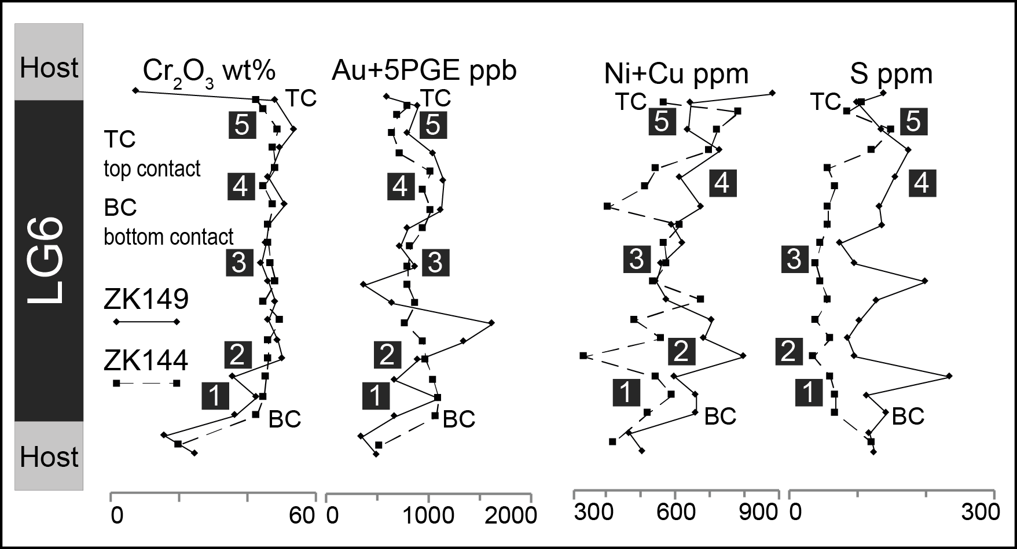
Figure A2 Detailed geochemistry of Cr₂O₃, Au+PGE (6E), Ni+Cu, and S concentrations versus stratigraphic height, normalized to 100 (ZK149: 83 cm; ZK144: 93 cm) in the LG6. Note the bottom (BC) and top contact (TC) of the intersections. 6E analyzed by Ni fire assay, aqua-regia digestion and ICP-MS finish, sulfur analyzed by “LECO” combustion.

Results - EPMA analyses – silicate minerals and chromite
Altogether, 359 analyses on LG-6A samples were obtained to describe the mineral chemistry of various silicate minerals as well as chromite in the LG seams. Table A1displays representative analyses of this sample set, extended by some analyses of important mineral compositions, namely Al-rich chromite, olivine, and serpentine, contained in a MG sample set due to a lack of these minerals in the measured LG sections. Mineral standard spectra for further MLA analysis were taken on grains with a known composition for a better identification during quantitative mineralogical assessment.
Figure A3A displays two different types of pyroxenes. One type yields an orthopyroxene X_{En}=78-85, X_{Fs} = 13-19 and X_{Wo} = 0.5-9 and is hereafter referred to as enstatite. The second type shows a slight trend from augitic to mainly diopsidic compositions and is composed of X_{En}=45-52, X_{Fs} = 5-9 and X_{Wo} = 38-48 (hereafter referred to as diopside). Amphiboles can be best described as magnesio-hornblende. Feldspars shown in Figure A3B yield plagioclase compositions ranging from andesine to bytownite, however, also minor albite and anorthite were analyzed by EDX measurement. Furthermore, sanidine with X_{Or} up to 90 % was encountered. For both, pyroxene and feldspar, there were no significant differences between samples detected. Chromite was analyzed in sample EL32D_LG-6A and ZK136D_LG-6A (Figure A3C). Data might indicate differences between samples, as sample EL32D_LG-6A displays low Fe³⁺ and slightly higher Al contents than ZK136D_LG-6A.

Figure A3 Ternary plots of EPMA measurements. (A) Classification diagram of pyroxene after Morimoto (1988). Both types of pyroxene – enstatite (orthopyroxene) and (augite)-diopside are rather chemically homogeneous. (B) Classification diagram of feldspar with endmembers anorthite (An), albite (Ab), alkalifeldspar/ orthoclase (Or). Beside plagioclase with variable composition alkali feldspar with sanidine composition was detected. (C) Ternary plot of trivalent cations, Cr, Al and Fe³⁺ in chromite. Note that the data show only little variation, however, all analyses of intersection EL32D_LG-6A display a lower concentration in Fe³⁺ compensated by a higher Al content.

Table A1 Representative EPMA analyses of all relevant silicate minerals and chromite, used for the MLA Mineral Reference List.
No. | 346 | 330 | 23 | 207 | 221 | 120 | 228 | 391 | 197 | 445 | 192 | 166 | 132
Core | ZK136D | EL32 | EL32D | EL32D | SC42 | ZK146 | SC42 | ZK136D | EL32D | EL32 | EL32D | EL32D | ZK146
Seam | LG-6A | MG1 | LG-6A | LG-6A | LG-6A | MG1 | LG-6A | LG-6A | LG-6A | MG1 | LG-6A | LG-6A | MG1
Mineral | Chromite | Al-Chromite | Chromite | ClinoPx | OrthoPx | Olivine | Plagioclase | K-Feldspar | Muscovite | Biotite | Amphibole | Talc | Serpentine
all data in wt%
Na₂O | bdl | bdl | bdl | 0.35 | 0.01 | 0.02 | 2.36 | 1.19 | 0.11 | 0.26 | 1.84 | 0.05 | 0.02
MgO | 4.84 | 14.26 | 6.56 | 18.00 | 31.44 | 45.36 | 0.04 | 0.01 | 0.54 | 18.84 | 16.64 | 25.69 | 35.97
Al₂O₃ | 7.43 | 48.11 | 17.40 | 2.00 | 1.38 | 0.00 | 32.54 | 18.33 | 34.88 | 20.71 | 10.25 | 0.38 | 0.01
SiO₂ | 0.04 | 0.72 | 0.03 | 53.28 | 55.32 | 40.03 | 49.18 | 63.29 | 47.30 | 39.39 | 47.60 | 59.28 | 40.58
K₂O | bdl | bdl | bdl | bdl | 0.01 | 0.00 | 0.04 | 15.44 | 9.66 | 9.24 | 0.15 | 0.02 | 0.03
CaO | bdl | bdl | bdl | 19.44 | 0.74 | 0.03 | 15.64 | 0.10 | 0.26 | 1.52 | 11.70 | 0.20 | 0.03
Cr₂O₃ | 50.81 | 14.86 | 46.53 | 0.99 | 0.56 | 0.00 | 0.23 | bdl | 0.02 | 0.06 | 2.01 | 0.09 | 0.01
V₂O₃ | 0.46 | 0.34 | 0.44 | 0.05 | 0.03 | 0.00 | 0.01 | 0.02 | 0.02 | 0.01 | 0.11 | 0.01 | 0.01
TiO₂ | 0.47 | 0.05 | 0.84 | 0.22 | 0.09 | 0.00 | bdl | 0.04 | bdl | 0.27 | 1.30 | 0.02 | 0.02
ZnO | 0.13 | 0.76 | 0.11 | bdl | bdl | bdl | bdl | bdl | bdl | bdl | bdl | bdl | bdl
NiO | 0.12 | 0.13 | 0.14 | 0.04 | 0.08 | 0.29 | bdl | 0.04 | bdl | 0.11 | 0.12 | 0.05 | 0.32
CoO | 0.13 | 0.13 | 0.09 | 0.02 | 0.03 | 0.03 | bdl | bdl | 0.01 | 0.02 | 0.02 | 0.01 | 0.03
MnO | 0.32 | 0.09 | 0.30 | 0.16 | 0.24 | 0.20 | bdl | bdl | 0.01 | 0.02 | 0.08 | 0.04 | 0.05
FeO | 25.33 | 16.88 | 24.52 | 5.40 | 9.88 | 13.92 | 0.28 | 0.35 | 2.24 | 4.82 | 5.91 | 8.69 | 7.59
Fe₂O₃ | 9.35 | 1.60 | 1.87
Total | 99.42 | 97.92 | 98.82 | 99.97 | 99.82 | 99.89 | 100.31 | 98.81 | 95.05 | 95.27 | 97.72 | 94.54 | 84.68
all data is given as apfu
Na |  |  |  | 0.025 | 0.001 | 0.001 | 0.208 | 0.108 | 0.015 | 0.035 | 0.198 | 0.014
Na (A) |  |  |  |  |  |  |  |  |  |  | 0.315
Mg | 2.019 | 4.763 | 2.591 | 0.979 | 1.653 | 1.693 | 0.003 | 0.001 | 0.053 | 1.981 | 3.565 | 5.096 | 5.302
Al | 3.678 | 19.052 | 8.152 | 0.086 | 0.058 |  | 1.748 | 1.014 | 2.731 | 1.722 | 1.735 | 0.060 | 0.002
Al IV |  |  |  | 0.055 | 0.049 |  |  |  | 0.857 | 1.221 | 1.160 | 0.060
Al VI |  |  |  | 0.031 | 0.008 |  |  |  | 1.874 | 0.502 | 0.576 |  | 0.002
Si | 0.024 | 0.323 | 0.014 | 1.945 | 1.951 | 1.002 | 2.241 | 2.969 | 3.143 | 2.779 | 6.840 | 7.889 | 4.012
Si (T1) |  |  |  |  |  |  |  |  |  |  | 2.840
K |  |  |  |  |  |  | 0.003 | 0.924 | 0.819 | 0.831 | 0.027 | 0.004 | 0.004
Ca |  |  |  | 0.760 | 0.028 | 0.001 | 0.763 | 0.005 | 0.018 | 0.115 | 1.802 | 0.028 | 0.004
Cr | 16.873 | 3.948 | 14.627 | 0.029 | 0.016 |  | 0.008 | 0.000 | 0.001 | 0.004 | 0.229 | 0.010 | 0.001
V | 0.160 | 0.095 | 0.146 | 0.002 | 0.001 |  |  | 0.001 | 0.001 | 0.001 | 0.014 | 0.001 | 0.001
Ti | 0.199 | 0.016 | 0.333 | 0.006 | 0.002 |  |  | 0.001 |  | 0.014 | 0.140 | 0.002 | 0.001
Zn | 0.026 | 0.126 | 0.022
Ni | 0.026 | 0.024 | 0.029 | 0.001 | 0.002 | 0.006 |  | 0.002 |  | 0.006 | 0.014 | 0.005 | 0.025
Co | 0.029 | 0.022 | 0.019 | 0.001 | 0.001 | 0.001 |  |  | 0.001 | 0.001 | 0.003 | 0.001 | 0.002
Mn | 0.076 | 0.017 | 0.068 | 0.005 | 0.007 | 0.004 |  |  | 0.001 | 0.001 | 0.009 | 0.004 | 0.004
Fe²⁺ | 5.928 | 3.163 | 5.433 | 0.165 | 0.291 | 0.292 | 0.011 | 0.014 | 0.124 | 0.284 | 0.710 | 0.967 | 0.628
Fe³⁺ | 2.955 | 0.404 | 0.560
Vac |  |  |  |  |  |  |  |  |  |  | 0.658
Total | 31.993 | 31.952 | 31.995 | 4.003 | 4.010 | 3.000 | 4.985 | 5.038 | 6.907 | 7.776 | 15.600 | 14.082 | 9.985
Cr/Al | 4.587 | 0.207 | 1.794
Mg# | 0.254 | 0.601 | 0.323 | 0.86 | 0.85
FFE | 0.333 | 0.113 | 0.093
Cr# | 0.821 | 0.172 | 0.642
Cr/Fe | 1.33 | 0.71 | 1.56
Sum IV |  |  |  | 2.000 | 2.000
Sum VI |  |  |  | 2.003 | 2.010
X_{Wo} |  |  |  | 39.92 | 1.43
X_{En} |  |  |  | 51.43 | 83.81
X_{Fs} |  |  |  | 8.65 | 14.77
Fo |  |  |  |  |  | 85.10
An |  |  |  |  |  |  | 78.35 | 0.50
Or |  |  |  |  |  |  | 0.26 | 89.08
X_{Mg} |  |  |  |  |  |  |  |  | 0.053 | 0.637 | 0.834
Na+K(A) |  |  |  |  |  |  |  |  |  |  | 0.342
Please note the analyses for Al-chromite, olivine, biotite and serpentine were taken from a different sample set of MG1 samples from the same locality. Calculation of chromite is normalized to 32 O; pyroxene is normalized to 6 O; olivine is normalized to 4 O; feldspar is normalized to 8 O; mica is normalized to 11 O; amphibole is normalized to 23 O; talc is normalized to 22 O; and serpentine is normalized to 14 O. apfu – atoms per formula unit.

ANOVA
An ANOVA was performed – followed by standard F-tests – to investigate the variability of the samples and to determine assemblages for classification according to the sub-compositions area%^{PGM}, area%^{BMS} and area%^{Gangue} (see legend in Figure A4A). Variability of the samples was tested for four explanatory factors (“surfaces A/B”, “intra seam”, “inter core” and “inter seam” (see in the methods section for definition of these explanatory factors). “Surfaces A/B” compares the results obtained for the two different polished surfaces (A and B) analysed for each sample. This explanatory factor is found to have no significant influence on the tested ANOVA model, which allows the conclusion that the exact position of the sample surface examined by MLA has no significant effect on the results obtained. Most notably, it suggests that the “nugget effect” (small scale variability) is negligible.
The explanatory factor “intra seam” considers the variance between samples of a different stratigraphic position within a sampled seam, i.e. if seams have systematically different mineral assemblages within their respective confines. The factor “intra seam” does have a significant influence for the variance of both, area%^{PGM} and area%^{BMS} and a highly significant influence for the variance of area%^{Gangue}. The two factors “inter seam” (considering systematic differences between the two studied seams, LG-6 and LG-6A) and “inter core” (considering systematic differences between different drill core intersections) show close interrelation, meaning that variance induced by “inter seam” will be a part of the variance induced by “inter core”. While the F-tests for the factor “inter seam” are non-significant for area%^{PGM} and area%^{BMS}, and highly significant for area%^{Gangue}, the factor “inter core” yields highly significant results in all cases. This suggests that systematic differences between distinct seams intersected within the same drill core are of minor importance compared to differences encountered between drill cores from different sites on the mine lease area.
Figure 4A shows the variance distribution for the two most relevant factors. “Inter core” is by far the most important explanatory factor, explaining between 59 and 77 % of the total variance. In comparison, the factor “intra core” explains only 6 % of total variance – a value that is similar for all sub-compositions. As mentioned above, the factor “seam” was not considered further, as it explains only between 2 and 13 % of the “inter core” variance for area%^{PGM} and area%^{BMS} and area%^{Gangue}. The factor “residuals” reports the variance that cannot be assigned to any of the previously mentioned factors and ranges between 23 and 35 % of the total variance. A detailed evaluation of the explanatory factor “inter core” for all sub-compositions based on ratios of certain mineral groups is shown in Figure A4B. The chosen ratios explain the bulk total variance, i.e. reflect the distribution of the group members. According to the ANOVA model the main part of the total variance in area%^{PGM} is invested in predicting the ratios [PGE -sulfarsenides and PGE-antimonides, -bismuthides vs. PGE –sulfides, -Cu-sulfides and -alloys of Fe,Sn]; i.e. these groups show a strong negative correlation and form distinctly different mineral assemblages. Furthermore, the ratio [PGE-Cu-sulfides vs. PGE –sulfides and –alloys of Fe,Sn] explains a significant portion of the total variance, and may be used to distinguish two more PGM mineral assemblages. The variability of IPGE -sulfides is rather low and only marginally explained by the factor “inter core”. The area%^{BMS} “inter core” variance is mostly related to the variability of (Co-rich) pentlandite with respect to the geometric average of the other four BMS considered (chalcopyrite, millerite, pyrite and violarite). The ratios [chalcopyrite vs. millerite] and [chalcopyrite and millerite vs. violarite] do also have relevant contributions. The mentioned relationships correspond well to the area%^{PGM} distribution, i.e. PGE-sulfarsenide/ -alloy of Sb,Bi-rich assemblages represent the same set of samples as the (Co-rich) pentlandite dominated BMS assemblages (forming assemblage (III)). On the other hand, PGE-(Cu)–sulfides and -alloys of Fe,Sn occur together with rather chalcopyrite, millerite, pyrite, violarite dominated samples – resulting in assemblage (I) and (II). The latter assemblages can be further subdivided into PGE-Cu-sulfides + chalcopyrite and millerite-rich samples (assemblage (II)), in contrast to assemblage (I) where a PGE-sulfide-rich assemblage is associated with a rather variable BMS assemblage consisting of chalcopyrite, pentlandite, pyrite and variable amounts of violarite.
In the area%^{Gangue} sub-composition total “inter core” variance is best described using the ratios [alteration silicates and silicates vs. carbonate] followed by [alteration silicates vs. silicates]. While carbonate-rich samples are associated with PGM-BMS assemblage (III), silicate-rich samples dominate PGM-BMS assemblage (I). Significant amounts of alteration silicates may occur in samples belonging to PGM-BMS assemblages (II) and (III).
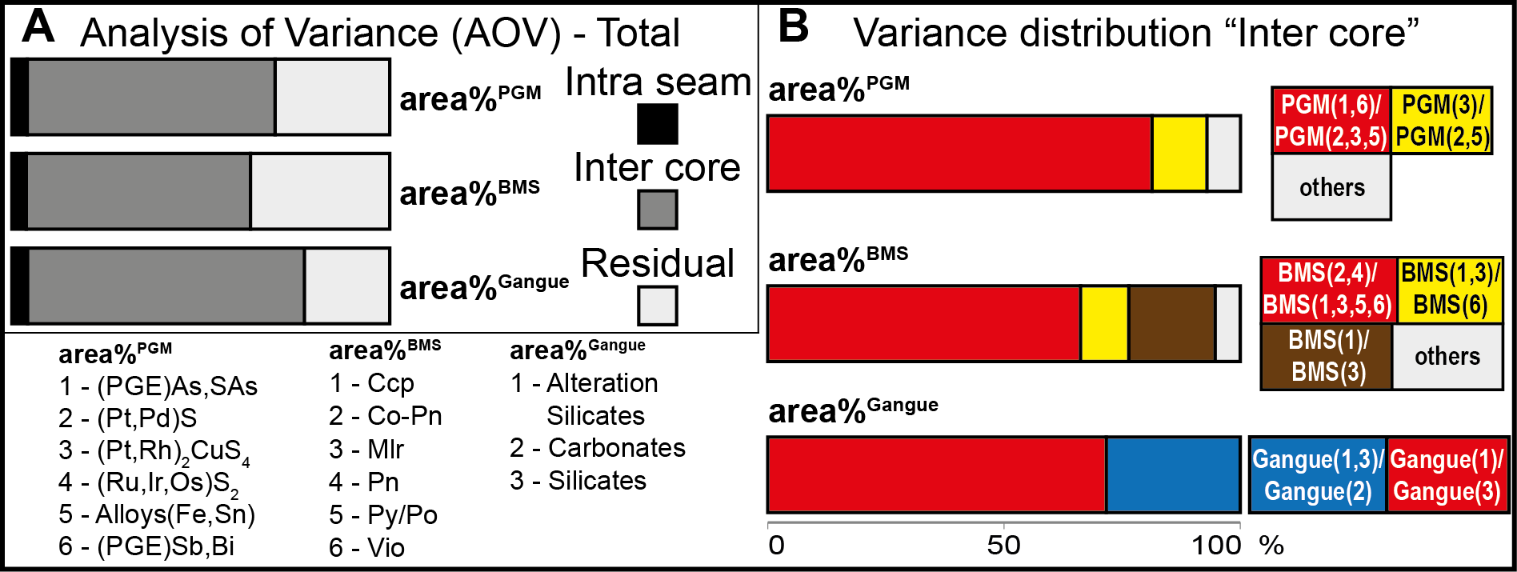
Figure A4 Stacked histograms of the results of an analysis of variance (AOV) of the modal mineralogy for PGM, BMS and rock forming minerals (Others). (A) Total variance distribution for area%^{PGM}, area%^{BMS} and area%^{Gangue}. (B) Variance distribution based on defined ratios of certain PGM/BMS/Gangue groups. For simplification, further reference to any group members will be as following, e.g. (PGE)As,AsS = PGM(1); Alloys(Sb,Bi) = PGM(6); Ccp = BMS(1), etc. (cf. Table 6; legend in (A)).

Cluster analysis
For a quantitative assessment of the variability of the mineral association a cluster analysis was performed according to the sub-compositions of PGM (without IPGE sulfides) and BMS. The results were linked to the mineral assemblages defined in the previous chapter (ANOVA).
Despite the very low total abundance of BMS (< 0.02 area% in all samples), PGM show a strong preferred association with BMS; they also show a close association with alteration silicates, occurring both in interstitial positions and as inclusion. PGM are only to a much lesser extent associated with silicates and chromite. PGM occur predominantly interstitial to chromite (with minor inclusions cf. Figure 2G). BMS show a very similar association to PGM.
The cluster analysis results in three distinct clusters: a dominant and two minor, for both PGM [n_{Cluster1} = 5, n_{Cluster2} = 16, n_{Cluster3} = 39] and for BMS [n_{Cluster1} = 39, n_{Cluster2} = 12, n_{Cluster3} = 9] (Figure A5). PGM cluster 1 consists of samples with a high silicate and lower chromite content, where most PGM occur in association with BMS. Cluster 2 includes carbonate-rich samples and PGM associated with alteration silicates and carbonates. Cluster 3, on the other hand, represents high chromite, high alteration silicate and low silicate content samples; PGM in this cluster are intergrown with alteration silicates and silicates. BMS cluster 1 is marked by high silicate/ alteration silicate ratios, where BMS occur predominantly as polymineralic aggregates intergrown with both alteration silicates and silicates. In contrast, the BMS cluster 3 lacks BMS aggregates and and includes samples with low silicate/alteration silicate ratios. BMS are closely associated with silicates and alteration silicates in these samples. Similar to PGM cluster 2, the BMS cluster 2 represents carbonate-rich samples. Both, PGM and BMS mineral associations thus define similar clusters - implying a separation of silicate-dominated from alteration silicate and/or carbonate-dominated clusters. BMS and PGM tend to be associated with alteration minerals, if present, hence, establishing cluster 1 as typical for assemblage (I) seems valid. Furthermore, cluster 2 can be assigned to assemblage (III), while cluster 3 mainly represents the alteration silicate-rich members of assemblage (II) and (III).
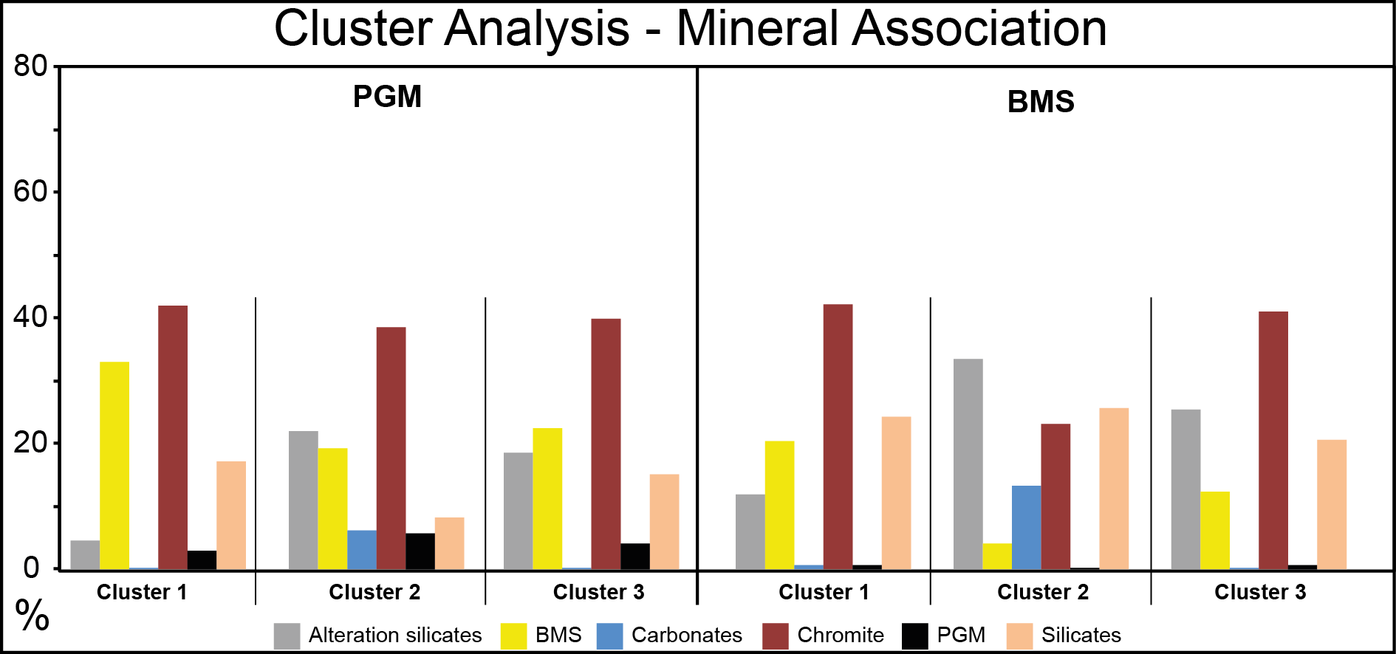
Figure A5 Histograms of average mineral associations of clusters defined by two cluster analysis for sub-compositions PGM (without IPGE –sulfides) and BMS, respectively. Color codes are explained below corresponding histograms. Cluster (I) displays high abundances of PGM-sulfides and alloys of Fe and Sn together with BMS dominated by pentlandite + chalcopyrite + pyrite. Cluster (II) comprises high amounts of PGM-sulfarsenides and PGM-arsenides together with PGE-antimonides, -bismuthides and scant –bismuthotellurides. Corresponding BMS are strongly dominated by pentlandite and Co-rich pentlandite. On the one hand, cluster (III) represents samples dominated by PGM-Cu-sulfide corresponding with high amounts of chalcopyrite. On the other hand, a minor amount of samples contains significant portions of PGM-sulfarsenides, -arsenides, -antimonides, and -bismuthides corresponding with a high abundance of pentlandite.

References
Morimoto N (1988) Nomenclature of pyroxenes. Mineralogy and Petrology 39(1):55–76
Philibert J (1963) X-ray optics and x-ray microanalysis. In Proceedings of the Third International Symposium, Stanford University, Pattee H.H., Cosslett, V.E. & Engström, A. (Eds.), New York, NY: Academic Press: 379
Philibert J, Tixier R (1968) Electron penetration and the atomic number correction in electron probe microanalysis. J Phys 1: 685–694
Reed SJB (1965) Characteristic fluorescence corrections in electron probe microanalysis. Br J Appl Phys 16: 913–926

