Petrography of ecandrewsite-bearing amphibolite
Type 1 amphibolite is a massive, slightly banded rock, dark green in color and fine grained (size range <1 mm; Fig 1). The general texture of the rock is equigranular granonematoblastic. It is composed of amphibole (pargasite; ∼ 70 %), plagioclase (47 to 68 mol % anorthite; ∼ 15 %) and phlogopite-rich biotite (Fe/Fe+Mg = 0.30 to 0.32, ∼ 10 %). Quartz, titanite, zircon, apatite, epidote, ilmenite group minerals (IGM) and chalcopyrite are accessory phases that sum up ∼ 5 % volume. The pargasite grains are euhedral to subhedral and range in size from 0.25 to 0.5 mm; these present inclusions of zircon, fluorapatite and scarce IGM phases, and are slightly replaced by actinolite. Plagioclase is found as anhedral crystals of less than 0.25 mm, and has gone through moderate sericitization and epidotization. Phlogopite is found in tabular aggregates less than 1 mm associated with amphibole and plagioclase; some crystals are slightly chloritized. Quartz is scarce and occurs in anhedral grains of no more than 0.1 mm associated with plagioclase. Abundant titanite in subhedral to euhedral grains as large as 0.1 mm is commonly distributed along the intercrystalline contacts between plagioclase and amphibole; most of them contain relic IGM inclusions as long as 75 µm, some are poorly hematitized. Zircon occurs in subhedral to euhedral grains of no more than 50 µm, mostly included in phlogopite, amphibole and plagioclase. Fluorapatite occurs in euhedral grains of up to 25 µm commonly as inclusions in amphiboles. Chalcopyrite partially replaced by covellite was identified as a few ∼ 5 µm anhedral grains included in titanite and plagioclase.
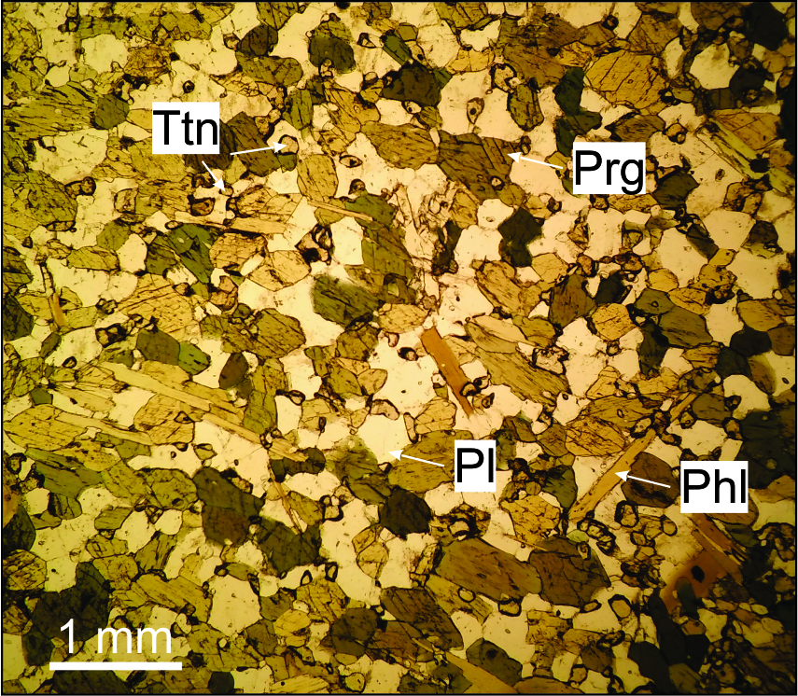
Fig. 1) Representative thin section of ecandrewsite-bearing amphibolite under plane polarized light (parallel Nichols). Prg: pargasite, Pl: plagioclase (An_{0.47-0.68}), Ttn: titanite, Phl: phlogopite.

