Supporting Information:
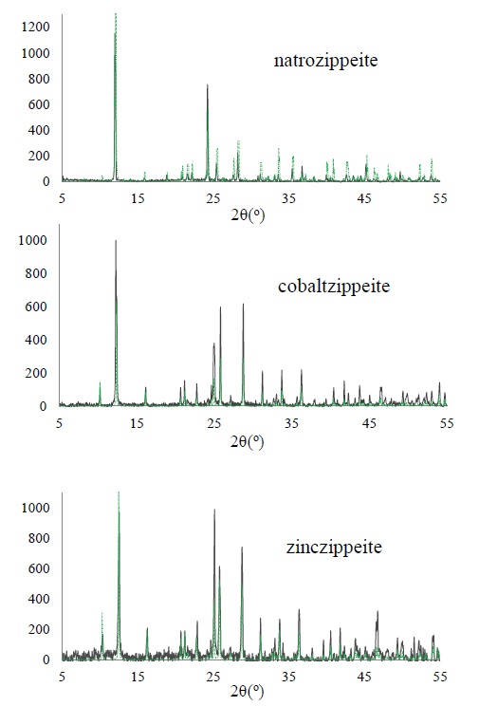
Figure S1- Powder X-ray diffraction patterns for natrozippeite, cobaltzippeite, and zinczippeite. Black trace corresponds to synthetic phase, and green peaks correspond to peak positions and heights calculated from the structural model (Burns et al., 2003)

Table S1. ICP-OES results for chemical analysis of synthetic Na-, Co-, and Zn-zippeite.
Sample | Ratio | Ideal | Actual
Natrozippeite | mol Na/mol U | 0.63 | 0.63±0.01
 | mol S/mol U | 0.5 | 0.48±0.03
Cobaltzippeite | mol Co/mol U | 0.5 | 0.5±0.02
 | mol S/mol U | 0.5 | 0.48±0.03
Zinczippeite | mol Zn/mol U | 0.5 | 0.53±0.02
 | mol S/mol U | 0.5 | 0.47±0.03

