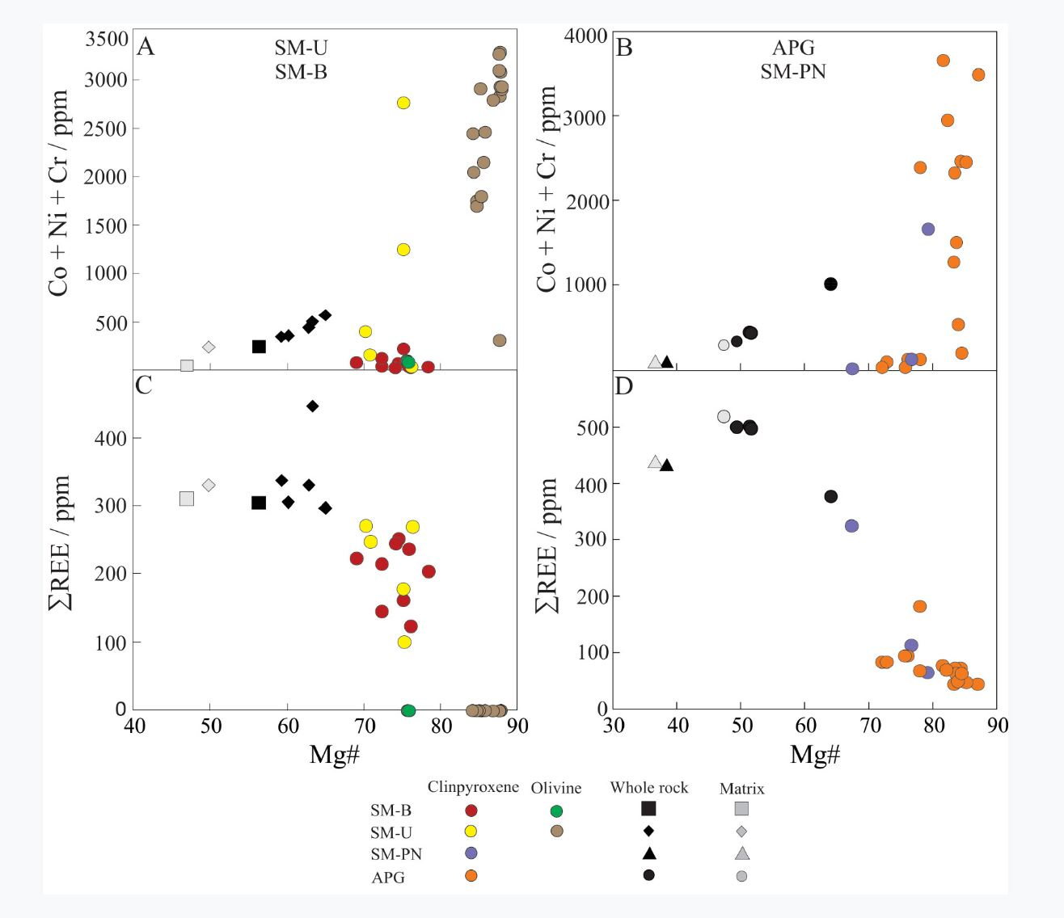
Fig. A1. (A and B) Co + Ni + Cr and (C and D) ∑REE versus Mg# for antecrysts or xenocrysts of olivine and clinopyroxene cores, whole-rock (sectors) and matrix. Mg# = [Mg/(Mg + Fe_{t})] × 100, in terms of apfu for crystals, or [MgO/(MgO + FeO_{t})], in terms of mol for whole rock and matrix. Data with ∑REE or Co + Ni + Cr equal to zero are analyses below the lower limit of determination. The diagrams show the influence of olivine and clinopyroxene antecrysts and xenocrysts (mainly represented by megacryst and macrocryst cores) on the composition of APG, SM-U, SM-PN, and SM-B, although diagrams A-D do not represent a mass balance approach. Cr + Ni + Co values of dike sectors richer in olivine and clinopyroxene macrocrysts (APG-C, SM-U-B2, SM-B-C) are close to the macrocryst compositions. In basaltic and basanitic systems, Cr, Co, and Ni can behave as compatible elements in clinopyroxene and olivine (Adam & Green 2006, Arzmastsev et al. 2009, Foley et al. 2011). Therefore, the higher the number of antecrysts/xenocrysts in the sector, the more similar whole-rock and foreign crystal compositions are. In the case of SM-PN, the whole-rock Cr + Ni + Co is similar to the cpx 3 crystal and the cpx 4 rim compositions (Table A5), which indicates that both crystals (cpx 3 and cpx 4 rim) and matrix crystallized from a melt with low abundances of Cr, Ni, and Cr. On the other hand, because of the incompatibility of REE in clinopyroxene (Adam & Green 2006, Arzmastsev et al. 2009, Foley et al. 2011), diagrams C and D show that dike sectors richer in olivine and/or clinopyroxene macrocrysts are more depleted in REE than other sectors. In Figure A1 - C, the data of SM-U-C show ΣREE above 400 ppm. This result can be explained by this zone of the dike having a great number of ocelli. In general, matrix data are located far from the macrocryst compositions, showing once again via this indirect approach the importance of antecryst/xenocryst contents in the whole-rock composition.

