Supplemental materials
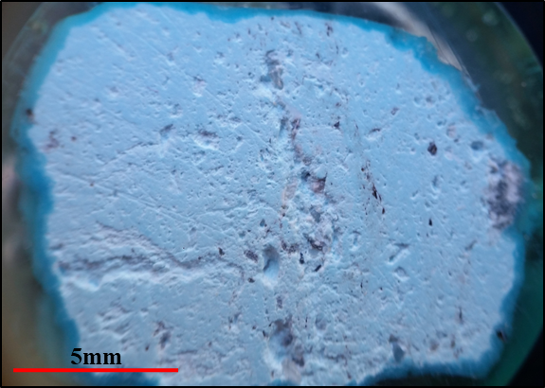
Figure A1: Pale blue turquoise with relict quartz and biotite, from the D-North pushback of the Continental Pit, 5840’ bench.
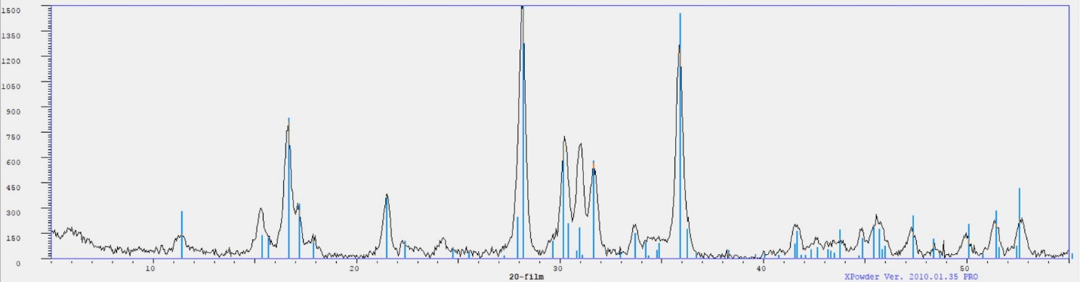
Figure A2: X-ray diffractogram for sample shown in Figure A1, with reference peaks for turquoise (AMCSD).
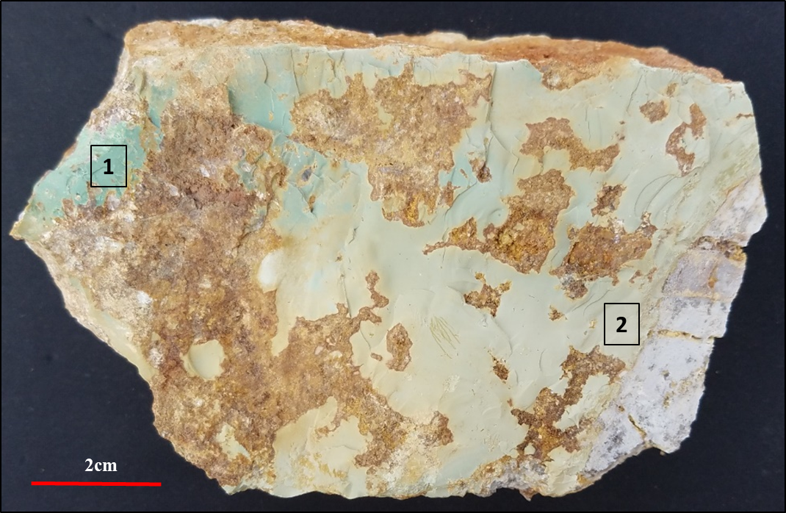
Figure A3: Fracture-filling Fe-turquoise and tinticite, Continental Pit, D-East pushback, 6360’ bench. Powder XRD results for sites 1 and 2 are shown in the following figures. A polished section shown in figures 2C and 2D was cut from site 1 of this sample, see figure A6 for SEM-EDS results.

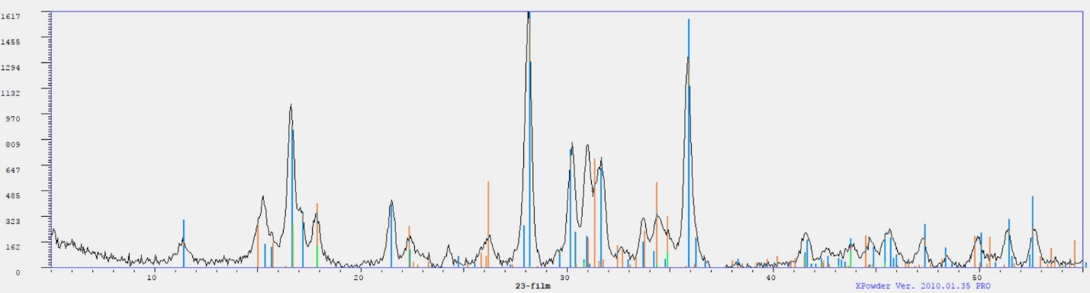
Figure A4: Sample site 1 in figure A3. X-Ray diffractogram for turquoise mixed with tinticite (2:1 ratio). Peaks shown with blue are for turquoise, peaks shown in orange are for tinticite.

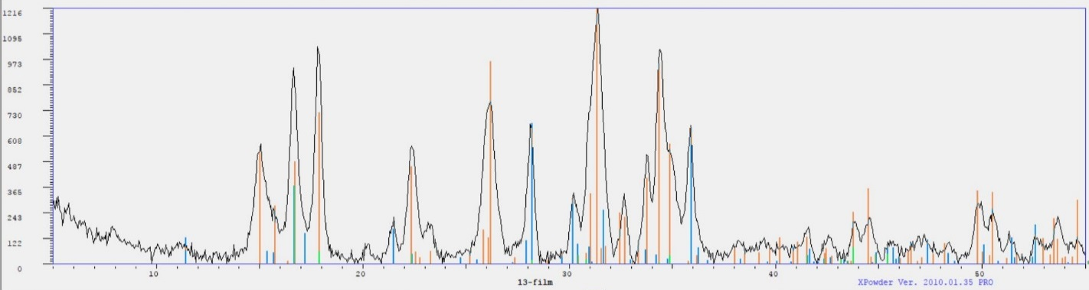
Figure A5: Sample site 2 in figure A3. X-Ray diffractogram for tinticite mixed with turquoise (2:1 ratio). Peaks shown with blue are for turquoise, peaks shown in orange are for tinticite.

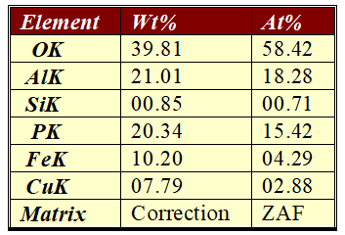
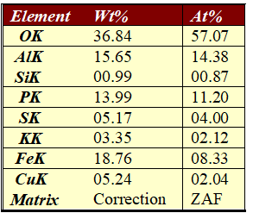
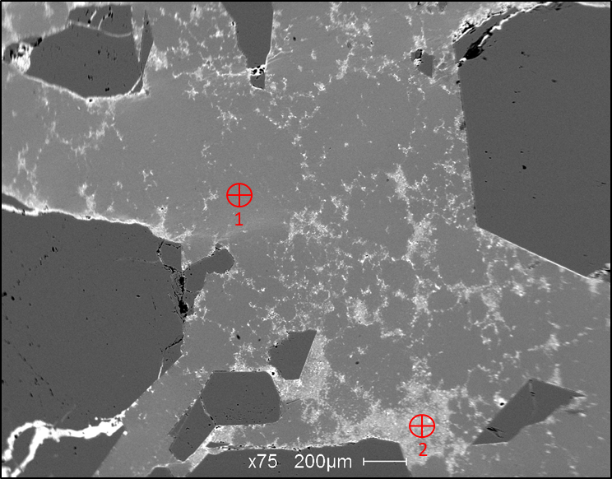
Figure A6: SEM-EDS analysis locations and results for image shown in Figure 2D; 1) Fe-turquoise and 2) Fe-turquoise and jarosite.

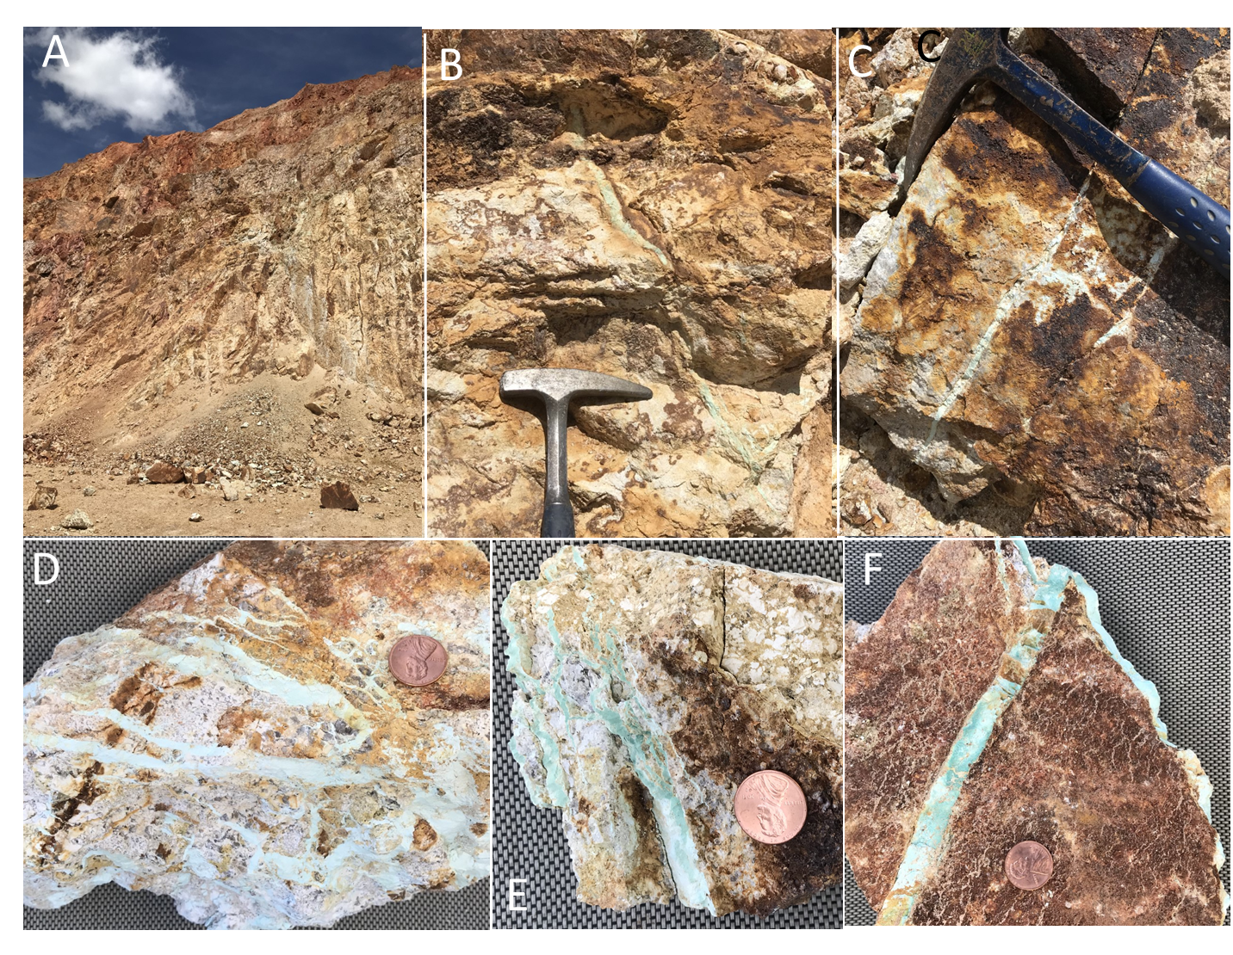
Figure A7: Photographs of leach cap material at D-East 6200’ level taken on May 27, 2020. A) View of the highwall, showing intense Fe-oxide alteration; B) 1 cm vein (center of photo) of Fe-bearing turquoise + kaolinite; C) Another thin, pale veinlet with jarosite + hematite + goethite; D, E, and F) Closeups of Fe-bearing turquoise + kaolinite (+ tinticite?) picked from the muck pile.

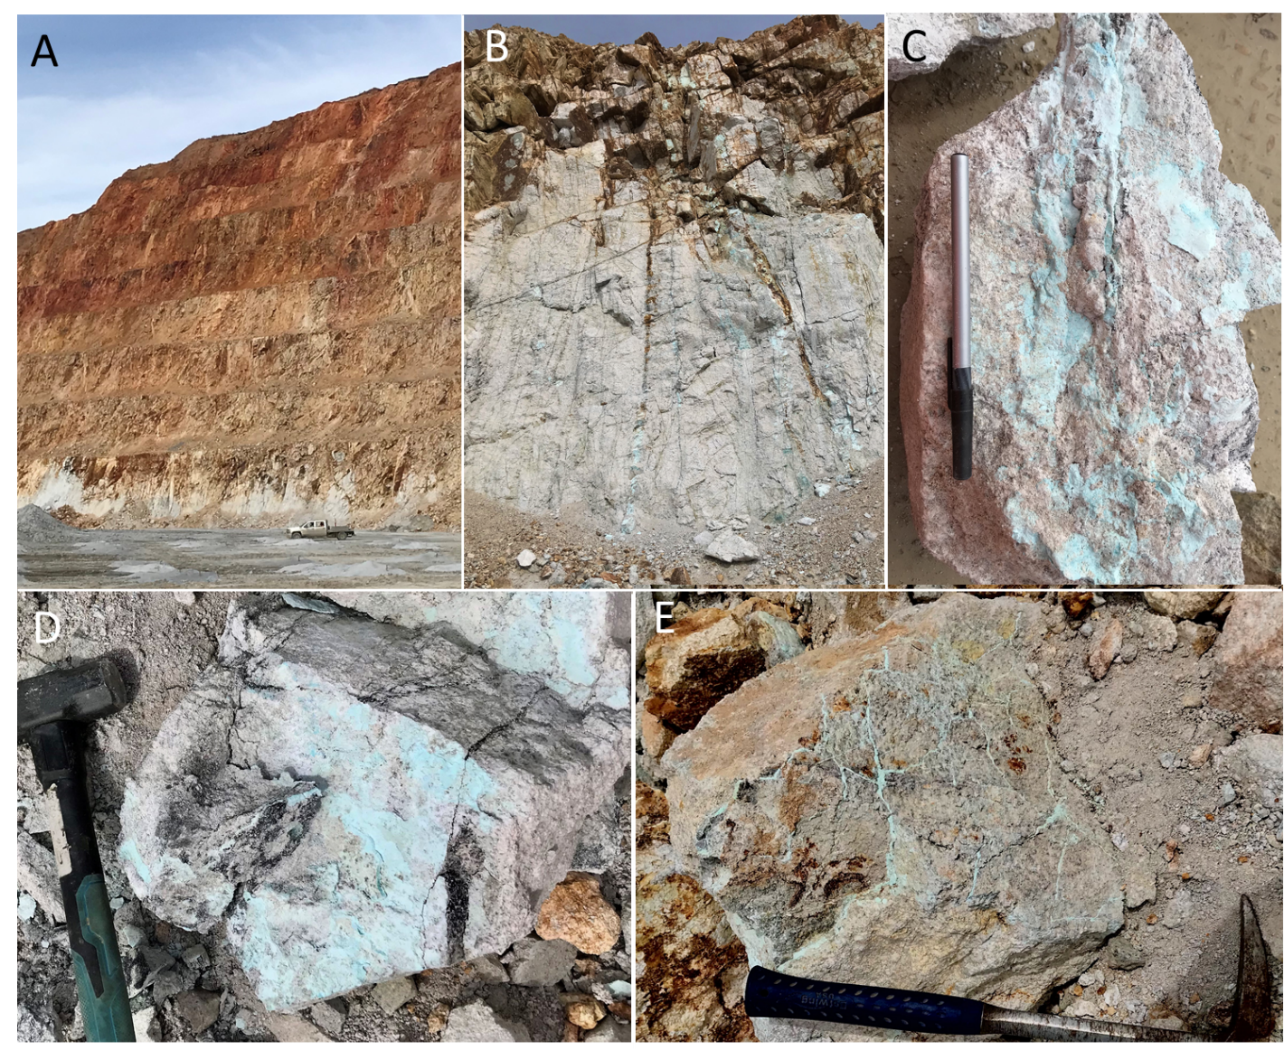
Figure A8: Photographs of the D-East Pushback (6080 ft. level) taken on April 1st, 2022. A) Highwall showing red, hematitic zone grading downwards to brown jarosite/goethite. Light gray rocks exposed on lowest bench are the top of the supergene enrichment blanket. B) Closeup photo of the highwall on the working bench showing transition from dark brown jarosite/goethite veins at top to powder-blue kaolinite-turquoise-chalcocite veins at bottom (image is roughly 4 m across); C) hand sample showing turquoise-kaolinite veinlets on altered granite; D) Turquoise-kaolinite coating joints and fractures with black chalcocite. Granite is strongly altered to kaolinite-halloysite; E) thin veinlets of turquoise-kaolinite cutting altered granite.

Table A1: Statistical summary of EPMA data for green Fe-bearing turquoise from the 6200’ and 6360’ benches of D-East (samples n= 3, analyses n=32); APFU (atoms per formula unit) values were calculated using 28 oxygens.
Element (apfu) |  | Min | Max | Mean | Median | Range | St. Dev.
Cu | 0.481 |  | 0.830 | 0.689 | 0.725 | 0.349 | 0.095
Al | 3.627 |  | 5.224 | 4.687 | 4.849 | 1.597 | 0.435
Fe | 0.375 |  | 1.557 | 0.967 | 0.943 | 1.182 | 0.346
P | 2.872 |  | 4.109 | 3.678 | 3.732 | 1.237 | 0.376
Ca | 0.003 |  | 0.028 | 0.014 | 0.011 | 0.025 | 0.008
Sr | 0.001 |  | 0.004 | 0.002 | 0.002 | 0.003 | 0.001
Ba | 0.001 |  | 0.007 | 0.003 | 0.001 | 0.006 | 0.002
Na | 0.004 |  | 0.058 | 0.015 | 0.006 | 0.054 | 0.017
K | 0.001 |  | 0.017 | 0.008 | 0.009 | 0.016 | 0.004
Zn | 0.003 |  | 0.008 | 0.004 | 0.003 | 0.005 | 0.001
S | 0.009 |  | 0.038 | 0.022 | 0.023 | 0.028 | 0.008
As | 0.001 |  | 0.004 | 0.001 | 0.001 | 0.003 | 0.001
Cl | 0.001 |  | 0.189 | 0.064 | 0.058 | 0.188 | 0.059
F | 0.069 |  | 0.133 | 0.092 | 0.089 | 0.064 | 0.017
H | 16.580 |  | 19.657 | 17.691 | 17.616 | 3.077 | 0.989

