Supplementary Material

Contents

Secondary standards values 2

MASS-1 2

FeS-5 2

Limit of Detection 3

Inclusion Analysis 3

Interference Analysis 4

Previous work methodology 5

Electron-microprobe analysis 5

Laser ablation ICP-MS analysis 5

Replicate Whole Rock Analysis 6

Primary Standard Preferred Values 7

UQAC-FeS-1 7

USGS-GSD-2G 8

References 9

# Secondary standards values

For the analysis measured at CSIRO, a difference of more than 10% of the published values is considered inaccurate and may indicate an interference or other problem with the chosen isotope. A relative standard deviation (RSD) of greater than 5 % are outside the threshold for acceptable precision.

## MASS-1

Table 1: Averaged measured values of MASS-1 secondary standard

|  |  |  |  |  |
| --- | --- | --- | --- | --- |
| **USGS-MASS-1** | Average | Published Value | Difference | RSD |
| Ti_ppm_m47 | 3.07 |  |  |  |
| V_ppm_m51 | 65.15 | 65 | 0% | 3% |
| Cr_ppm_m53 | 68.59 | 65 | 5% | 6% |
| Mn_ppm_m55 | 272.10 | 280 | -3% | 7% |
| Co_ppm_m59 | 68.73 | 60 | 13% | 3% |
| Ni_ppm_m60 | 102.57 | 97 | 5% | 3% |
| Ni_ppm_m61 | 100.16 | 97 | 3% | 3% |
| Ni_ppm_m62 | 101.28 | 97 | 4% | 3% |
| Cu_ppm_m63 | 135555 | 134000 | 1% | 2% |
| Cu_ppm_m65 | 134836 | 134000 | 1% | 2% |
| Zn_ppm_m66 | 193336 | 210000 | -9% | 4% |

## FeS-5

Table 2: Averaged measured values of FeS-5 secondary standard

|  |  |  |  |  |
| --- | --- | --- | --- | --- |
| **UQAC_FeS-5** | Average | Published Value | Accuracy | Precision |
| Ti_ppm_m47 | 15 | 16 | -6% | 5% |
| V_ppm_m51 | 25 | 24.8 | -1% | 3% |
| Cr_ppm_m53 | 818 | 793.5 | 3% | 6% |
| Mn_ppm_m55 | 943 | 991.5 | -5% | 4% |
| Co_ppm_m59 | 566 | 543.3 | 4% | 2% |
| Ni_ppm_m60 | 26020 | 25360.8 | 3% | 2% |
| Ni_ppm_m61 | 26248 | 25360.8 | 3% | 2% |
| Ni_ppm_m62 | 26090 | 25360.8 | 3% | 3% |
| Cu_ppm_m63 | 8413 | 7723.5 | 8% | 2% |
| Cu_ppm_m65 | 8293 | 7723.5 | 7% | 1% |
| Zn_ppm_m66 | 2009 | 1702.7 | 15% | 9% |
| Ru_ppm_m99 | 88.1 | **88.1** | 0% | 2% |
| Ru_ppm_m101 | 87.3 | **88.1** | -1% | 2% |
| Ru_ppm_m102 | 87.5 | **88.1** | -1% | 3% |
| Rh_ppm_m103 | 107.1 | **98** | 9% | 5% |
| Ru_ppm_m104 | 91.1 | **88.1** | 3% | 3% |
| Pd_ppm_m105 | 75.7 | **80.6** | -7% | 5% |
| Pd_ppm_m106 | 71.2 | **80.6** | -13% | 6% |
| Ir_ppm_m191 | 75.3 | 65.7 | 13% | 4% |
| Os_ppm_m192 | 40.8 | 35.1 | 14% | 2% |
| Ir_ppm_m193 | 76.2 | 65.7 | 14% | 4% |
| Pt_ppm_m194 | 114.2 | **106.7** | 7% | 5% |
| Pt_ppm_m195 | 116.0 | **106.7** | 8% | 6% |
| Au_ppm_m197 | 91.2 | 91.5 | 0% | 5% |

# Limit of Detection

Table 3: Average detection limit from chromite analysis with LA-ICP-MS using a 150 μm circular spot. Data not corrected for argide metal interferences.

|  |  |
| --- | --- |
| Element_mass | LOD (ppb) |
| Ru_99 | 12.8 |
| Ru_100 | 5.0 |
| Ru_101 | 37.4 |
| Ru_102 | 14.6 |
| Rh_103 | 3.3 |
| Ru_104 | 3.1 |
| Pd_105 | 6.2 |
| Pd_106 | 4.6 |
| Pd_108 | 4.2 |
| Ir_191 | 5.1 |
| Os_192 | 4.9 |
| Ir_193 | 3.4 |
| Pt_194 | 6.1 |
| Pt_195 | 9.0 |

# Inclusion Analysis

It is noted that platinum group elements have a tendency of forming small grains or “micro-nuggets” of their own minerals which is particularly true of the IPGEs (Ir, Os, Ru) in chromitite (Park et al., 2012). Therefore, the time resolved analysis presented here were carefully examined for spikes that would indicate a sub-surface micro-nugget. Analysis containing nuggets were avoided, and therefore, in the absence of inclusions the measured PGE are contained as solid solution within crystal lattice of the chromite.

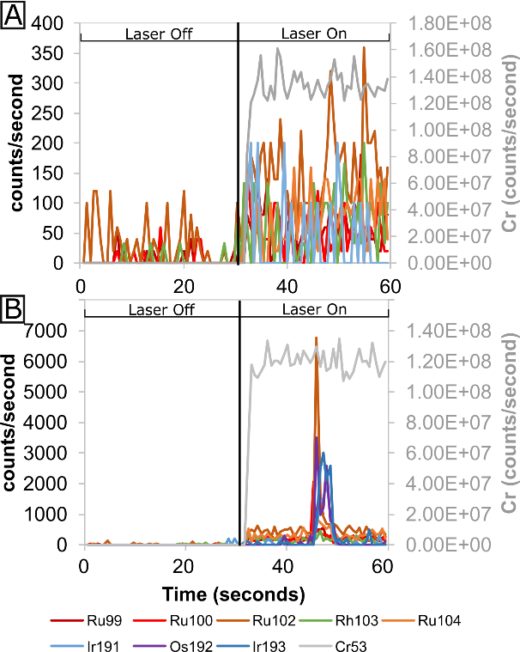

Figure 2: A) Time resolved laser ablation analysis of chromite with all PGE contained within the crystal lattice with B) time resolved laser ablation analysis with a PGE nugget.

# Interference Analysis

Although platinum group elements have known argide interferences with metals, measuring multiple masses of Ru (99,100,102,104) give comparable results (supplementary material). The argide production rate of the system was measured using copper, nickel and cobalt metals and were found be very low (supplementary material), more than an order of magnitude less than the Park et al. (2012) study which were found to only effect the data by at most 7 % of the measured value. The argide production during the ablation of USGS-MASS-1 sulfide standard was also investigated for 103Rh and 105Pd and found to be comparable to the argide generate from the pure metal. MASS-1 is copper rich and does not contain Pd or Rh. This standard produced false values of 27 ppb and 54 ppb Rh and Pd respectively for each 1 wt% Cu. The values of Cu, Ni and Co in the chromite from Coobina are very low (< 1000 ppm for Co and Ni and < 20 ppm for Cu) there is no need to correct for these interferences.

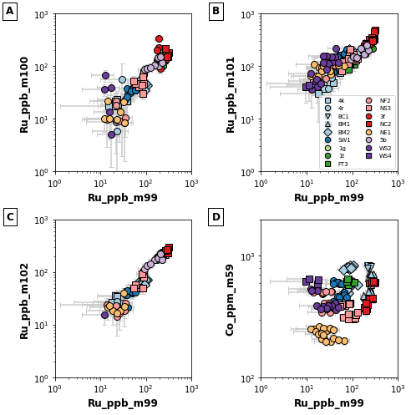

Figure 1: Uncorrected Ru values from different isotopes. 100Ru, 101Ru and 102Ru all have values compatible to 99Ru. This suggests the metal argide interferences are not a concern in these chromite analysis and need not be corrected.

Table 4: Table of argide interferences on PGEs measured during LA-ICP-MS analysis. No correction was conducted.

|  |  |  |
| --- | --- | --- |
| PGE isotope | Argide interference | Argide production rate on pure metal (MAr+/M+) |
| 99Ru | 59Co40Ar | 4.65 * 10-6 |
| 100Ru | 60Ni40Ar | 1.20 * 10-5 |
| 101Ru | 61Ni40Ar | No measurable argide produced |
| 102Ru | 62Ni40Ar | No measurable argide produced |
| 103Rh | 63Cu40Ar | 9.11 * 10-6 |
| 104Ru | 64Ni40Ar | Interference on Ni |
| 105Pd | 65Cu40Ar | 1.03 * 10-5 |

# LA mapping methodology

The trace elements were collected using a Photonmachines, ATLex 300si-x Excite 193nm Excimer ArF laser connected to an Agilent 7700 ICP-MS located in the National Geosequestration Laboratory at CSIRO in Perth. The instrument and plasma were calibrated daily, to obtain highest counts with oxide production (248ThO/232Th) remaining below 0.3%.

The isotopes measured in this routine were: 24Mg, 27Al, 29Si, 34S, 45Sc, 47Ti, 51V, 52Cr, 55Mn, 57Fe, 59Co, 60Ni, 63Cu, 66Zn, 71Ga, 72Ge, 75As, 99Ru, 101Ru, 193Ir, 195Pt, and 208Pb. The Ru isotopes were set to a counting time of 30ms, with 10ms for all other isotopes giving a total sampling period of 0.304 seconds. The spot was as a 35x35um square, with the sample traversing under the beam at 26 um/s and a repetition rate of 10Hz. The reference materials were UQAC_FeS-1 for sulphur and the PGEs while GSD2G was used for all other elements. The data reduction was carried out in Iolite v4 (Paton et al. 2011) using the semi-quantitate trace elements data reduction scheme with Fe57 as the internal standard element.

# Previous work methodology

## Electron-microprobe analysis

Major and minor element analyses of chromite were performed using a Cameca SX-100 electron microprobe equipped with five wavelength dispersive spectrometers (WDS) and a Bruker energy dispersive system (EDS) in the Geochemical Analysis Unit, CCFS/GEMOC, Macquarie University. The analytical conditions were 15 kV accelerating voltage, 20 nA sample current, ~1 µm beam size, and 10 seconds measurement time (peak) for Cr, Fe, Mg, Si, Mn, Al, Fe, Zn, V, whereas 20 seconds measurement time were used for Ni, 30 seconds for Ca and Ti, and 60 seconds for Na. Standards used were a combination of natural minerals and pure metals.

## Laser ablation ICP-MS analysis

A Photon Machines Excite Excimer laser ablation system connected to an Agilent 7700cx Octopole ICP-MS at CCFS/GEMOC was used to determine the trace elements concentrations in chromite. The operating parameters of this system are given in Table 1. Chromite grains were analysed for the following masses: 24Mg, 25Mg, 27Al, 29Si, 43Ca, 44Ca, 45Sc, 47Ti, 51V, 53Cr, 55Mn, 57Fe, 59Co, 60Ni, 62Ni, 66Zn, 69Ga, 71Ga, 89Y, 99Ru, 101Ru, 103Rh, 105Pd, 106Pd, 178Hf, 189Os, 190Os, 191Ir, 193Ir, 194Pt, 195Pt, and 238U.

The instrument was calibrated against the NIST 610 silicate glass standard (National Institute of Standards and Technology, Gaithersburg, USA; (Norman et al., 1996), and the in-house nickel sulphide standard PGE-A (Alard et al., 2000). Aluminium concentrations obtained by electron microprobe were used as the internal standard with NIST 610 to determine trace element concentrations other than the PGE in chromite. The PGE were quantified using the PGE-A standard and the Ni value obtained from the NIST 610 calibration as the internal standard. All data were processed using the GLITTER software (Griffin et al., 2008).

The BCR-2g reference material (basaltic glass prepared from the U.S. Geological Survey reference material BCR-2, Columbia River, USA (Norman et al., 1996; Gao et al., 2002) was analysed as unknown during each analytical run to monitor the accuracy and precision of the analysis of elements that were determined using the NIST 610 as the external standard. As BCR-2g does not contain Ru, the in-house chromite standard KJD2403-A (Kurrajong lava lake (Locmelis et al., 2011) was analysed as an unknown during each analytical run to assess the accuracy and precision of the Ru analysis. The repeated analyses (n=8) yielded an average of 326 ± 27 ppb and detection limits between 7.5 -24 ppb, which is within uncertainty of the published value of 322 ± 6 ppb Ru (Locmelis et al., 2011).

The Ru contents of chromite were determined independently for the isotopes 99Ru and 101Ru. In most cases, the analyses were affected by an interference on 101Ru. This interference was identified because it produces a non-natural isotopic ratio for 101Ru/99Ru; i.e. the measured ratio is distinctly higher than the natural isotope ratio (101Ru/99Ru = 1.34). This interference is presumably caused by the nickel-argide 61Ni40Ar that is produced during ablation as the result of the high nickel contents of the PGE-A nickel sulphide standard (71.5 wt% Ni). Therefore, the 99Ru values rather than 101Ru (which is normally the recommended mass number for laser based mass spectrometry analysis) were used for all the interpretations of the results, the descriptions, the plots and the figures. For all other PGE, the recommended masses were used to present the data (i.e. 103Rh, 105Pd, 189Os, 193Ir, and 195Pt).

Table 5: Operating parameters of the laser ablation ICP-MS system at CCFS/GEMOC 

## Replicate Whole Rock Analysis

Table 6: Standard deviation on replicate whole rock analysis

|  |  |  |  |  |  |  |  |  |  |  |
| --- | --- | --- | --- | --- | --- | --- | --- | --- | --- | --- |
| Sample | Ir_ppb | Ru_ppb | Rh_ppb | Pt_ppb | Pd_ppb | Ir RSD | Ru RSD | Rh RSD | Pt RSD | Pd RSD |
| CB1110CF2 | 47.18 | 112.20 | 14.28 | 50.75 | 8.78 | 3% | 7% | 3% | 35% | 1% |
| CB1110NE1 | 50.31 | 154.57 | 14.28 | 12.92 | 11.86 | 3% | 3% | 1% | 25% | 8% |
| CB1110OM1 | 26.40 | 62.60 | 9.24 | 16.60 | 2.16 | 2% | 7% | 1% | 62% | 1% |
| CB1110WF3 | 37.16 | 148.93 | 7.02 | 2.58 | 0.84 | 2% | 1% | 0.1% | 3% | 2% |

# Primary Standard Preferred Values

## UQAC-FeS-1

Reference Material is a pressed-pellet sulfide with major composition Fe (45%), S (41%), Ni (2.5%), Cu (2.3%) and traces elements ranging 10 – 1000ppm: Ag, As, Au, Ba, Bi, Co, Cr, Ga, Hg, In, Ir, Mg, Mn, Mo, Nb, Os, Pb, Pd, Pt, Re, Rh, Ru, Sb, Se, Sn, Te, Ti, V, W, Zn.

Data source: Dany Savard, LabMaTer, UQAC, ddsavard@uqac.ca

Last update 2018 June 11th, compilation from round robin laboratories (multiples external techniques: (LA-ICP-MS, XRF, HG-AFS, isotopes dill., fire assay, solution ICP-MS, ICP-OES, IR) and expected homogeneity from 20 pellets, same analytical parameter.

|  |  |  |  |
| --- | --- | --- | --- |
| **Parameter** | **Units** | **Value** | **Uncertainty** |
| Fe | ppm | 435136.1 | 9572.994 |
| S | ppm | 415677.2 | 5403.804 |
| Ti | ppm | 309.4 | 20.7298 |
| V | ppm | 21.2 | 0.5512 |
| Cr | ppm | 264.8 | 10.0624 |
| Mn | ppm | 53.7 | 2.8461 |
| Co | ppm | 626 | 8.764 |
| Ni | ppm | 24453.5 | 342.349 |
| Cu | ppm | 22199.8 | 244.1978 |
| Zn | ppm | 271.3 | 30.9282 |
| Ga | ppm | 10.4 | 0.4056 |
| Ge | ppm | 4.4 | 0.132 |
| As | ppm | 1048.8 | 30.4152 |
| Se | ppm | 329.4 | 8.8938 |
| Nb | ppm | 40.3 | 2.2971 |
| Mo | ppm | 66.2 | 1.0592 |
| Ru | ppm | 65.7 | 1.1169 |
| Rh | ppm | 61.2 | 1.7136 |
| Pd | ppm | 47.4 | 2.7492 |
| Ag | ppm | 154.9 | 6.9705 |
| Cd | ppm | 1.9 | 0.1463 |
| In | ppm | 9.2 | 0.184 |
| Sn | ppm | 180.8 | 10.4864 |
| Sb | ppm | 95.8 | 7.9514 |
| Te | ppm | 139.4 | 3.485 |
| Ba | ppm | 250.7 | 10.028 |
| W | ppm | 1084.9 | 322.2153 |
| Re | ppm | 67.6 | 1.352 |
| Os | ppm | 81.6 | 1.9584 |
| Ir | ppm | 57.8 | 1.2716 |
| Pt | ppm | 51 | 3.774 |
| Au | ppm | 62.6 | 4.1316 |
| Hg | ppm | 46.8 | 3.3228 |
| Tl | ppm | 0.3 | 0.0201 |
| Pb | ppm | 94.3 | 7.4497 |
| Bi | ppm | 120.7 | 12.4321 |
| U | ppm | 2.7 | 0.6264 |
| Si | ppm | 26247.9 | 944.9244 |

## USGS-GSD-2G

New batch of GSD-1g. Basaltic glass with doped trace elements at approximately 40 ppm ea

Data source: Steve Wilson USGS

Last updated: 8th Nov 2018

|  |  |  |  |
| --- | --- | --- | --- |
| **Parameter** | **Units** | **Value** | **Uncertainty** |
| Ag | ppm | 24 | 1 |
| Al | ppm | 69200 | 1800 |
| As | ppm | 30 | 3 |
| Ba | ppm | 44 | 9 |
| Be | ppm | 52 | 6 |
| Bi | ppm | 18 | 2 |
| Ca | ppm | 46000 | 1100 |
| Cd | ppm | 2.7 | 0.2 |
| Ce | ppm | 45.1 | 1.9 |
| Co | ppm | 42.6 | 1.9 |
| Cr | ppm | 42 | 8 |
| Cs | ppm | 35.2 | 3.4 |
| Cu | ppm | 41 | 7 |
| Dy | ppm | 45.1 | 0.96 |
| Er | ppm | 43.9 | 0.76 |
| Eu | ppm | 42.4 | 1.2 |
| Fe | ppm | 92400 | 3800 |
| Ga | ppm | 52 | 2.6 |
| Gd | ppm | 43.8 | 3.8 |
| Ge | ppm | 43 | 0.7 |
| Hf | ppm | 42.4 | 2.6 |
| Ho | ppm | 46.2 | 3.7 |
| In | ppm | 32 | 1.7 |
| K | ppm | 21700 | 400 |
| La | ppm | 42.2 | 2 |
| Li | ppm | 43 | 1 |
| Lu | ppm | 47 | 3.9 |
| Mg | ppm | 21300 | 700 |
| Mn | ppm | 634 | 21 |
| Mo | ppm | 42 | 2.1 |
| Na | ppm | 29100 | 1600 |
| Nb | ppm | 48 | 2.5 |
| Nd | ppm | 45 | 2 |
| Ni | ppm | 46 | 4 |
| P | ppm | 1400 | 60 |
| Pb | ppm | 30.4 | 2.6 |
| Pr | ppm | 45.6 | 1.2 |
| Rb | ppm | 42.4 | 1.8 |
| S | ppm | 500 | 0 |
| Sb | ppm | 42 | 4 |
| Sc | ppm | 43.5 | 5.9 |
| Se | ppm | 0.6 | - |
| Si | ppm | 260900 | 3000 |
| Sm | ppm | 44.8 | 2.3 |
| Sn | ppm | 36 | 3 |
| Sr | ppm | 67.8 | 2.9 |
| Ta | ppm | 42 | 5 |
| Tb | ppm | 44.5 | 3.3 |
| Te | ppm | 6.338 | 0.745934 |
| Th | ppm | 43.37 | 4.711935 |
| Ti | ppm | 7100 | 100 |
| Tl | ppm | 0.266 | 0.011402 |
| Tm | ppm | 46.2 | 2.7 |
| U | ppm | 44.3 | 4.5 |
| V | ppm | 54 | 1.4 |
| W | ppm | 40 | 1.8 |
| Y | ppm | 47.4 | 1.6 |
| Yb | ppm | 47.4 | 3.1 |
| Zn | ppm | 50 | 5 |
| Zr | ppm | 50 | 4 |

# References

Alard, O., Griffin, W. L., Lorand, J. P., Jackson, S. E., and O'Reilly, S. Y., 2000, Non-chondritic distribution of the highly siderophile elements in mantle sulphides: Nature, v. 407, p. 891-894.

Gao, S., Liu, X., Yuan, H., Hattendorf, B., Günther, D., Chen, L., and Hu, S., 2002, Determination of Forty Two Major and Trace Elements in USGS and NIST SRM Glasses by Laser Ablation-Inductively Coupled Plasma-Mass Spectrometry: Geostandards Newsletter, v. 26, p. 181-196.

Griffin, W. L., Powell, W. J., Pearson, N. J., and O'Reilly, S. Y., 2008, GLITTER: data reduction software for Laser Ablation ICP-MS: In: P. Sylvester, Editor, Laser Ablation-ICP–MS in the Earth Sciences: Current Practices and Outstanding Issues, Mineralogical Association Canada Short Course 40, 308–311.

Locmelis, M., Pearson, N. J., Barnes, S. J., and Fiorentini, M. L., 2011, Ruthenium in komatiitic chromite: Geochimica et Cosmochimica Acta, v. 75, p. 3645-3661.

Norman, M. D., Pearson, N. J., Sharma, A., and Griffin, W. L., 1996, Quantitative analysis of trace elements in geological materials by laser ablation ICPMS: Instrumental operating conditions and calibration values of NIST glasses: Geostandards Newsletter, v. 20, p. 247-261.