Appendix A
SWIR mineral data
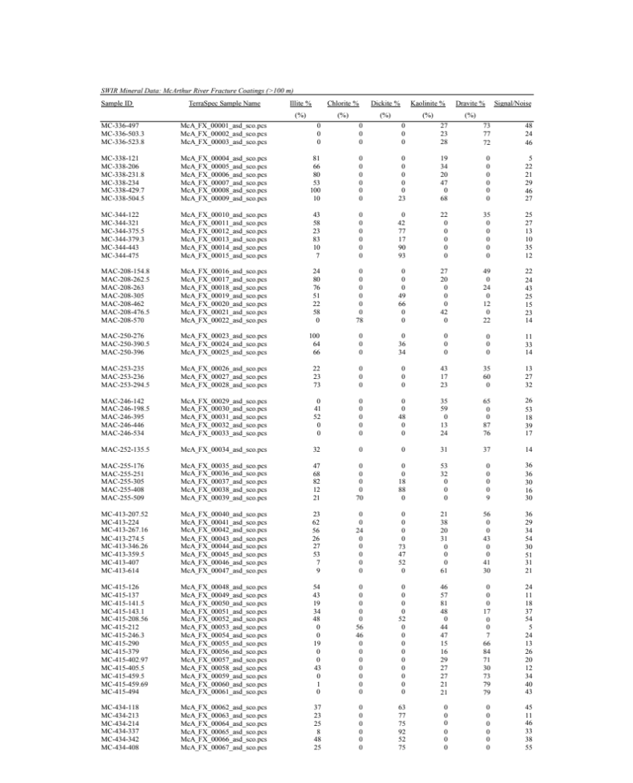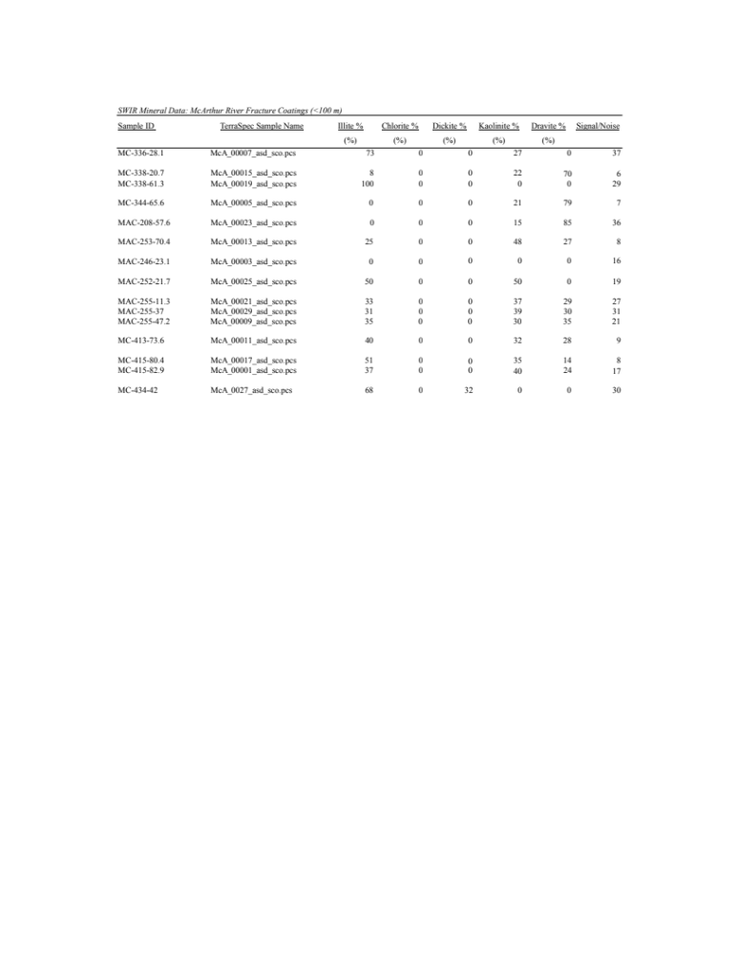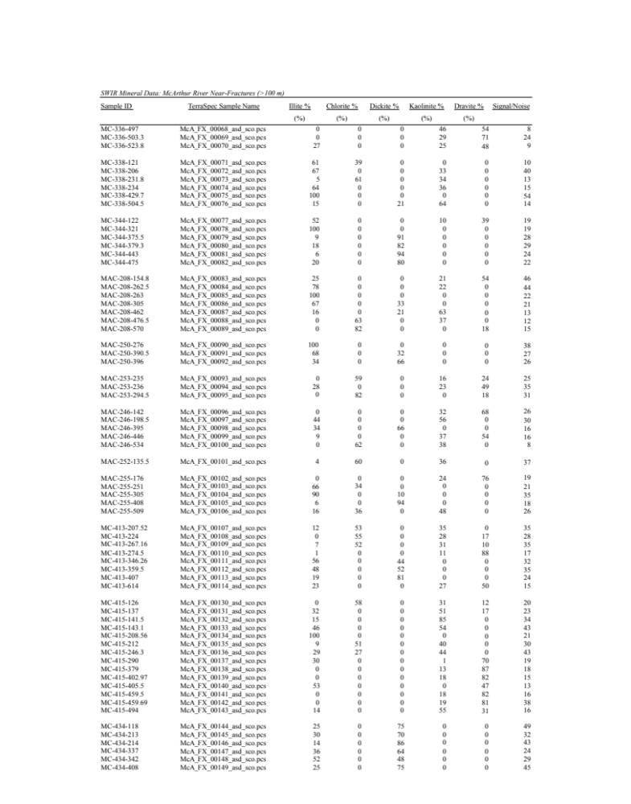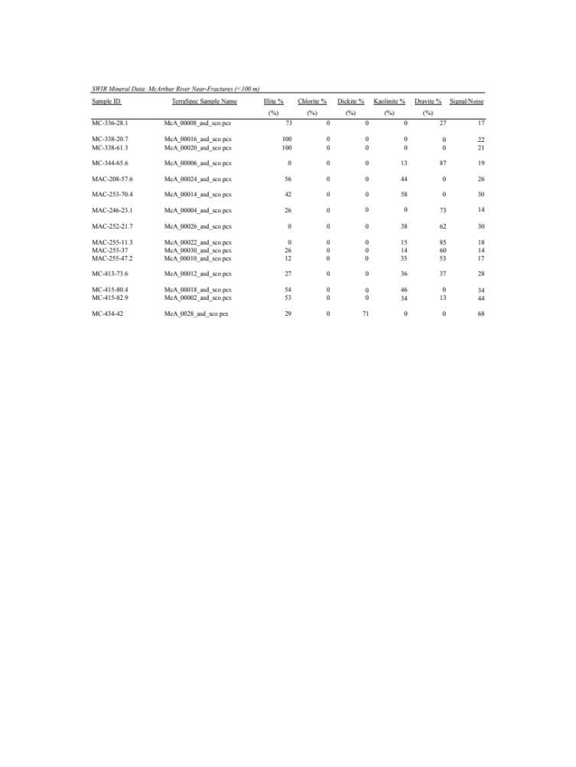

Appendix B
Error Bar Calculation

Sample ID | Dominant Mineral Phase (~70 %) | Measured δ¹⁸O (‰) | Dominant Contaminant Mineral Phase (~30 %) | *Calculated δ¹⁸O (‰) of Quartz | **Calculated δ¹⁸O (‰) of  Dominant Mineral Phase | ***Calculated Error Bar (‰)
MAC-255-408 | Dickite | 8.5 | Quartz | 15.1 | 5.7 | 2.8
MC-413-346.26 | Dickite | 13.2 | Quartz | 19.8 | 10.4 | 2.8
MC-413-614 | Kaolinite | 9.2 | Quartz | 15.8 | 6.4 | 2.8
MAC-246-446 | Dravite | 9.7 | Quartz | 14.6 | 7.6 | 2.1
MC-336-503.3 | Dravite | 9.8 | Quartz | 14.7 | 7.7 | 2.1
MC-336-523.8 | Dravite | 10.1 | Quartz | 15 | 8.0 | 2.1
MAC-255-176 | Kaolinite | 12.3 | Quartz | 0.2 | 17.5 | -5.2
MAC-208-462 | Goethite | 8.8 | Quartz | 18.6 | 4.6 | 4.2
MC-338-504.5 | Goethite | 13.2 | Quartz | 1.4 | 18.3 | -5.1
MC-434-408 | Goethite | 9.6 | Quartz | 19.4 | 5.4 | 4.2
MC-338-206 | Goethite | 5.8 | Quartz | 15.6 | 1.6 | 4.2
MC-344-375.5 | Goethite | 5.9 | Quartz | 12.1 | 3.2 | 2.7
MC-344-379.3 | Goethite | 0.6 | Quartz | 7.5 | -2.4 | 3.0
MC-344-443 | Goethite | 5.0 | Quartz | 11.2 | 2.3 | 2.7
MAC-208-305 | Mn oxy-hydroxide | 9.8 | Quartz | 19.6 | 5.6 | 4.2
MAC-250-276 | Mn oxy-hydroxide | 10.4 | Quartz | 21 | 5.9 | 4.5
e.g. MC-413-614
* 1) δ¹⁸O_{kaolinite} - δ¹⁸O_{H2O} = 2.76 x 10⁶ (T⁻²) - 6.75 (Sheppard & Gilg 1996)
9.2 ‰ - δ¹⁸O_{H2O} = 2.76 x 10⁶ (473.15⁻²) - 6.75
δ¹⁸O_{H2O} = 3.62 ‰
2) δ¹⁸O_{quartz} - δ¹⁸O_{H2O} = (3.38 x 10⁶/T²) – 2.90 (Clayton et al. 1972)
δ¹⁸O_{quartz} – 3.62 = (3.38 x 10⁶/473.15²) – 2.90
δ¹⁸O_{quartz} = 15.8 ‰
** δT = 1M1 + δ2M2
δ¹⁸O_{kaolinite} (before quartz was added) = (9.2 ‰ – (0.3 x 15.8 ‰))/0.7
= 6.4 ‰
***Measured δ¹⁸O_{kaolinite} - δ¹⁸O_{kaolinite} (before quartz was added) = 9.2 ‰ – 6.4 ‰
= 2.8 ‰

Appendix C
Fracture types showing (a) open fracture face, (b) fracture orientation, (c) optical mineralogy, and (d) SEM mineralogy
Type 1 - Brown fracture coating (MC-344-379.3)
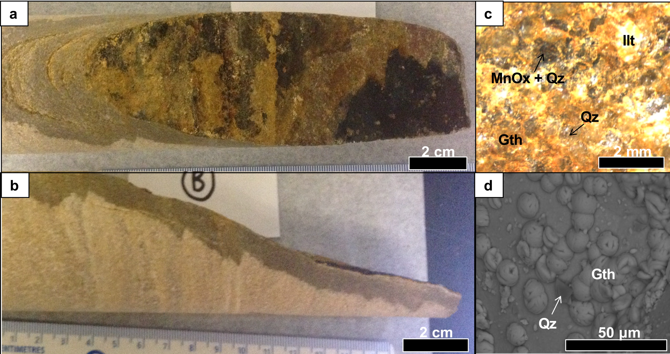
Type 2 - White and Yellow fracture coating (MC-338-504.5)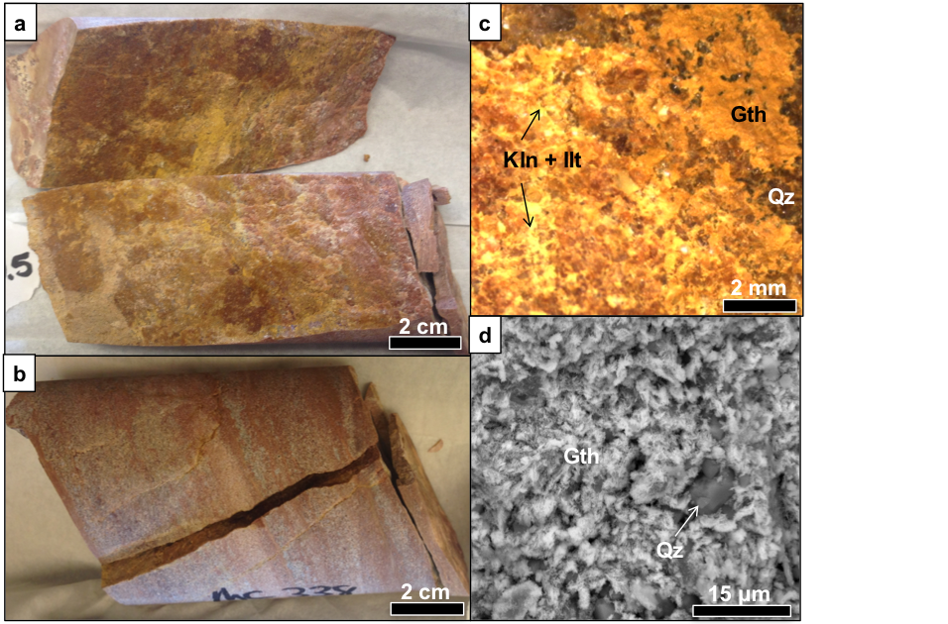
Type 3 - White fracture coating (MC-413-614)
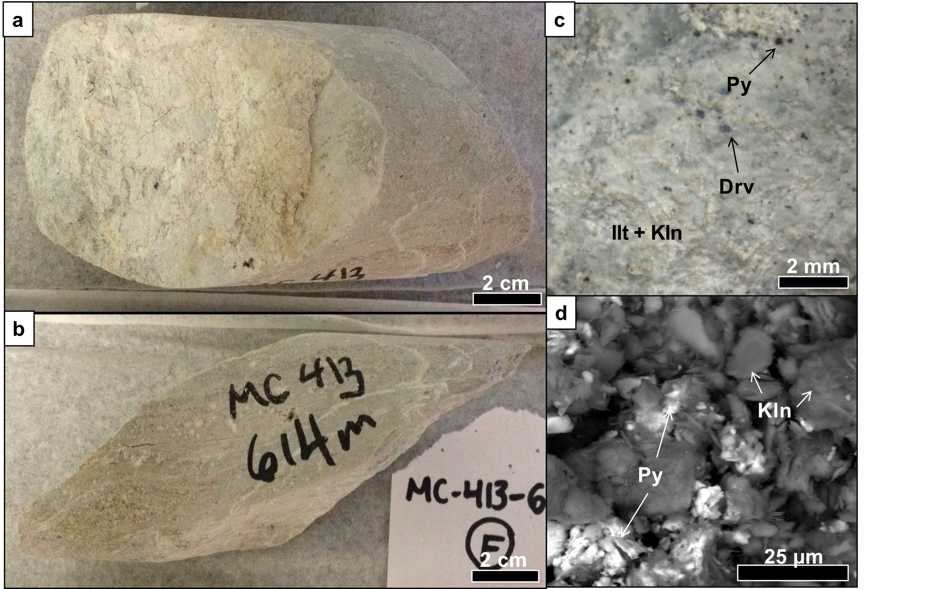
Type 4 - Black fracture coating (MC-415-290)
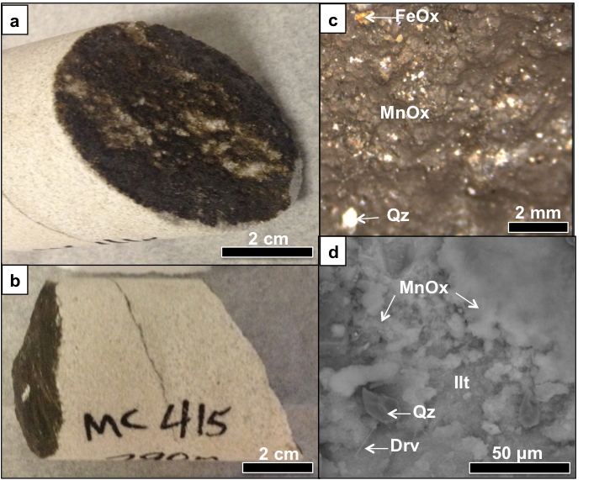
Type 5 - Black and orange fracture coating (MC-338-206)
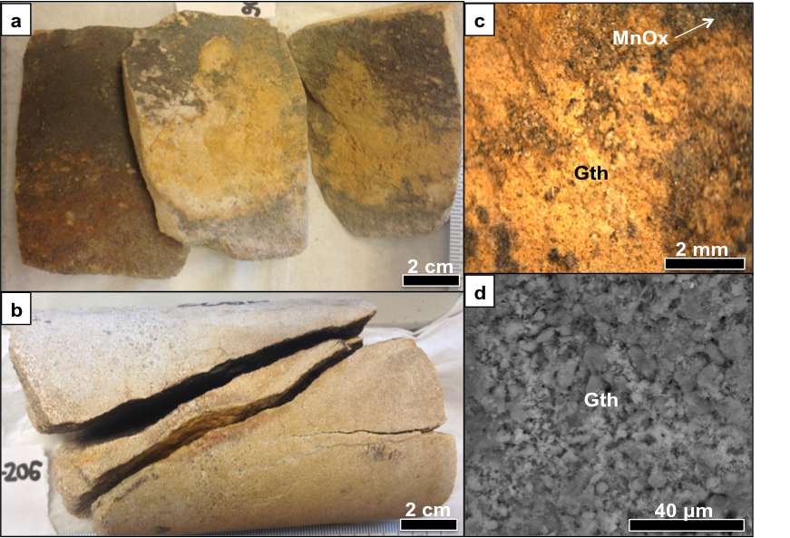
Type 6 - Drusy quartz fracture coating (MAC-250-396)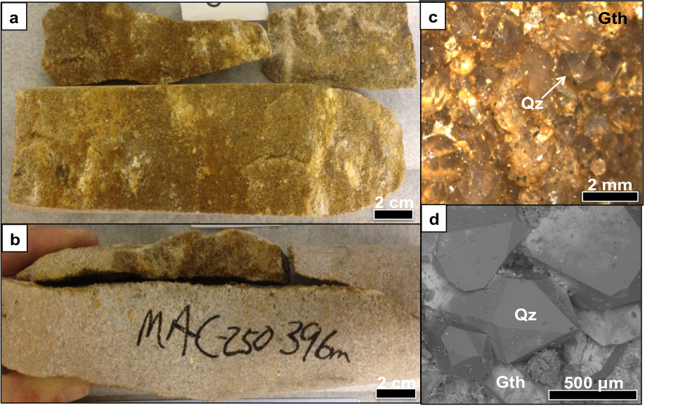
Type 7 - Pink fracture coating (MAC-255-176)
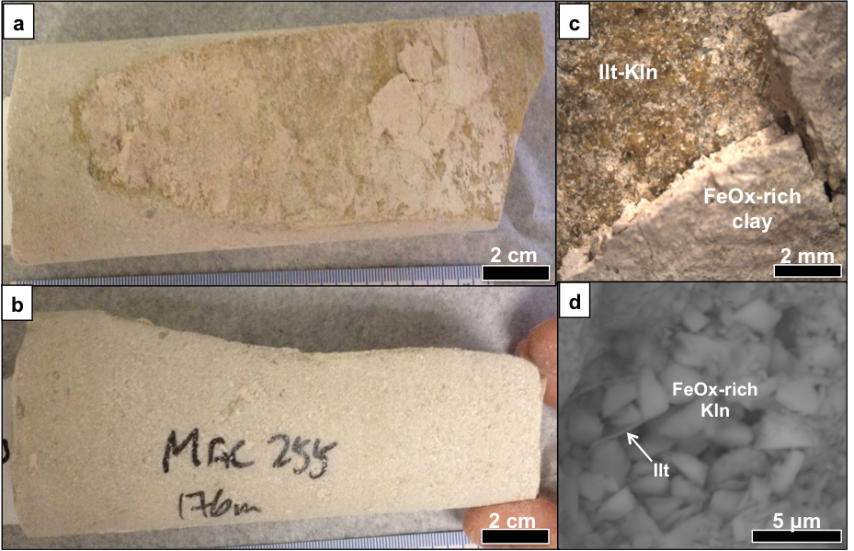
Appendix D
Fracture Angle Calculation
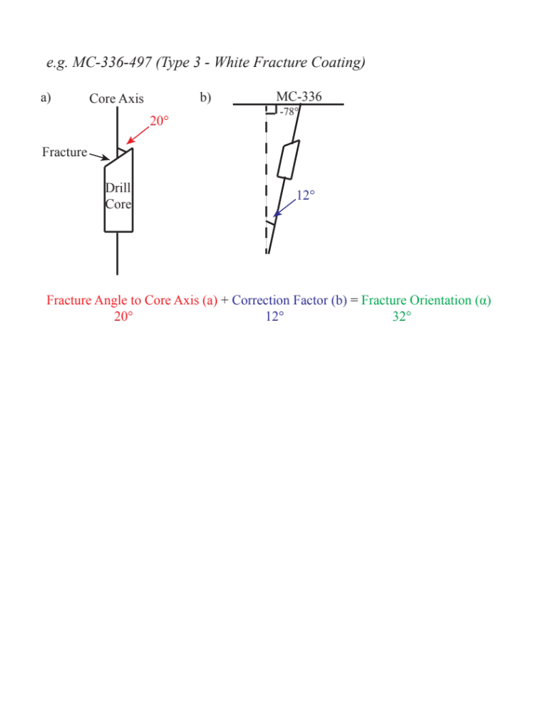
Appendix E
XRD spectra

XRD Spectra: McArthur River Fracture Coatings (>100 m)
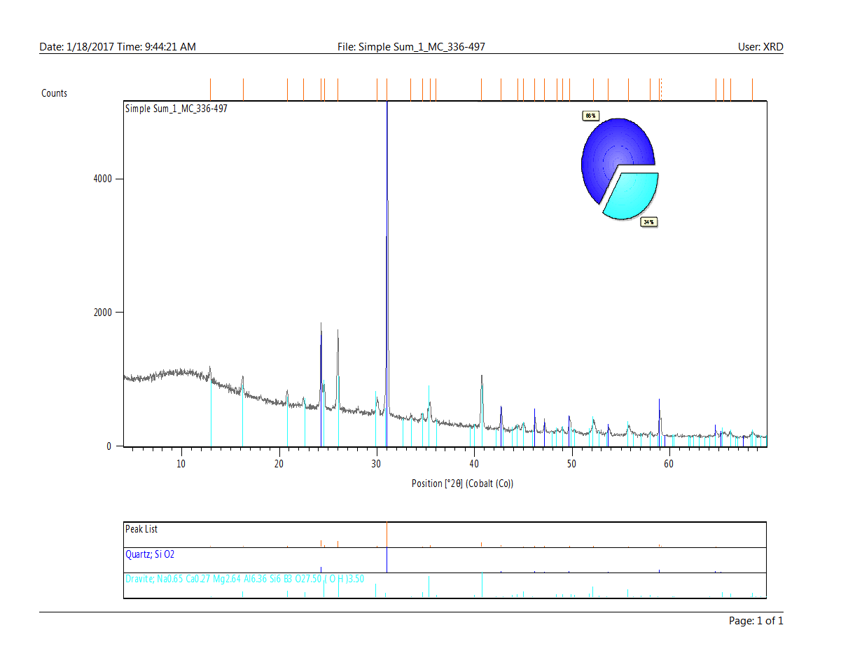
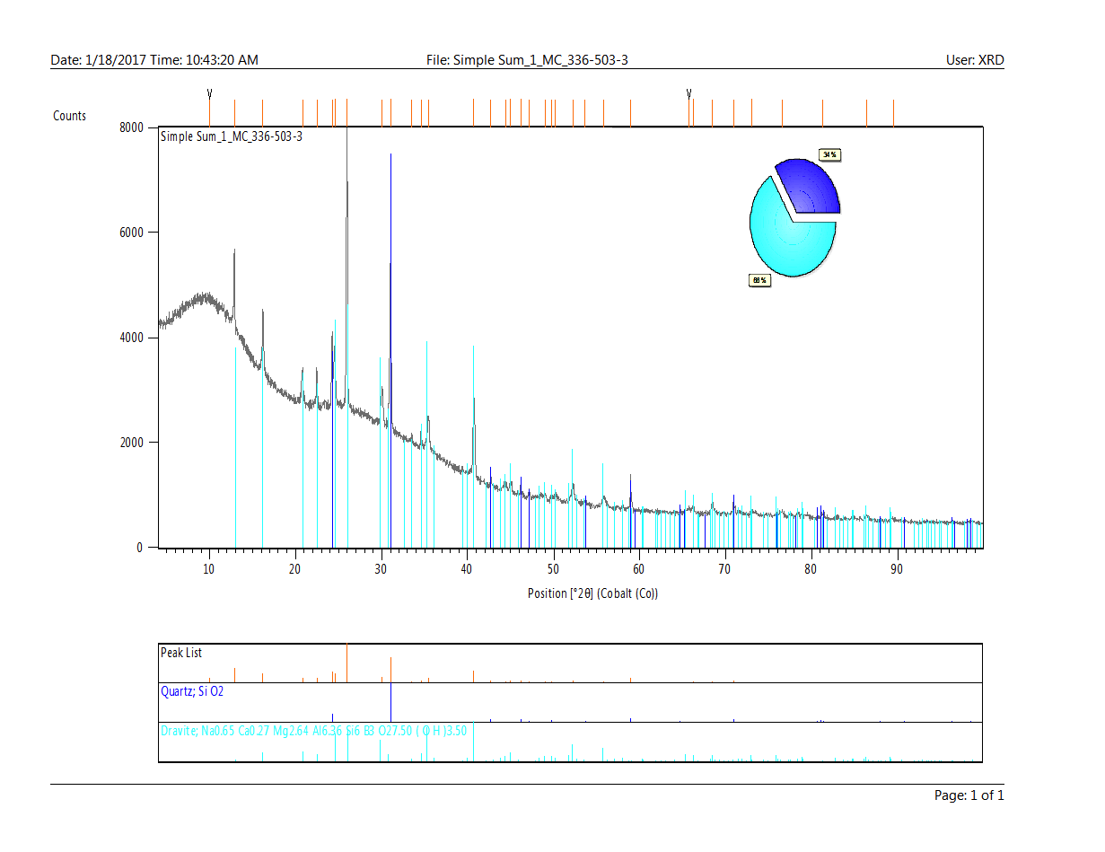
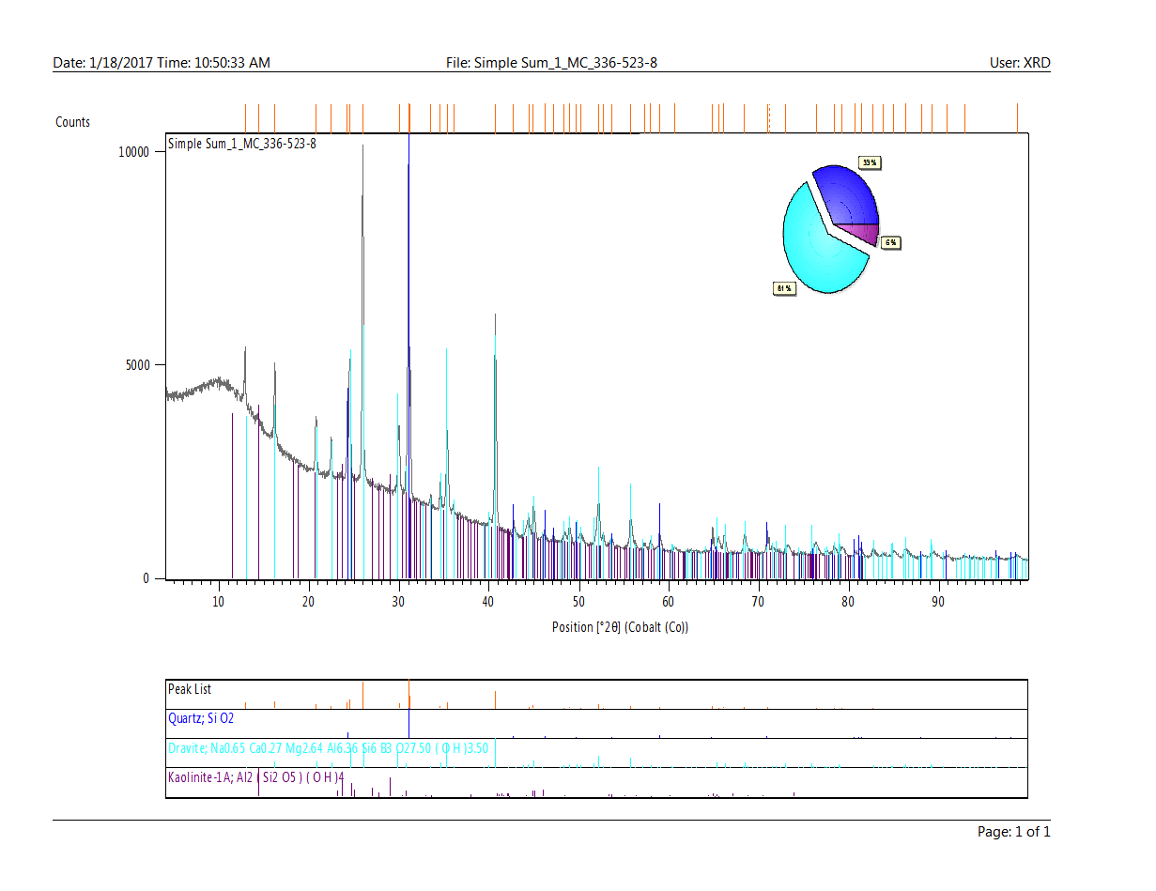
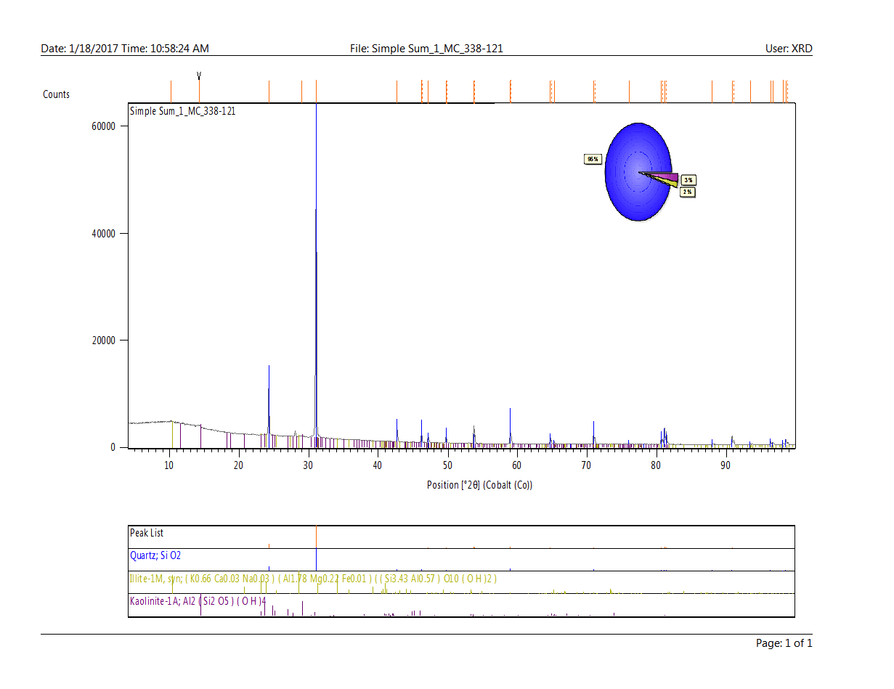
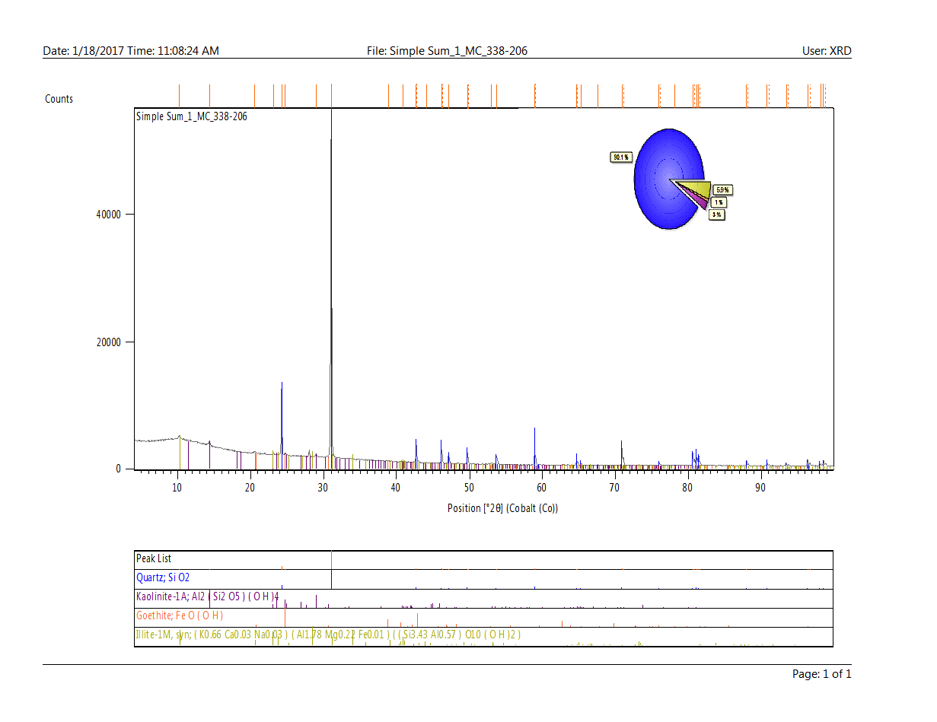
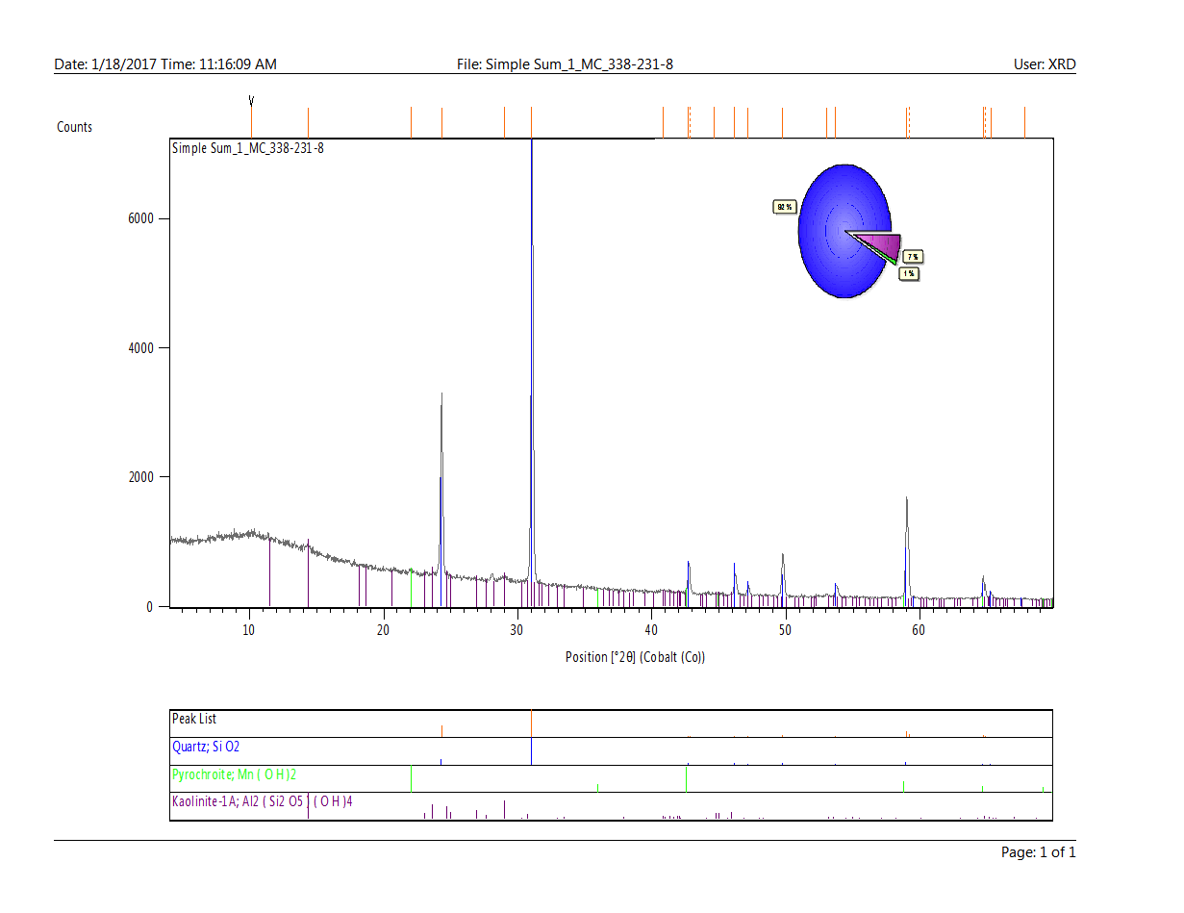
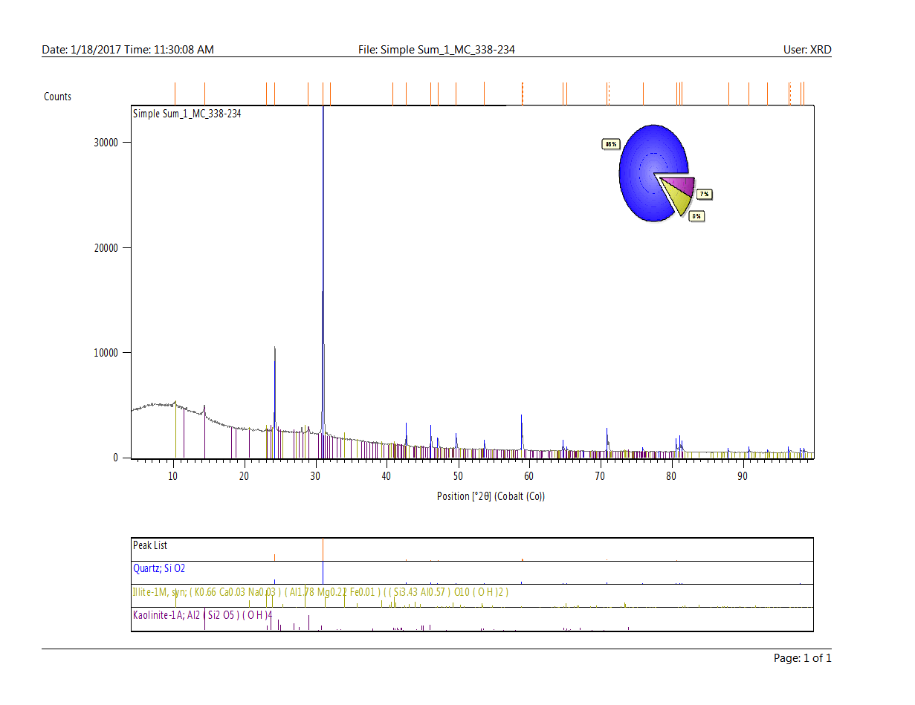

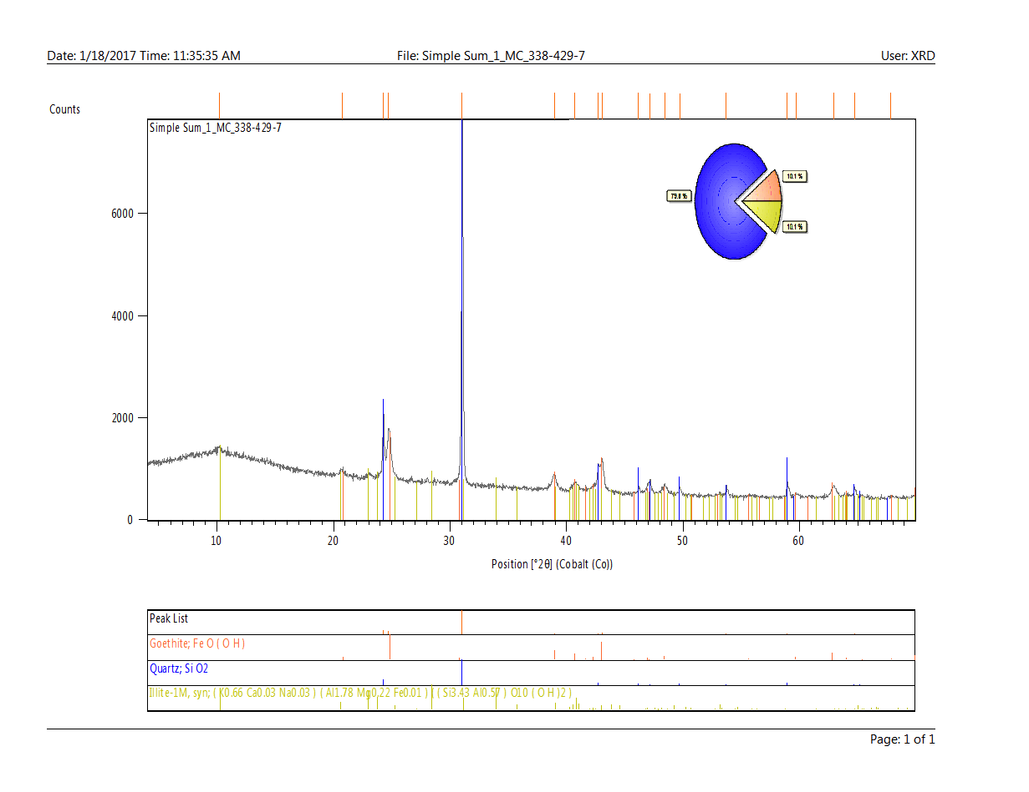

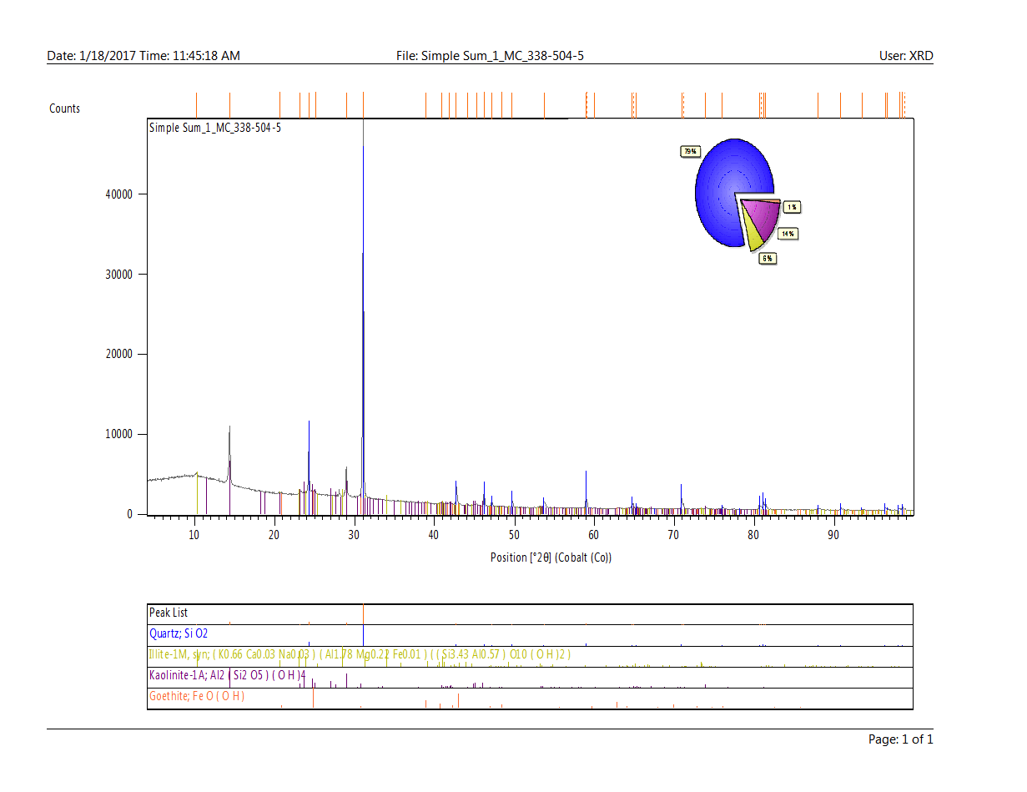

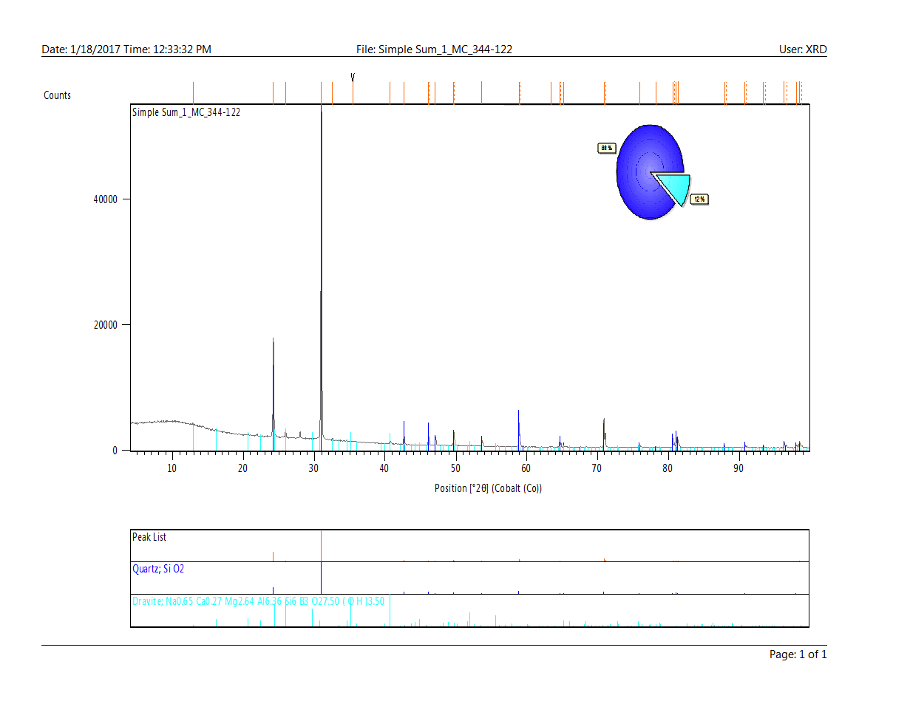
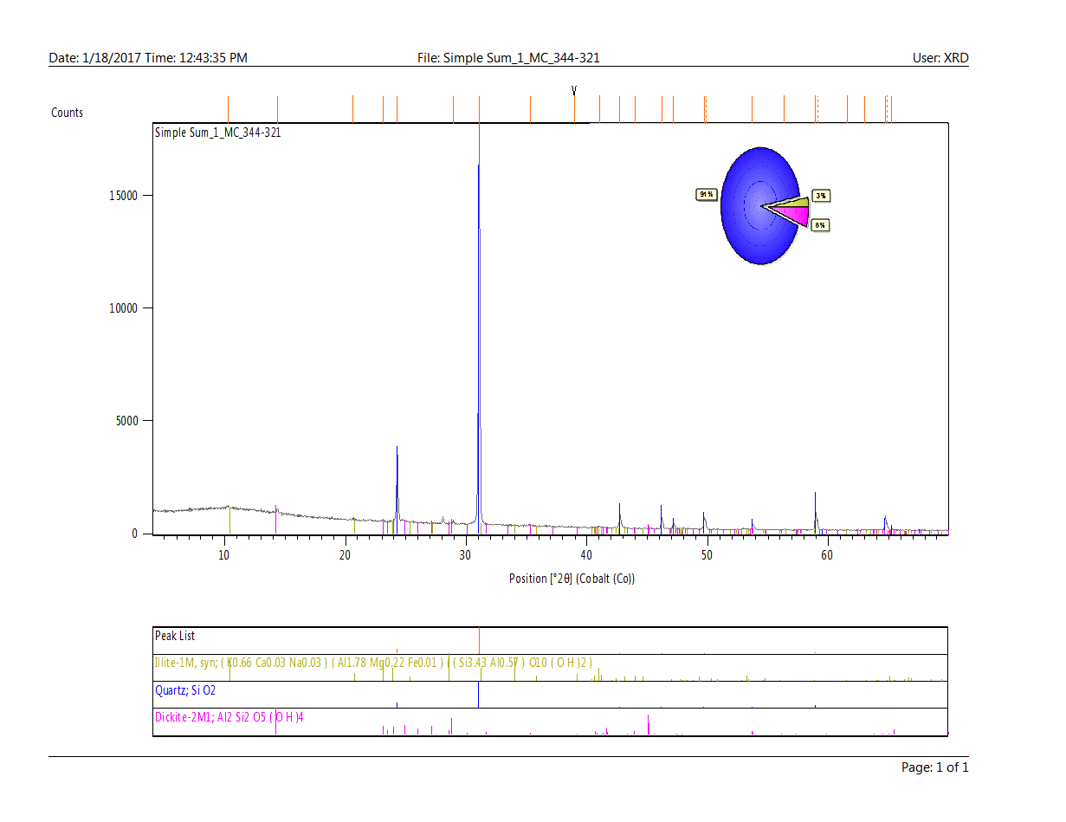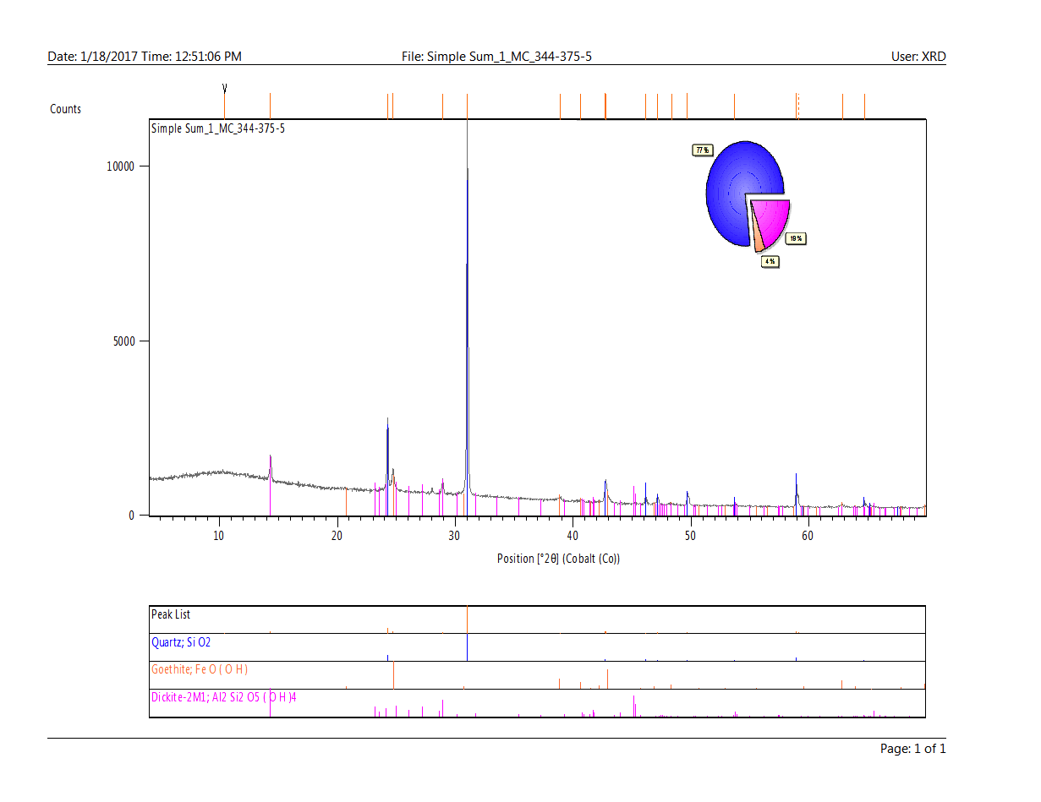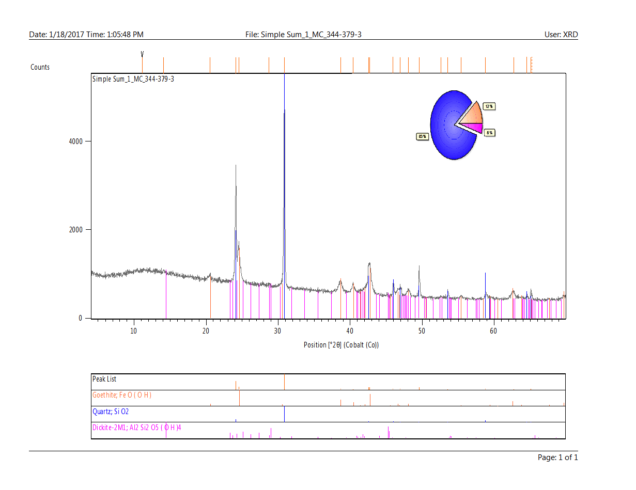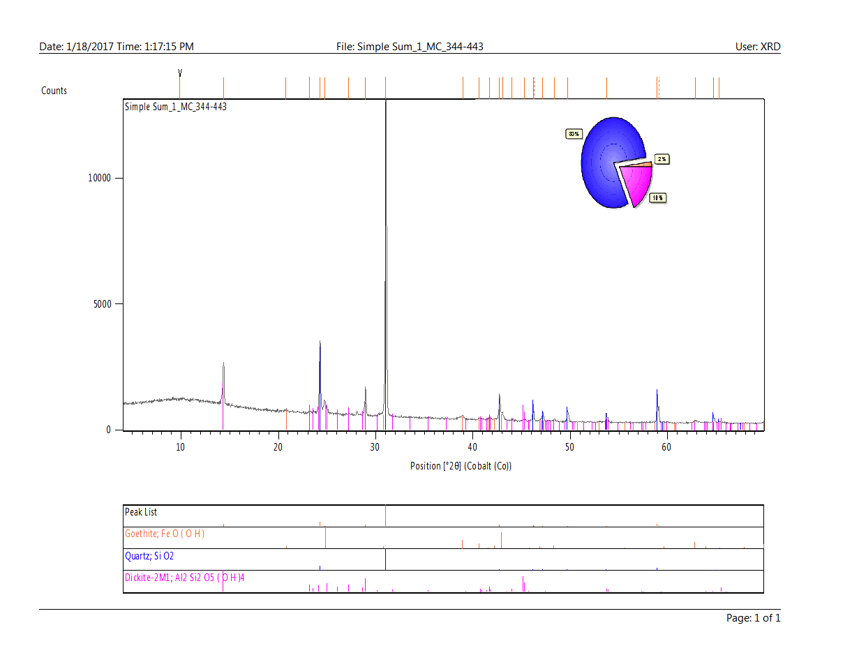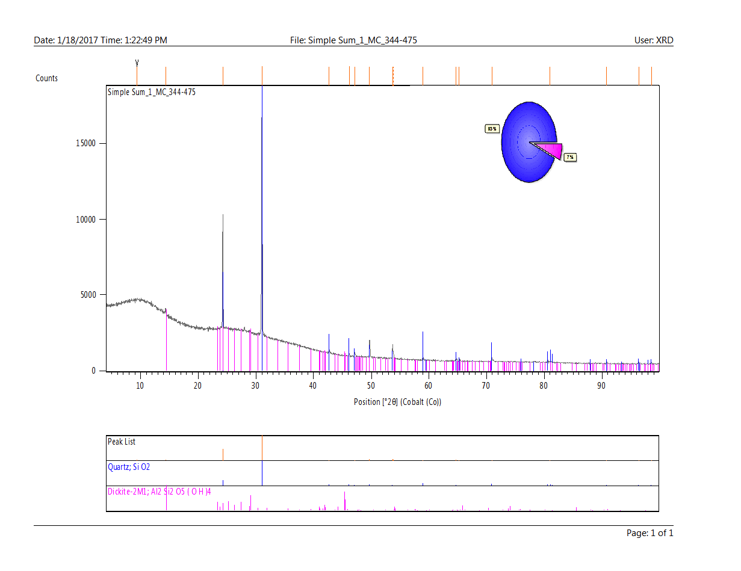

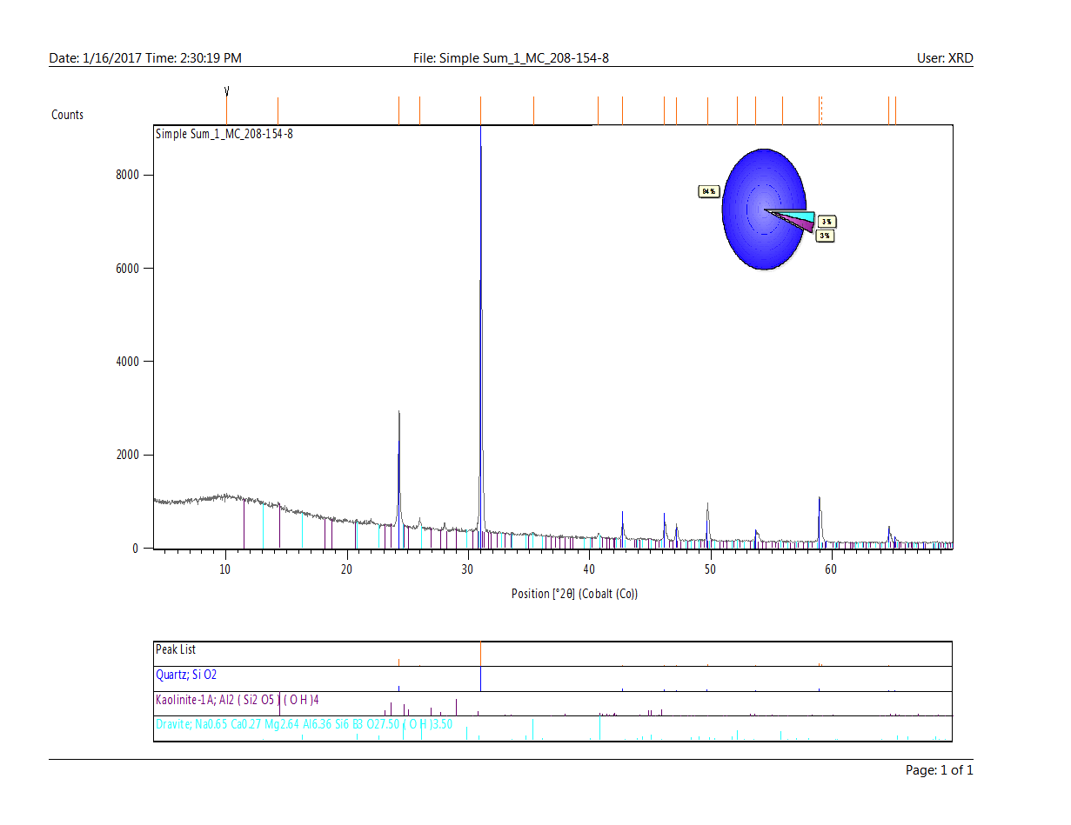

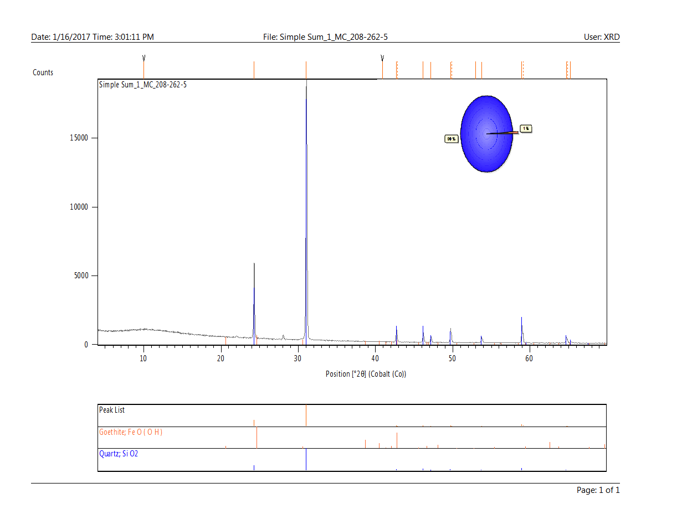
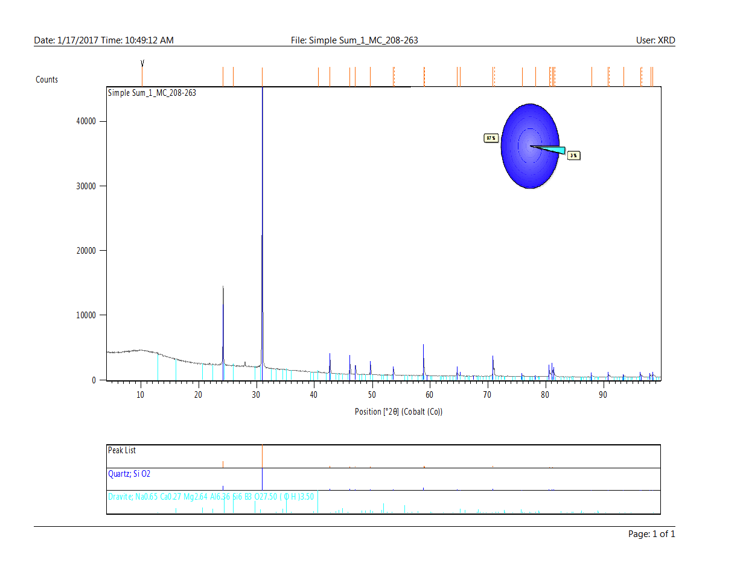
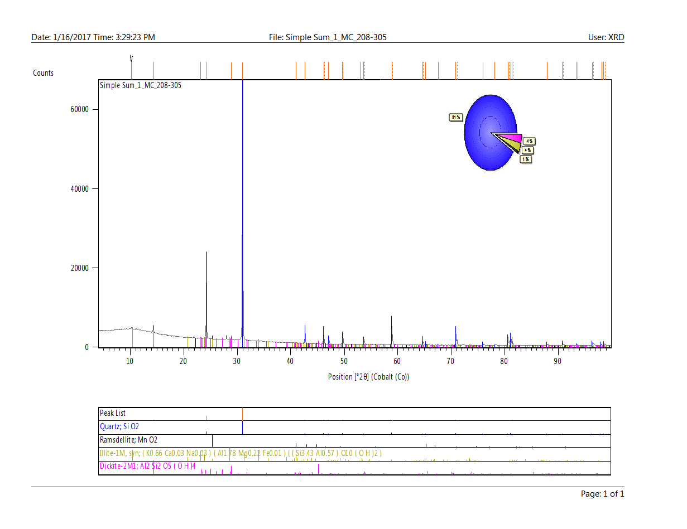
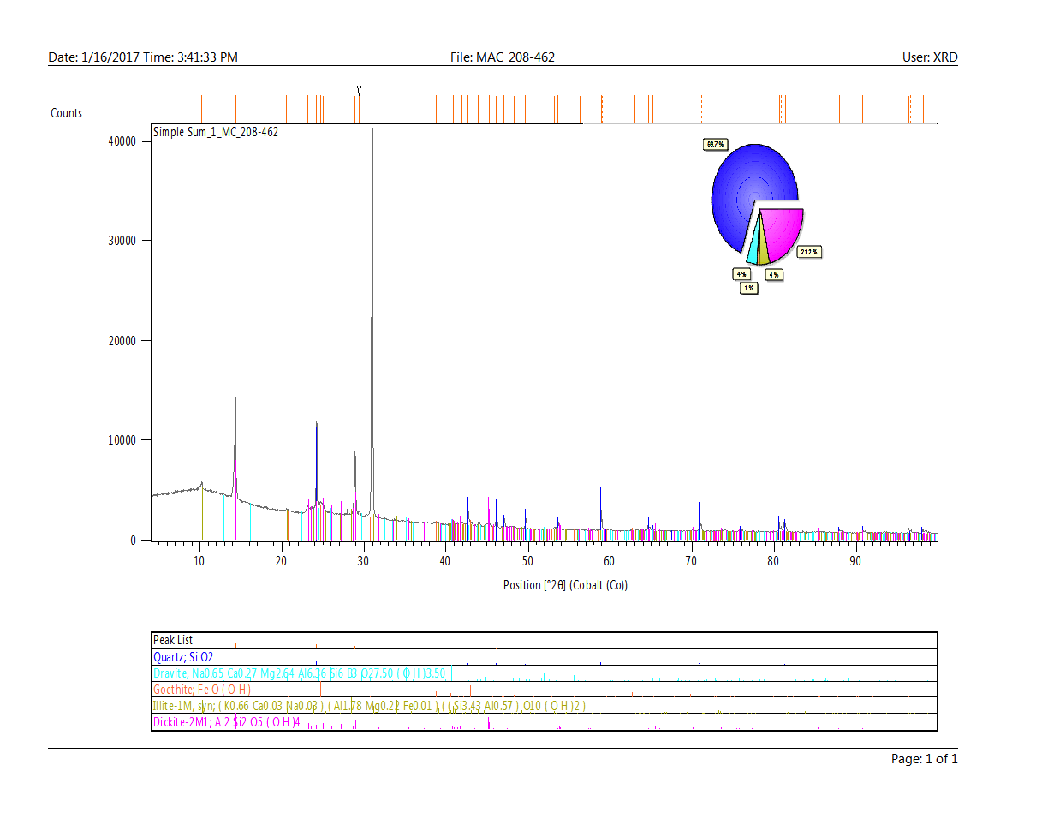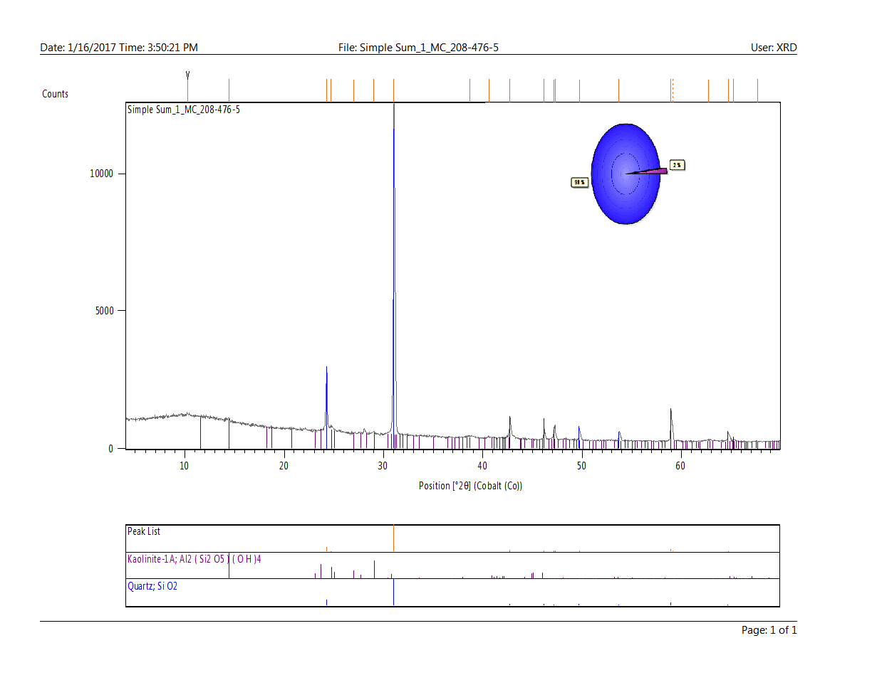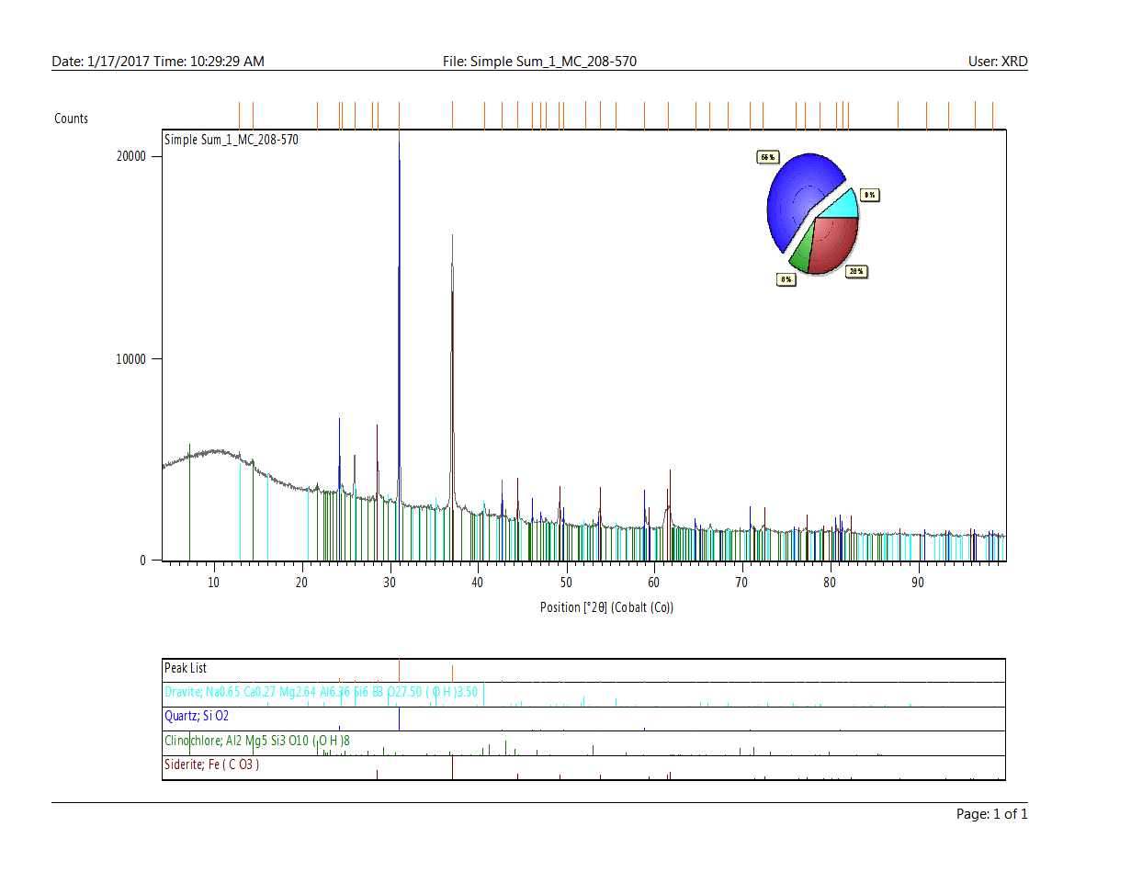
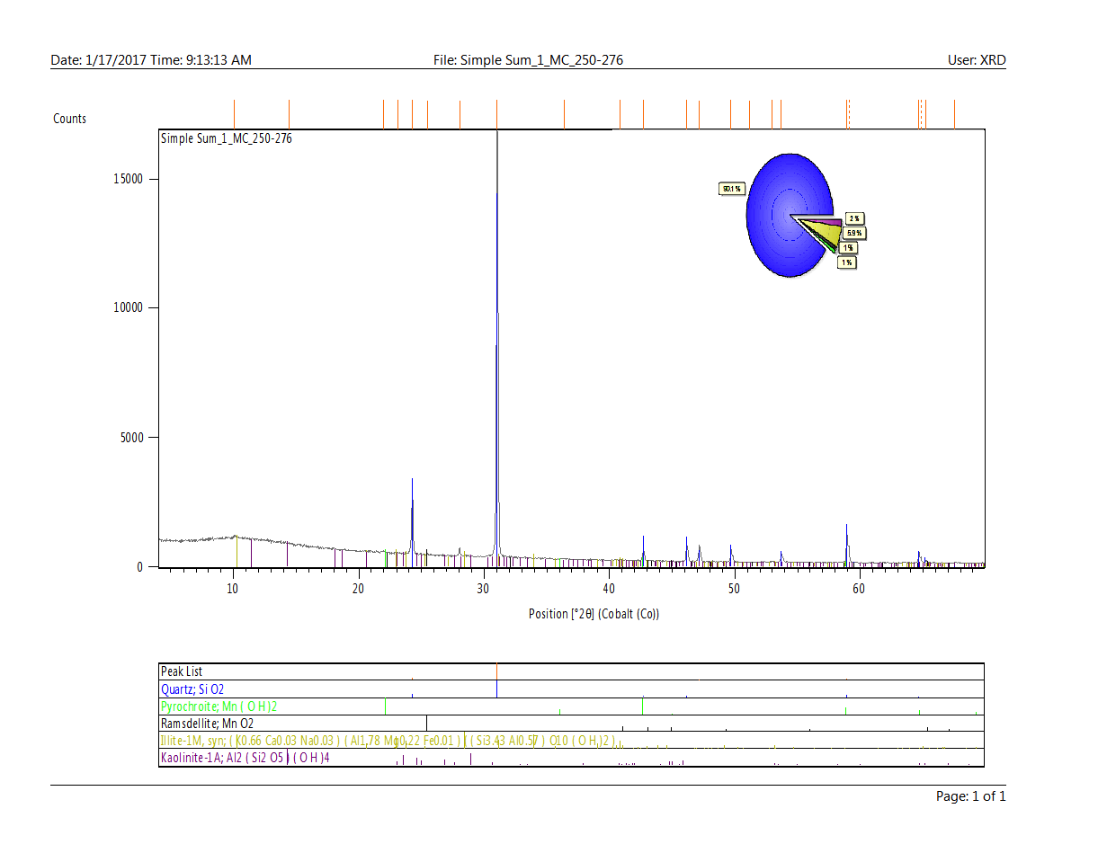
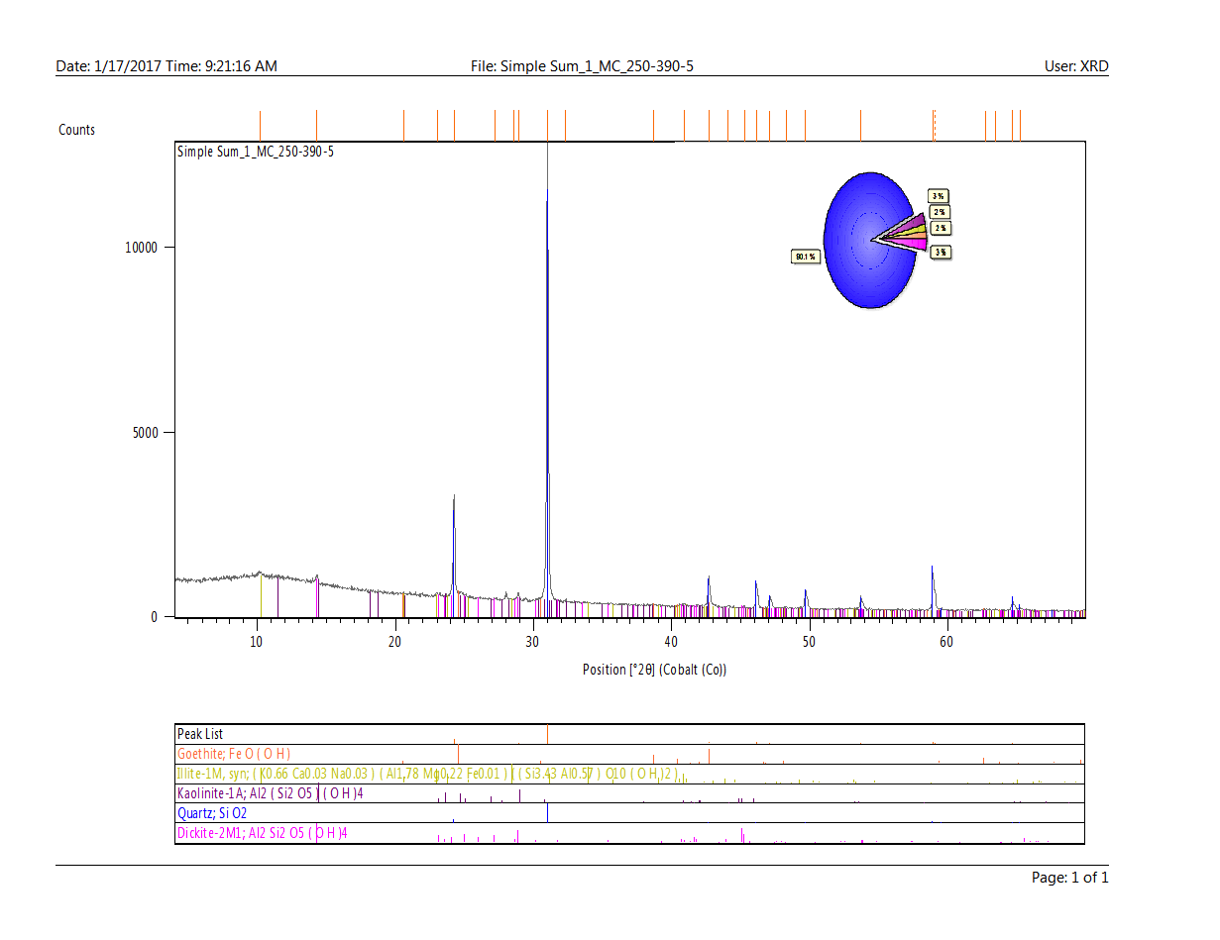
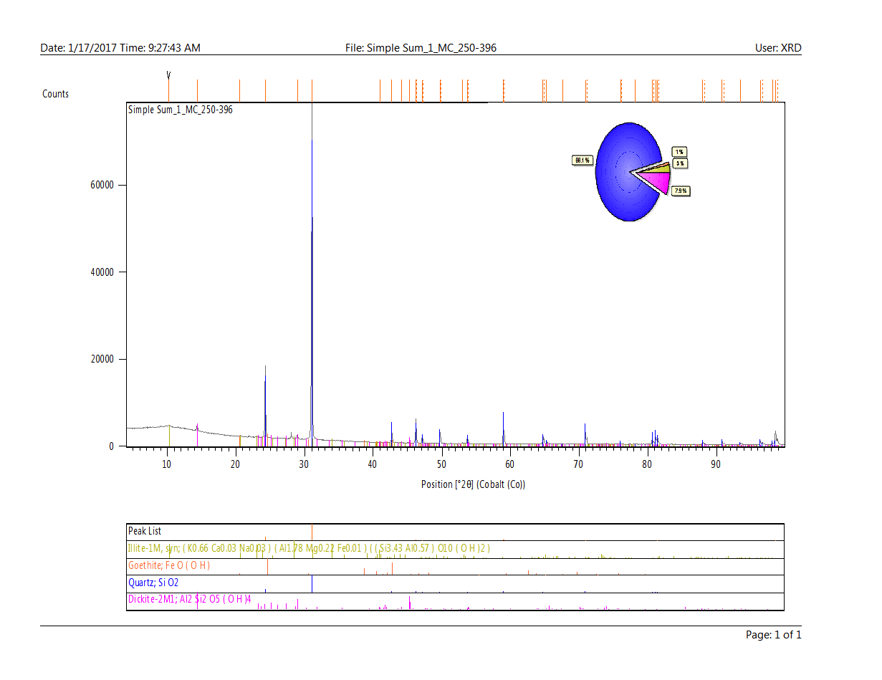
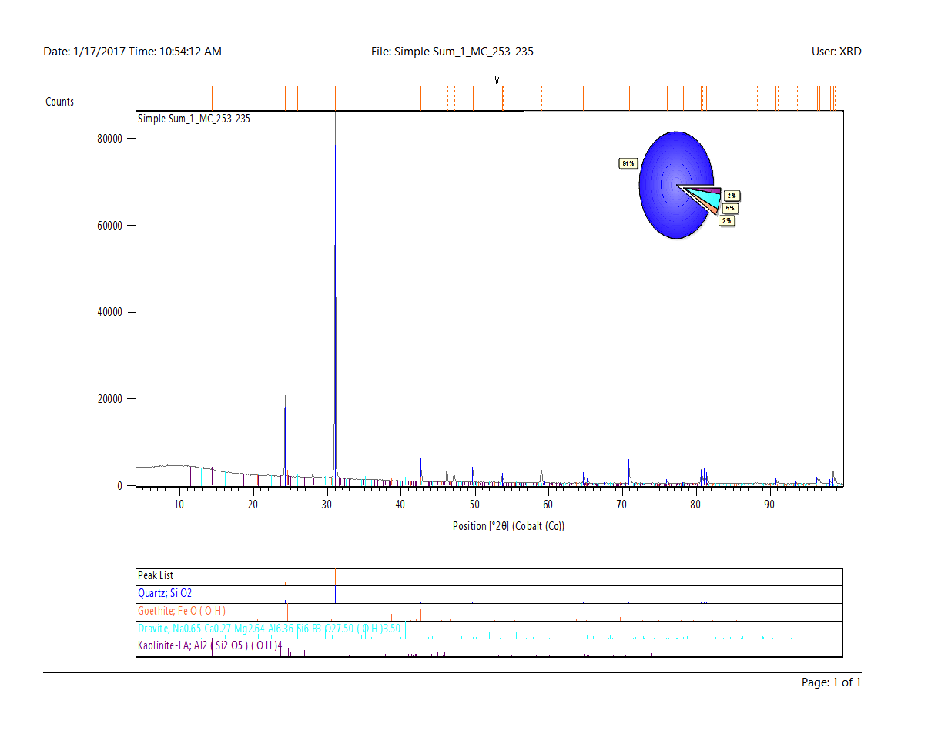
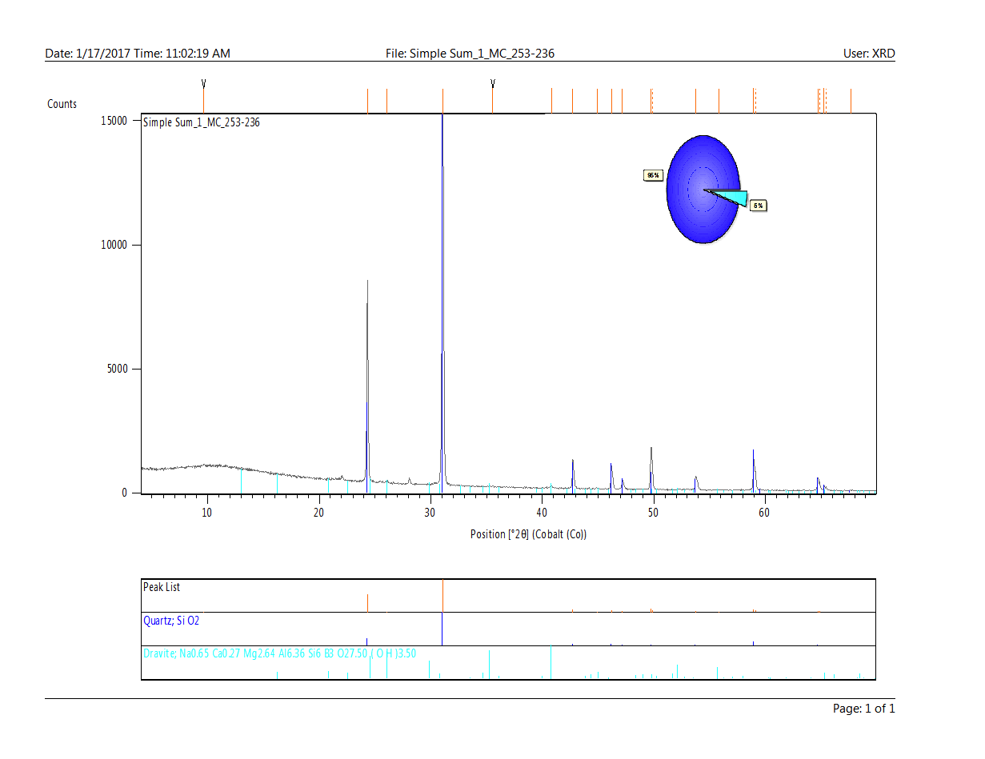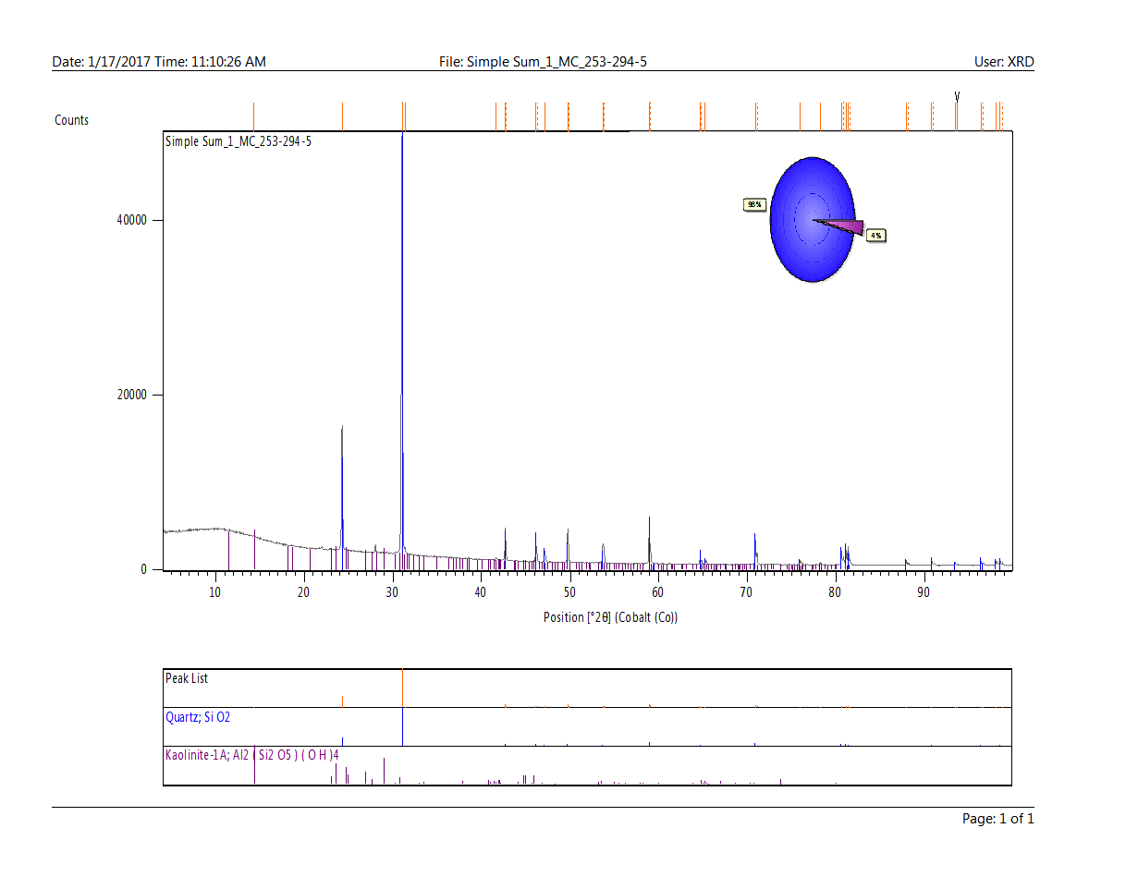
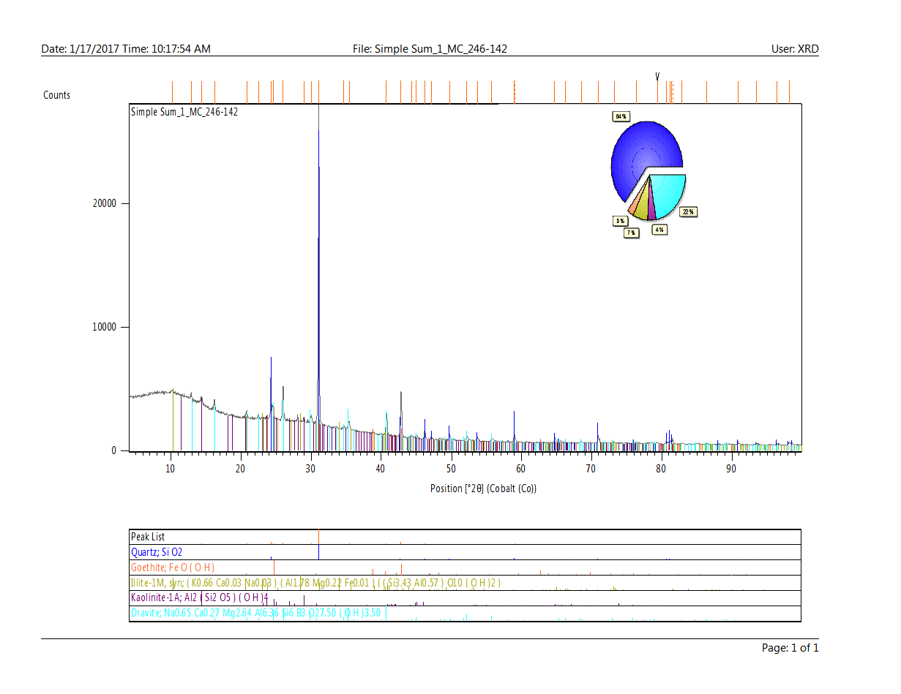
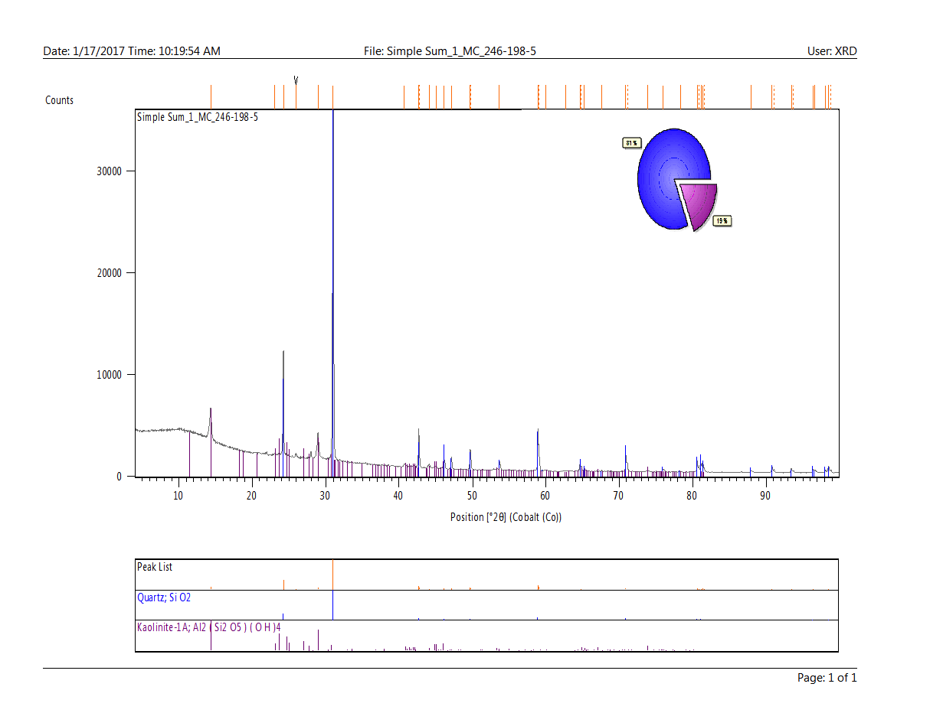

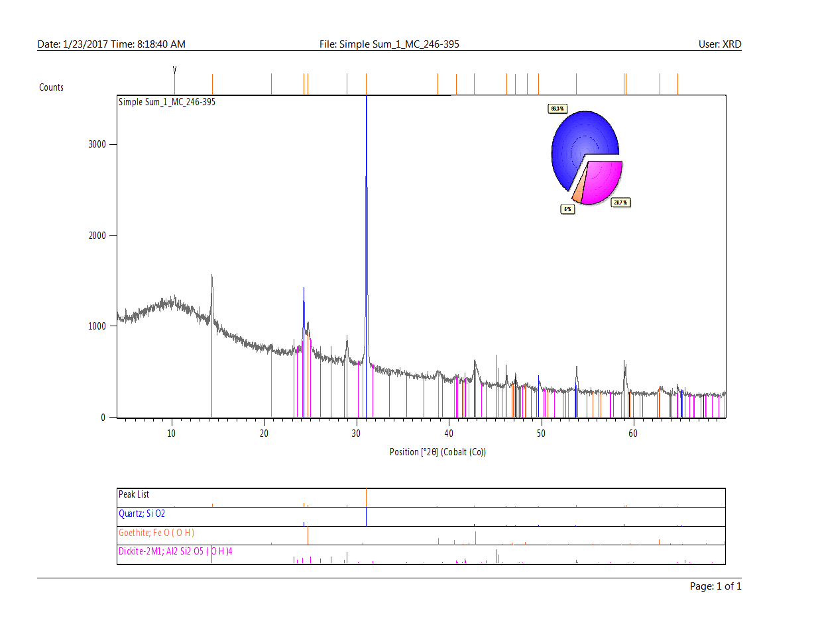

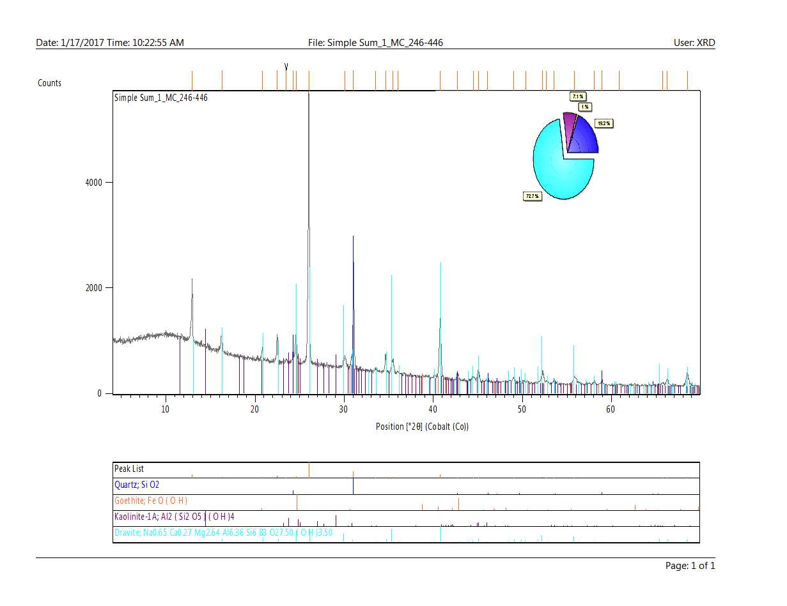
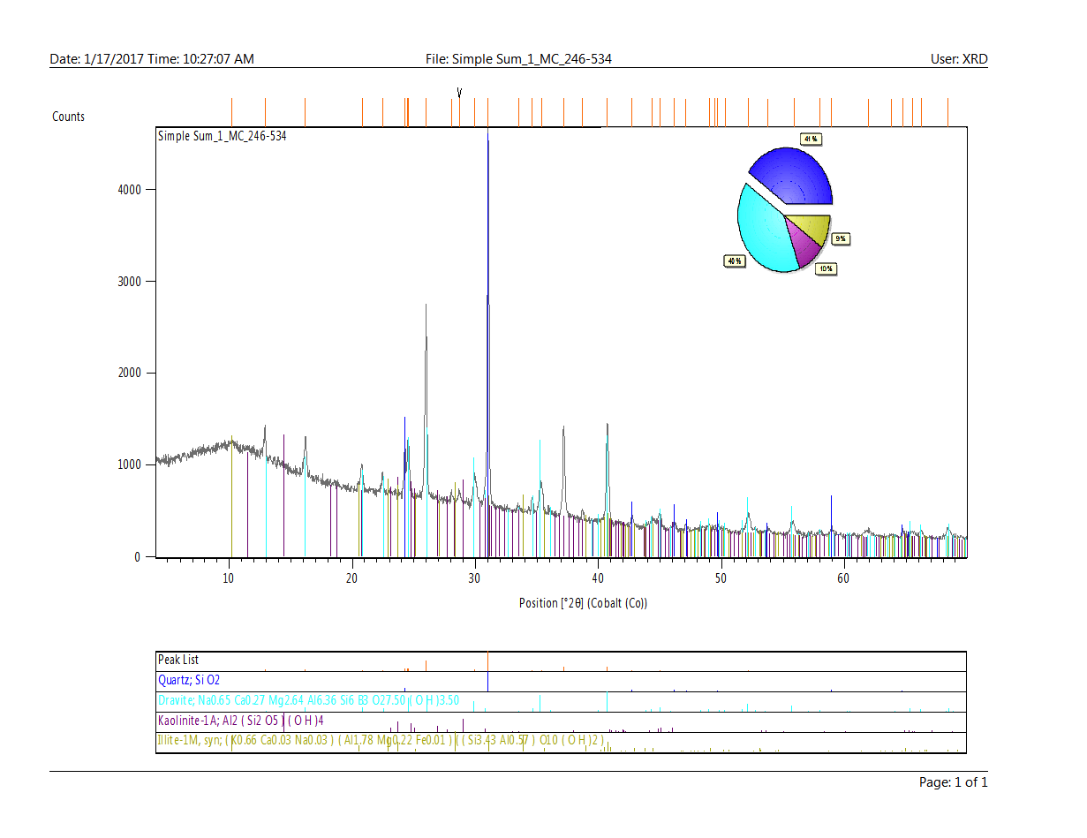
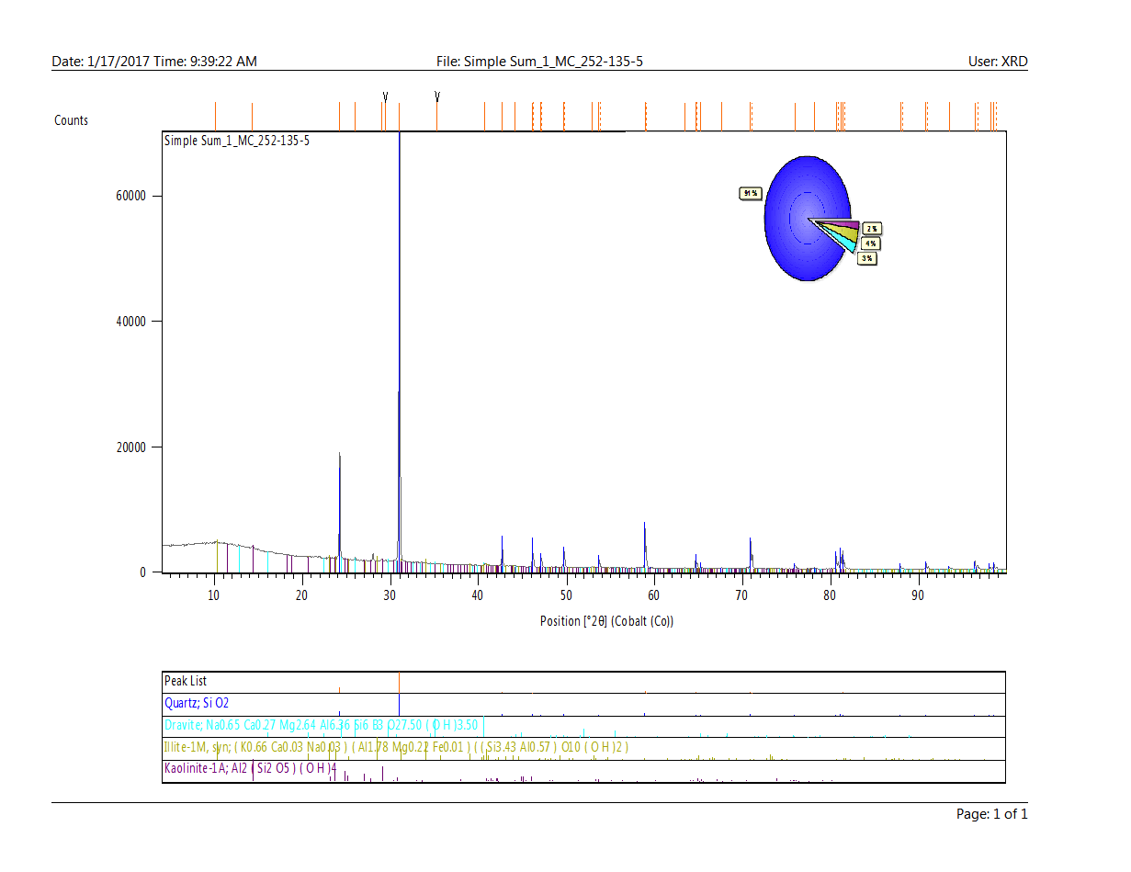

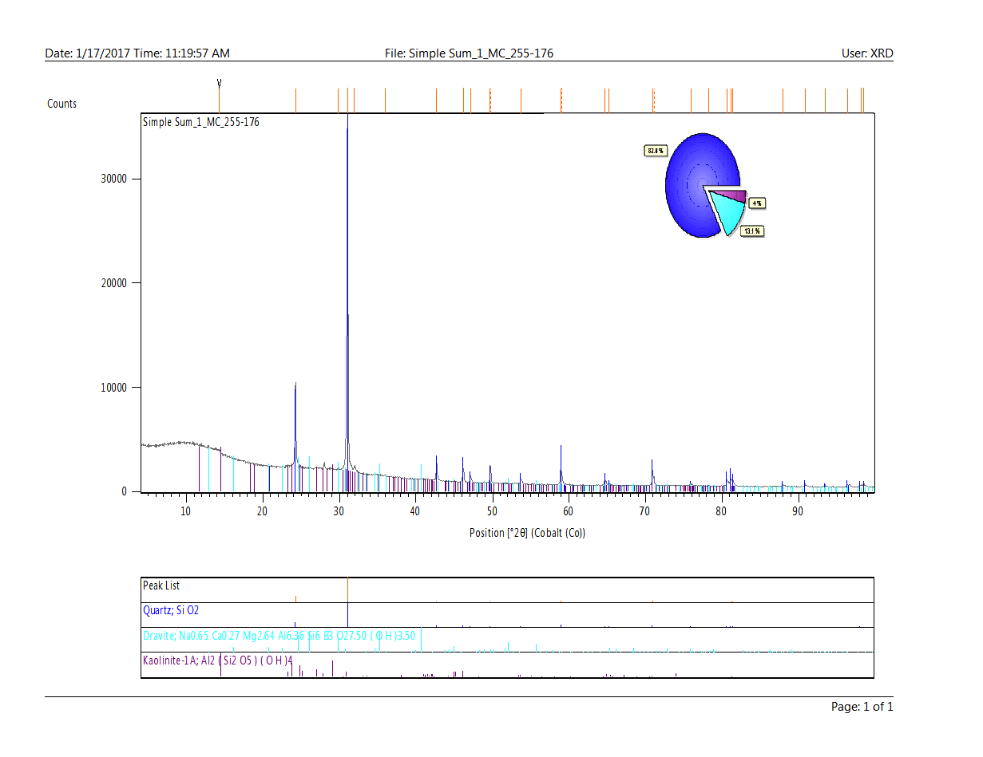
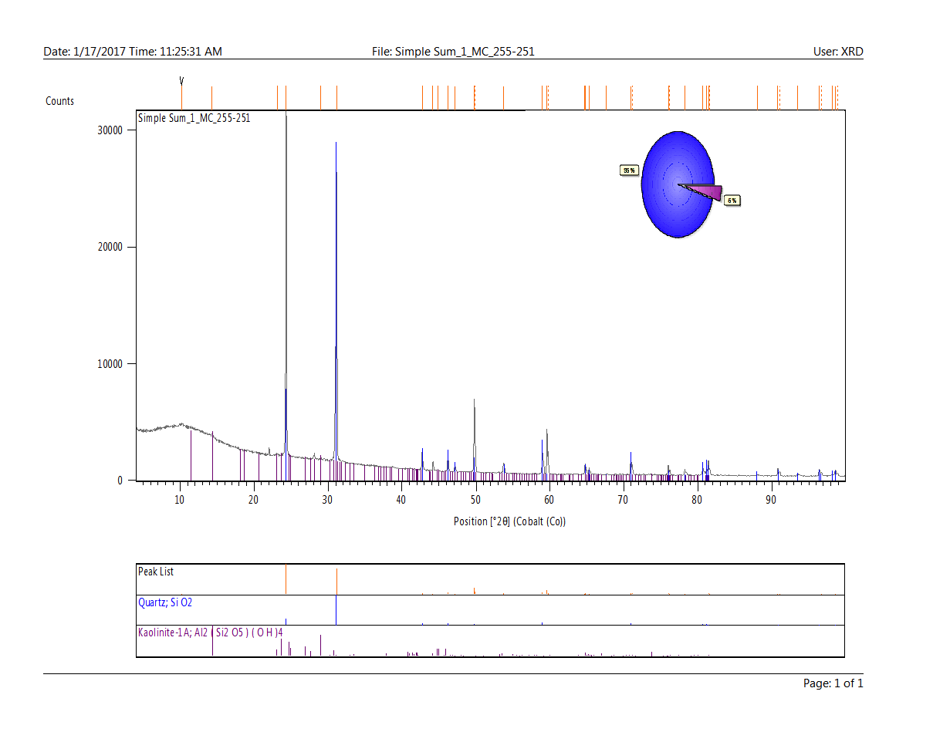

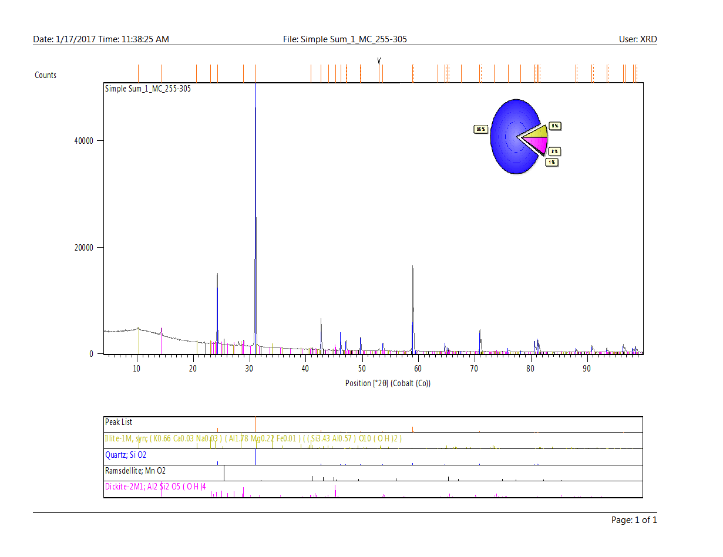
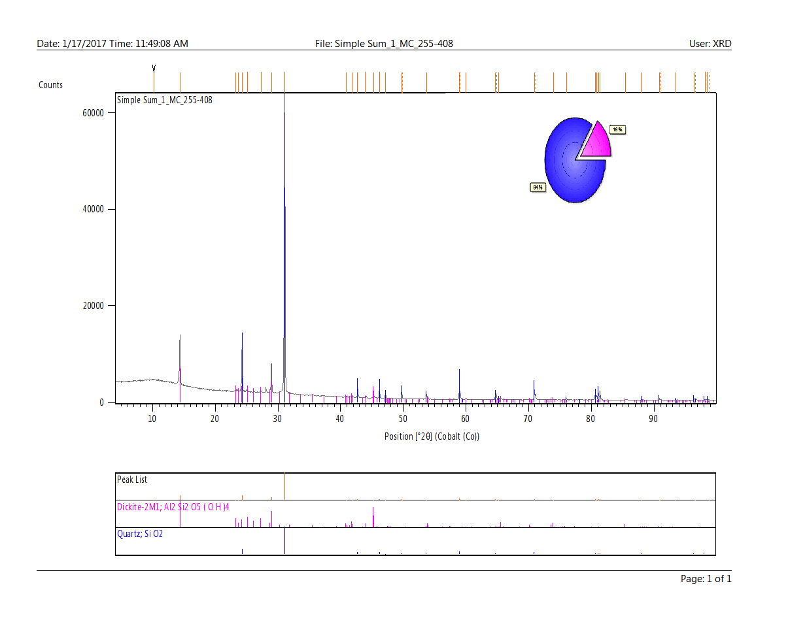

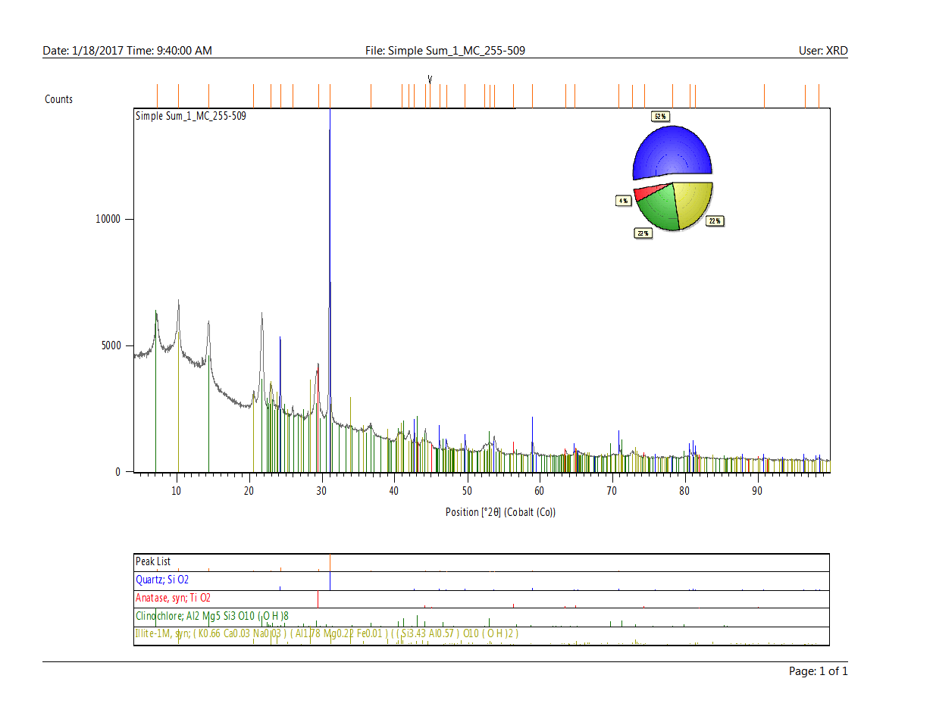
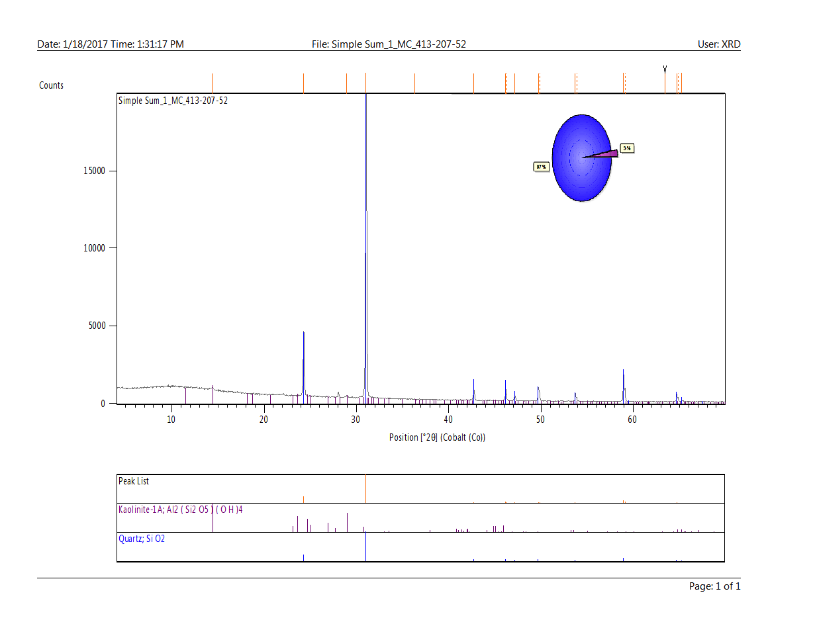

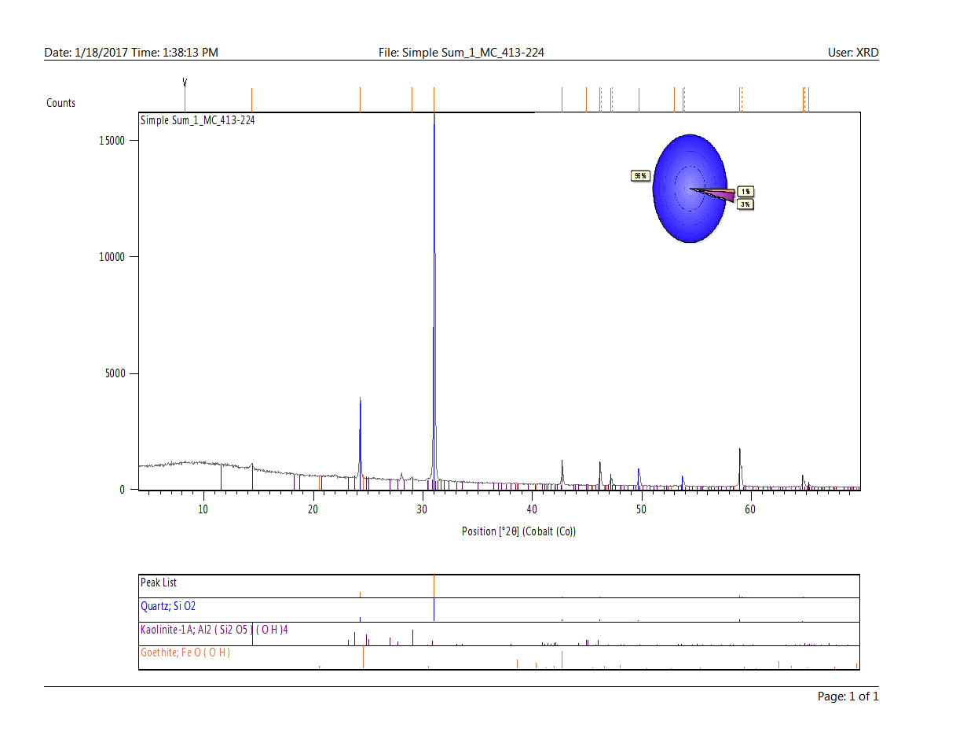
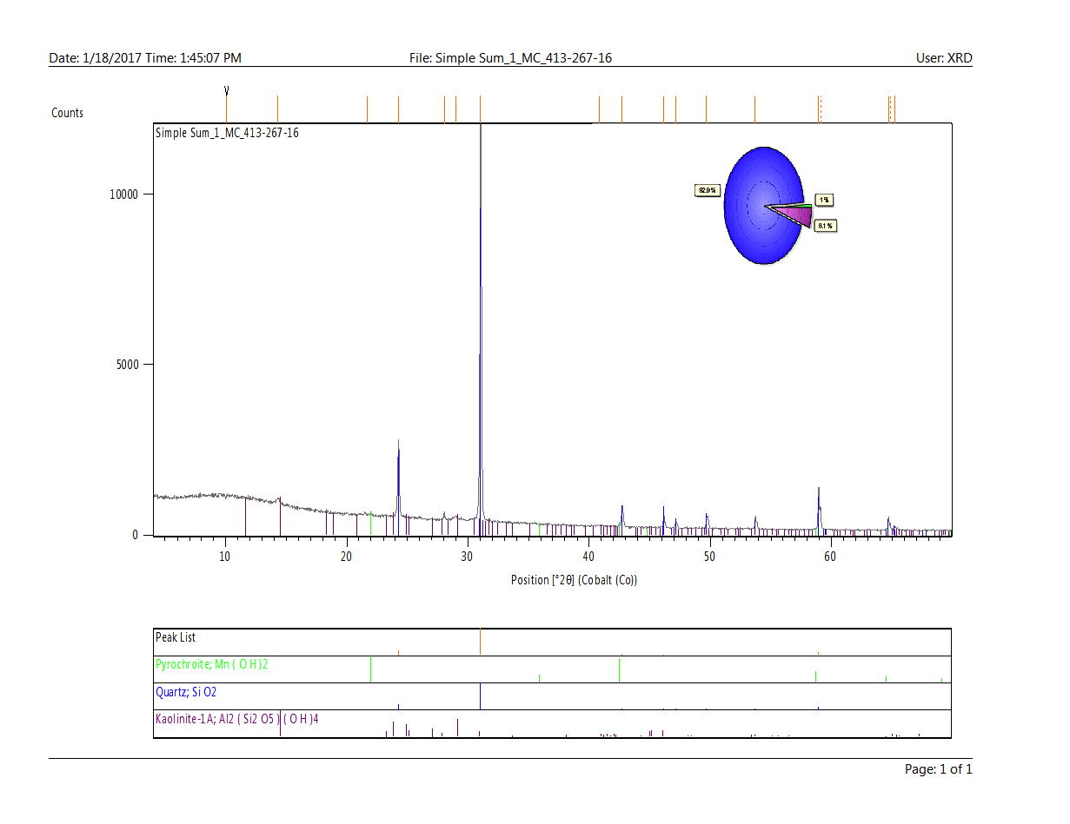

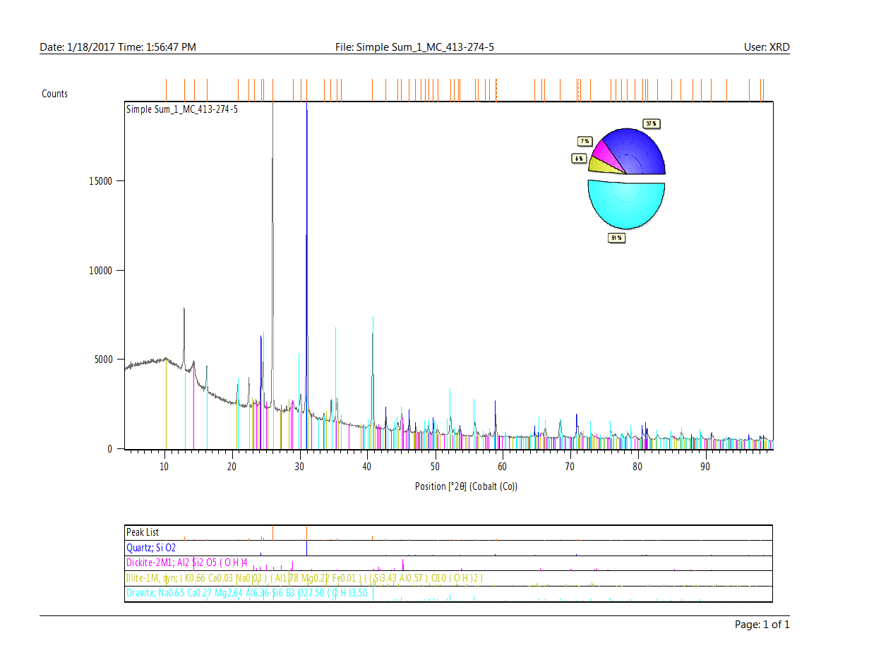
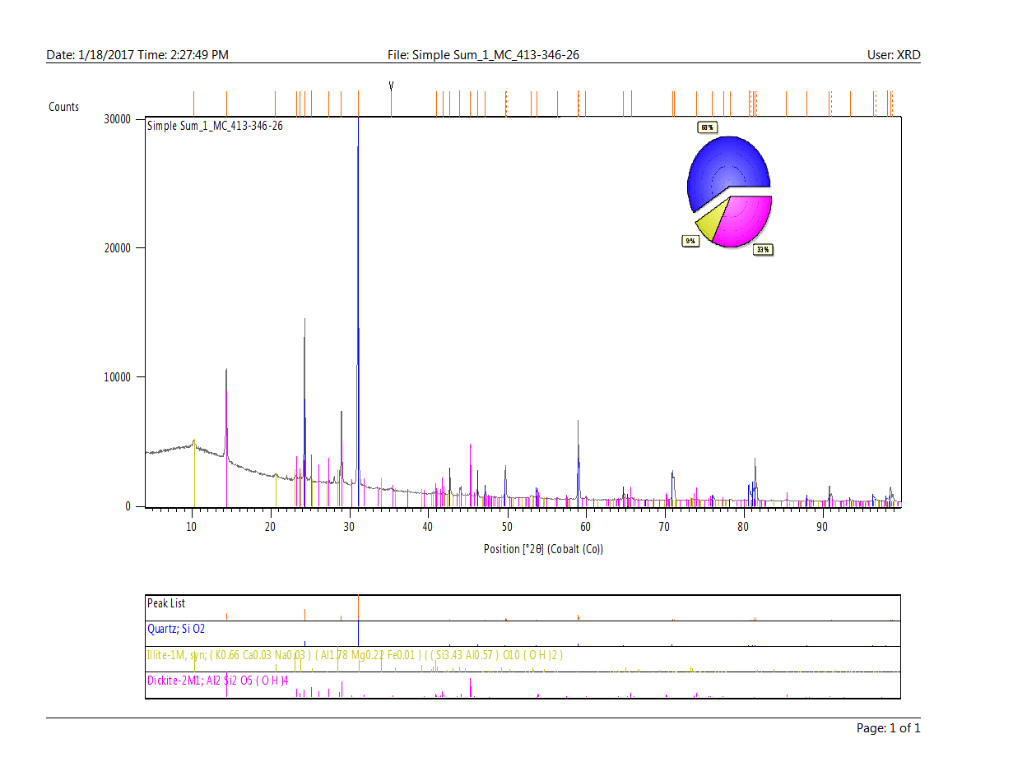

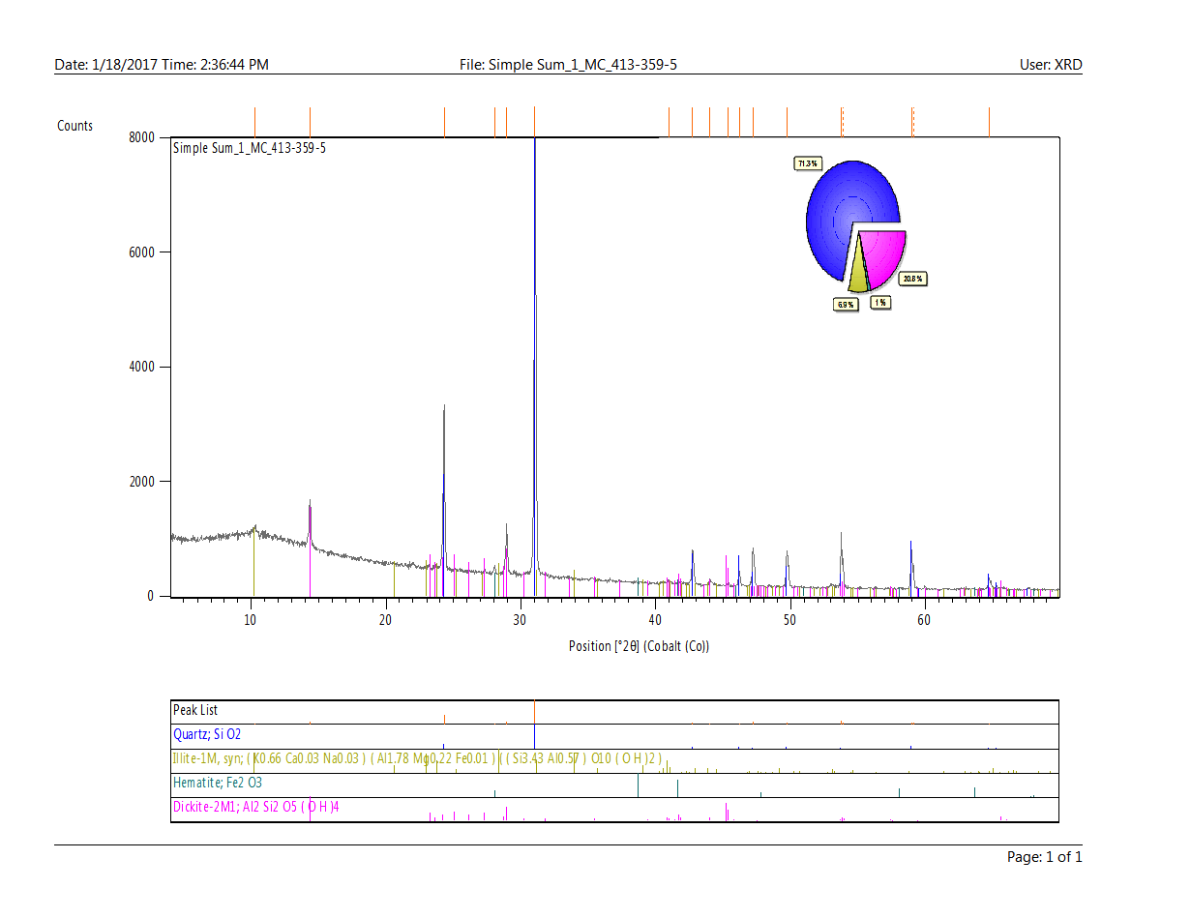
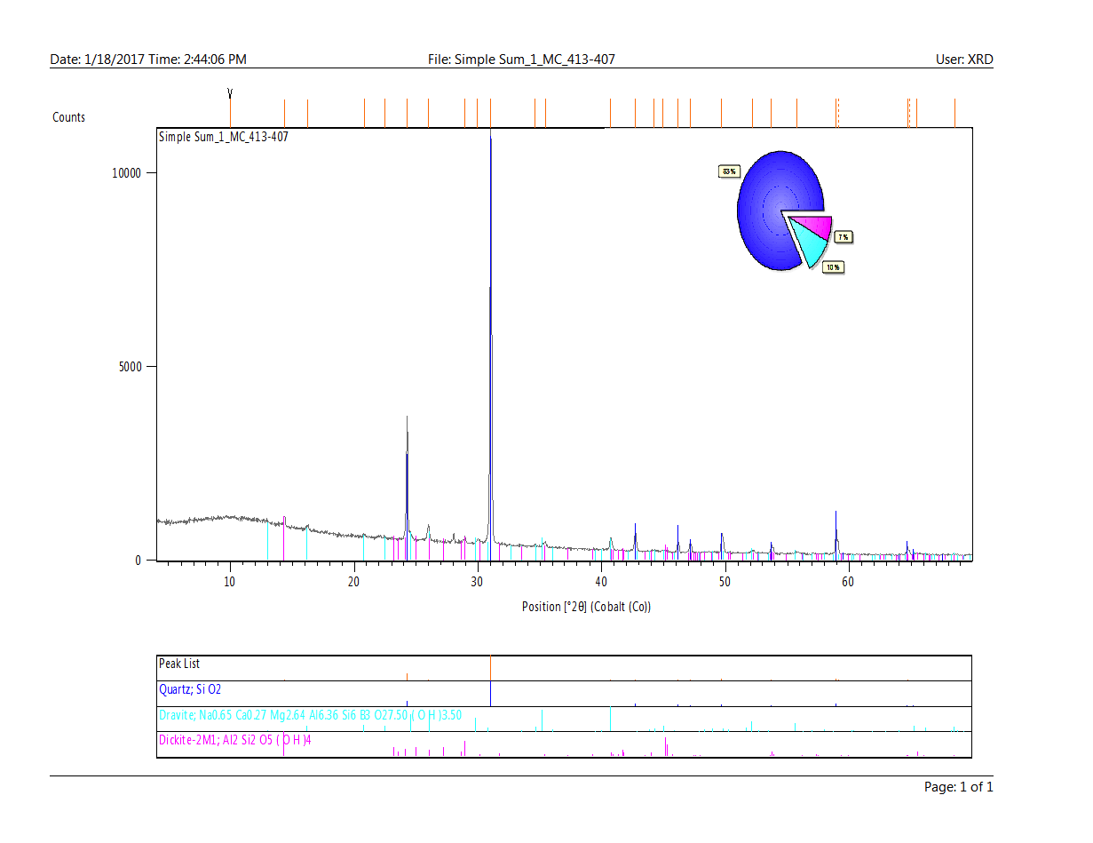
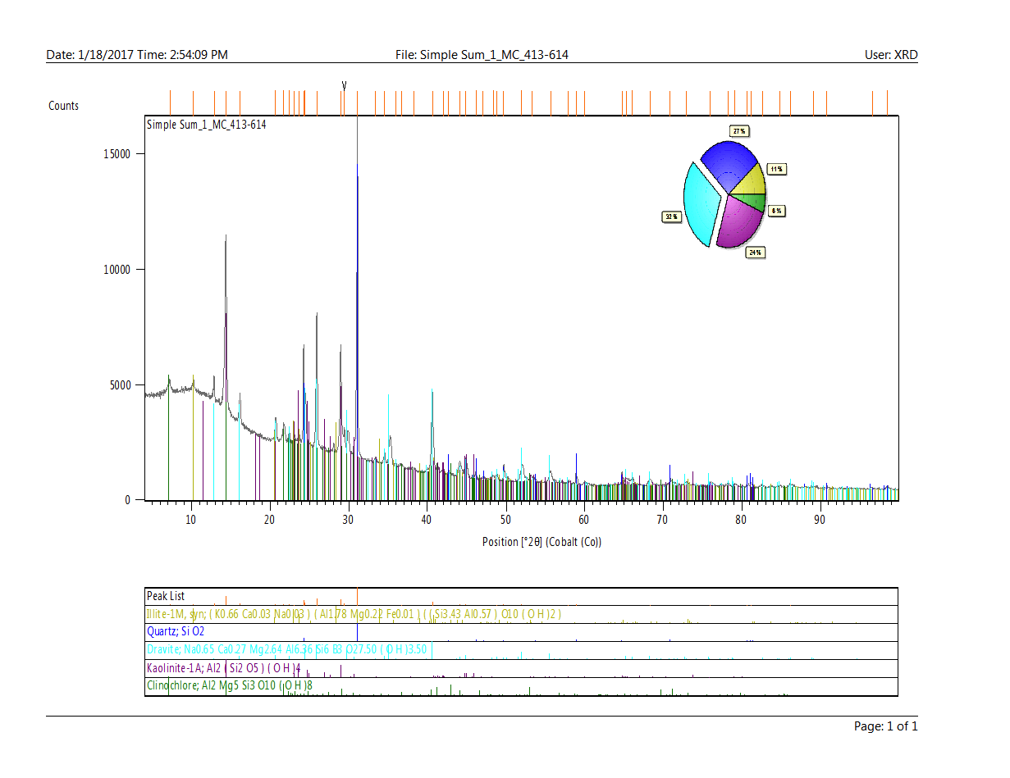
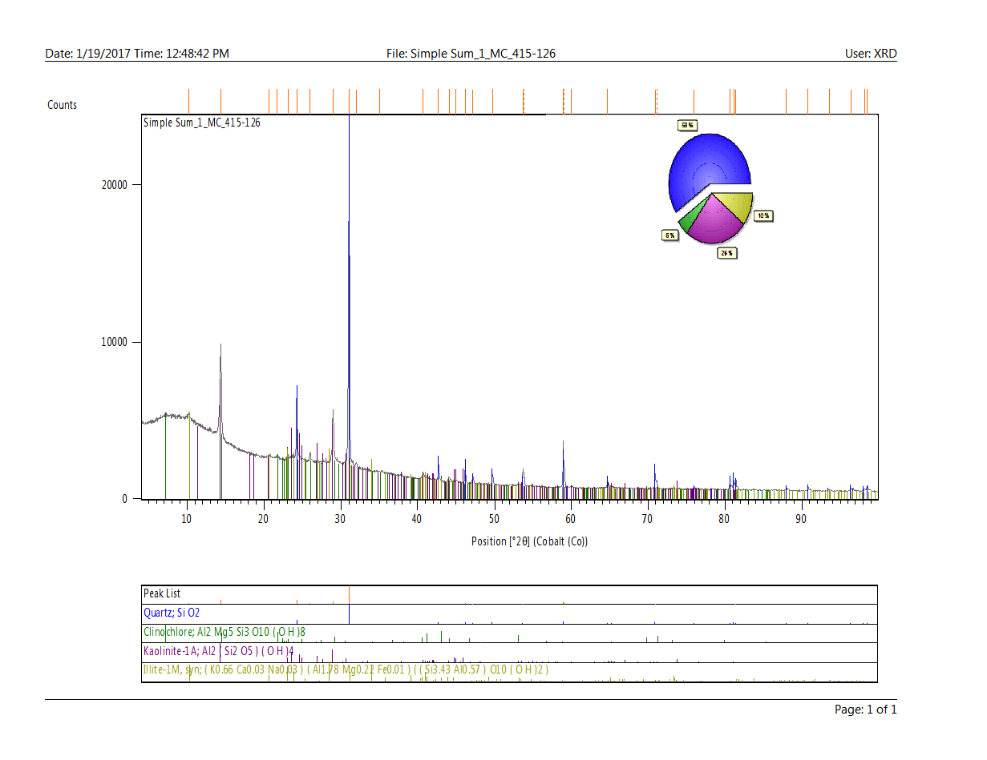
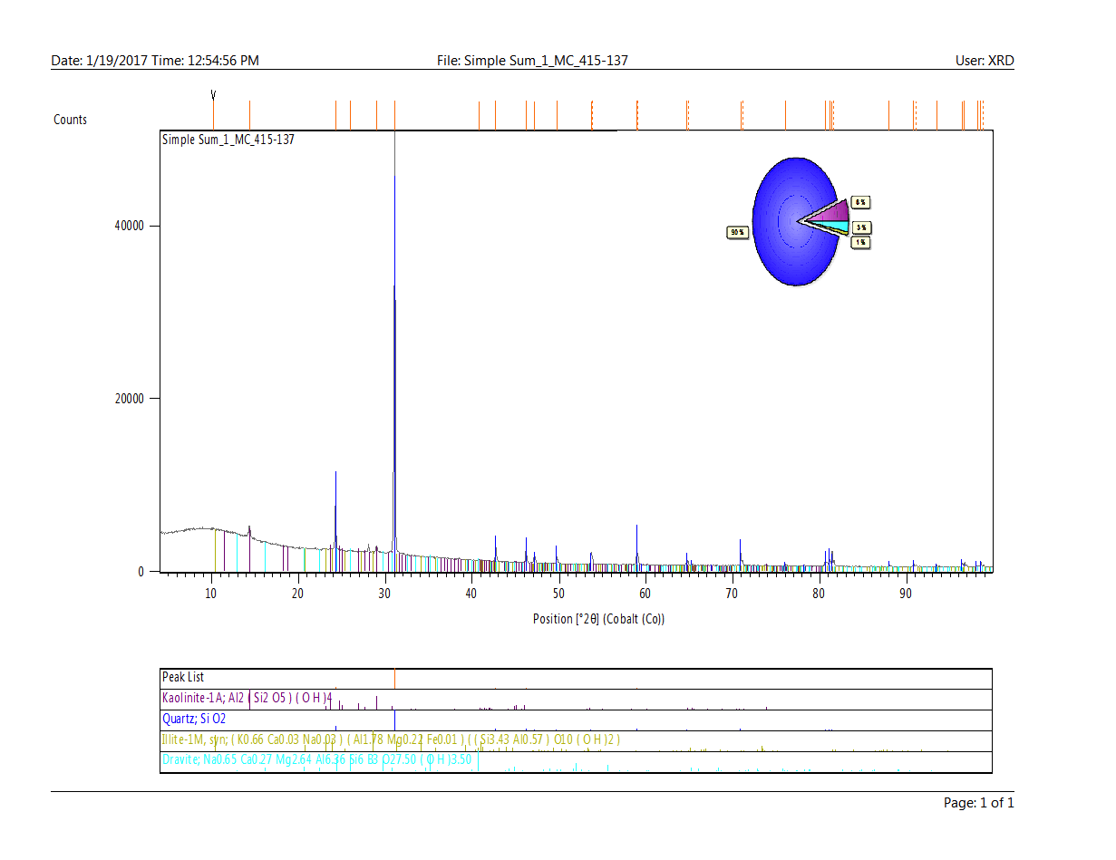
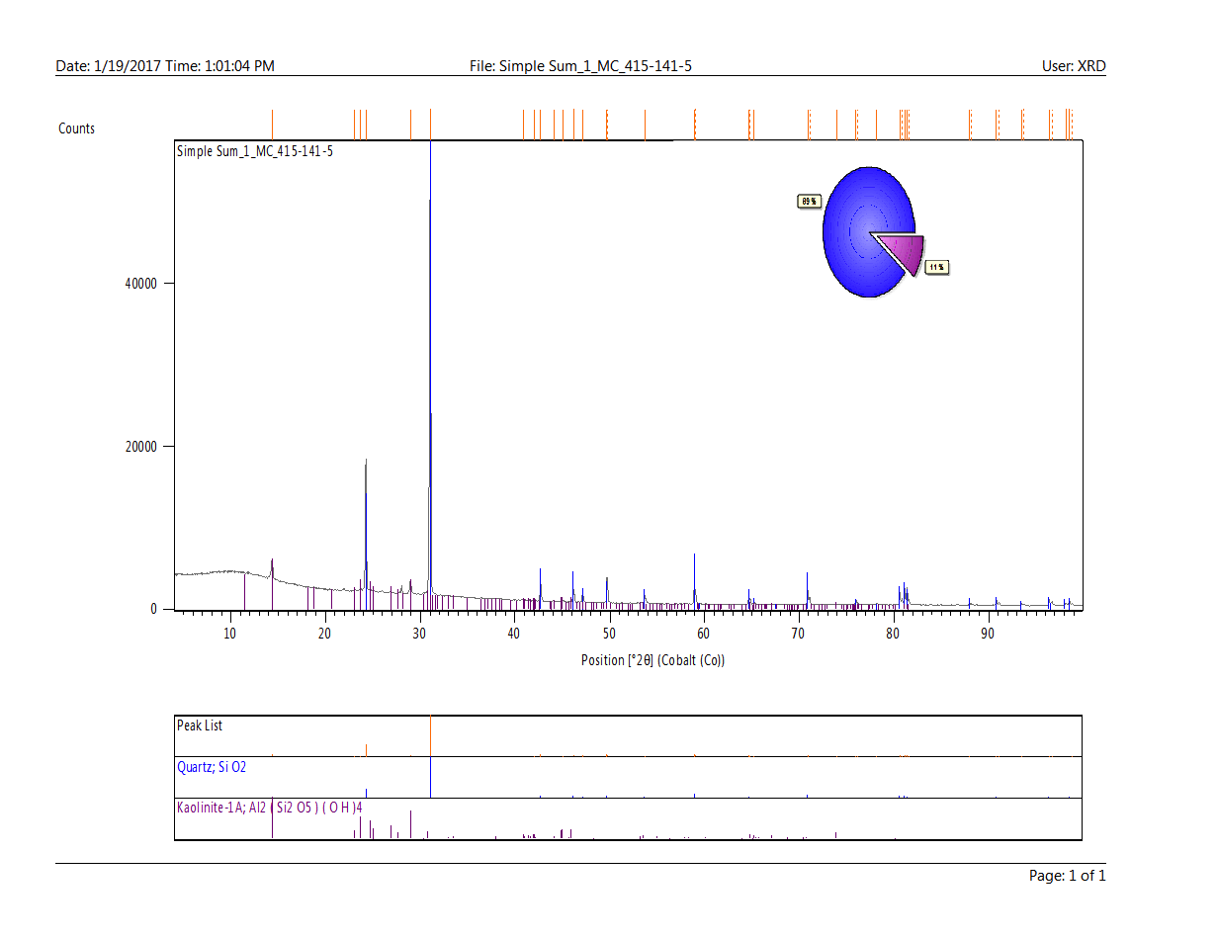
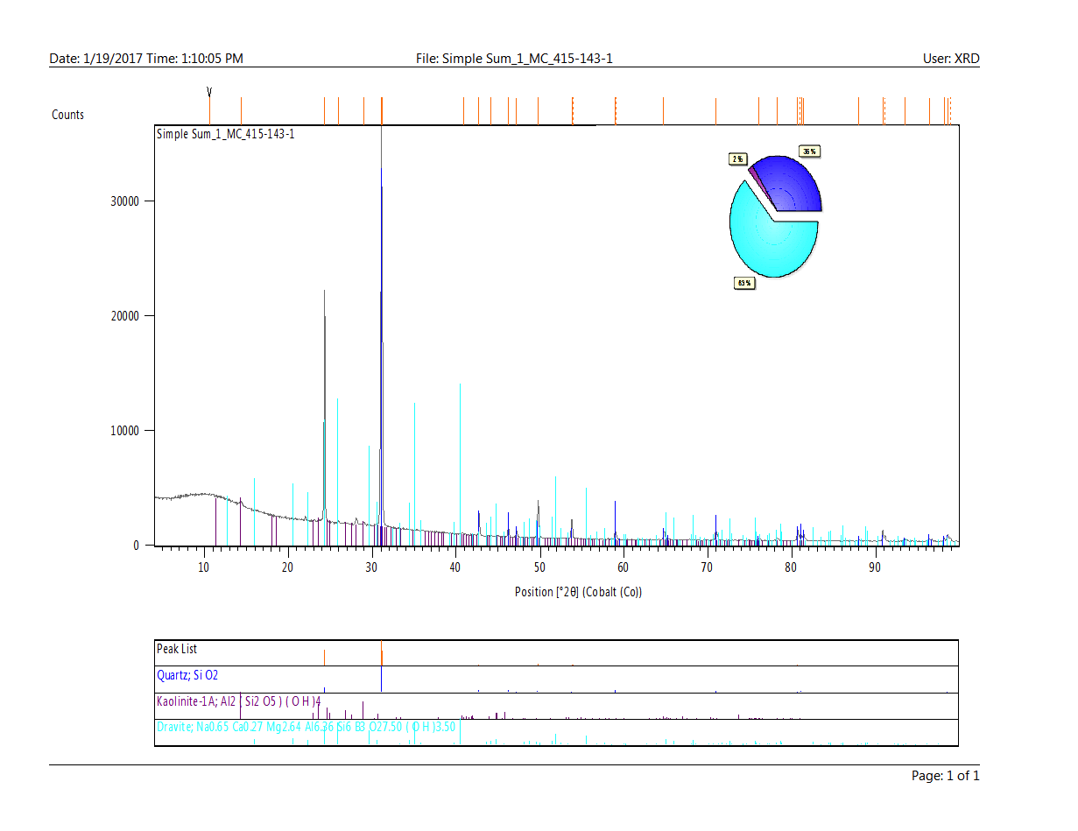
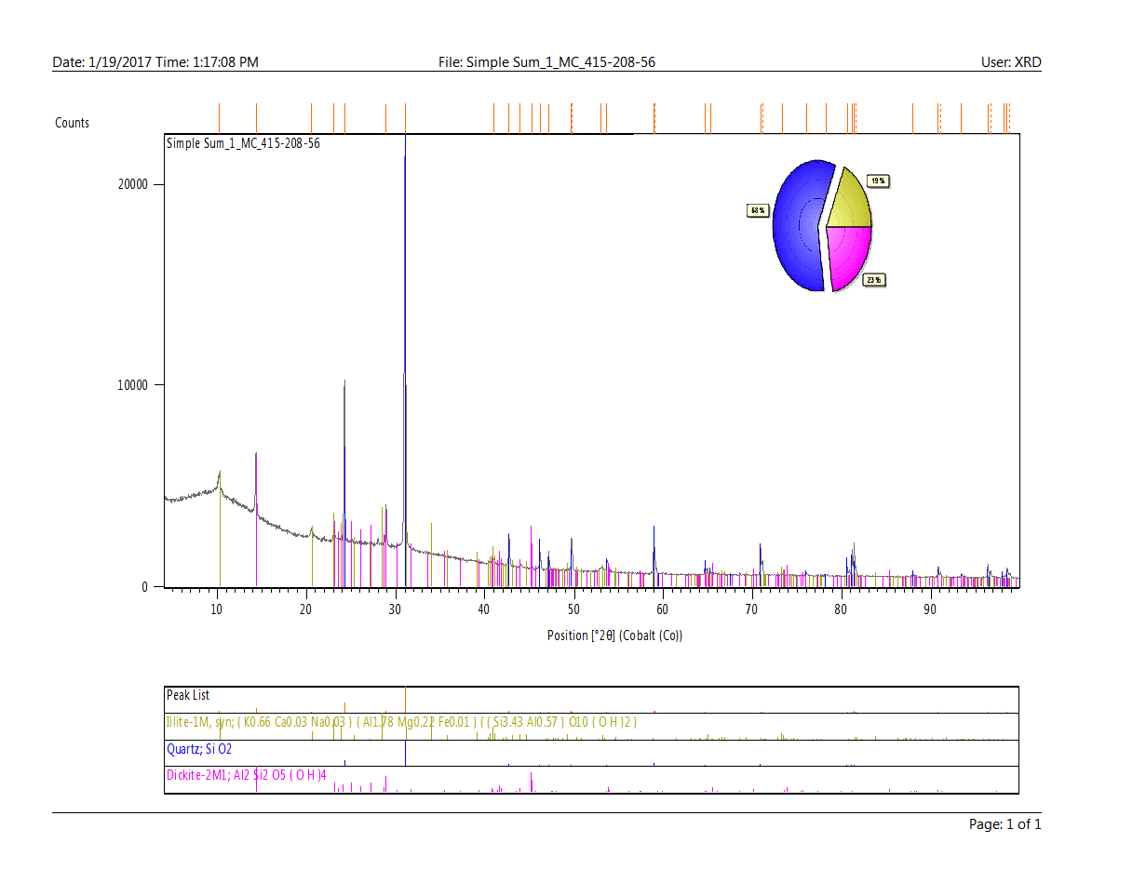
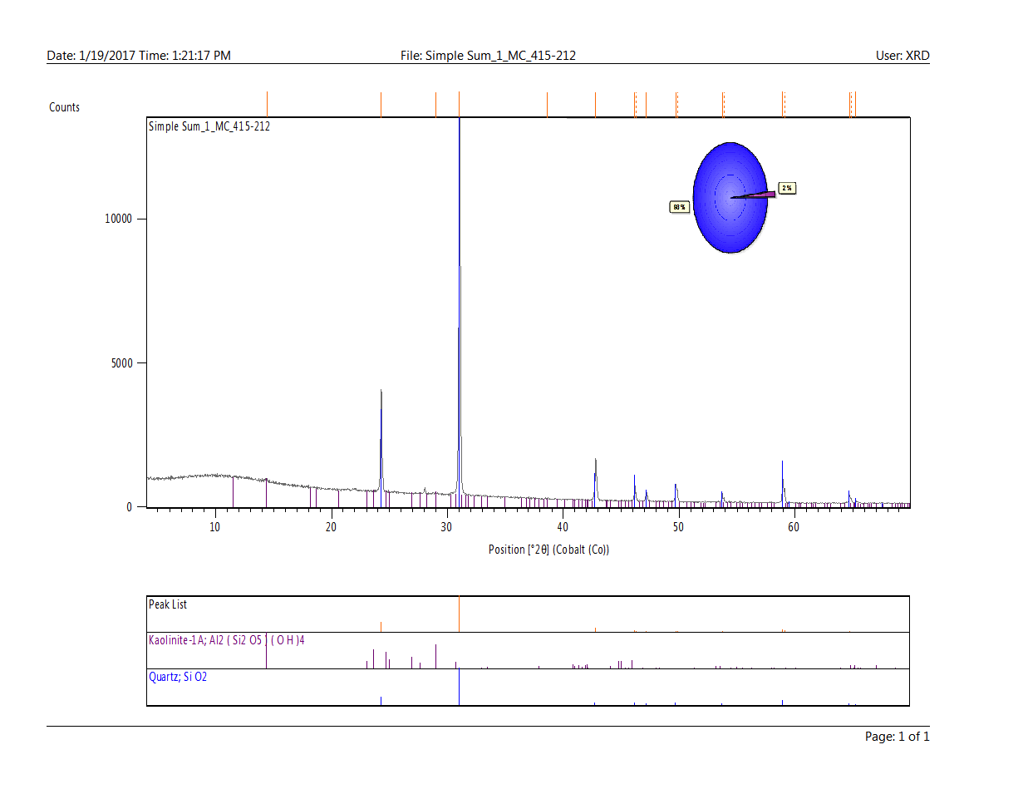
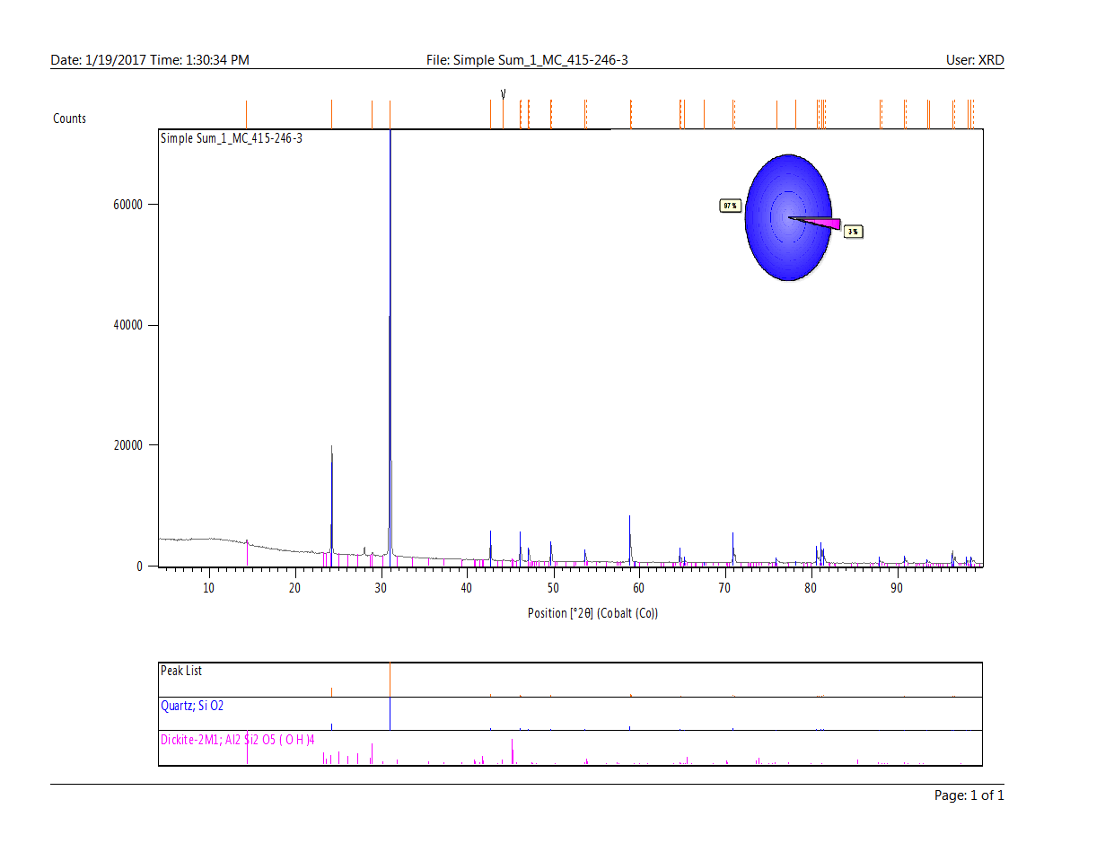

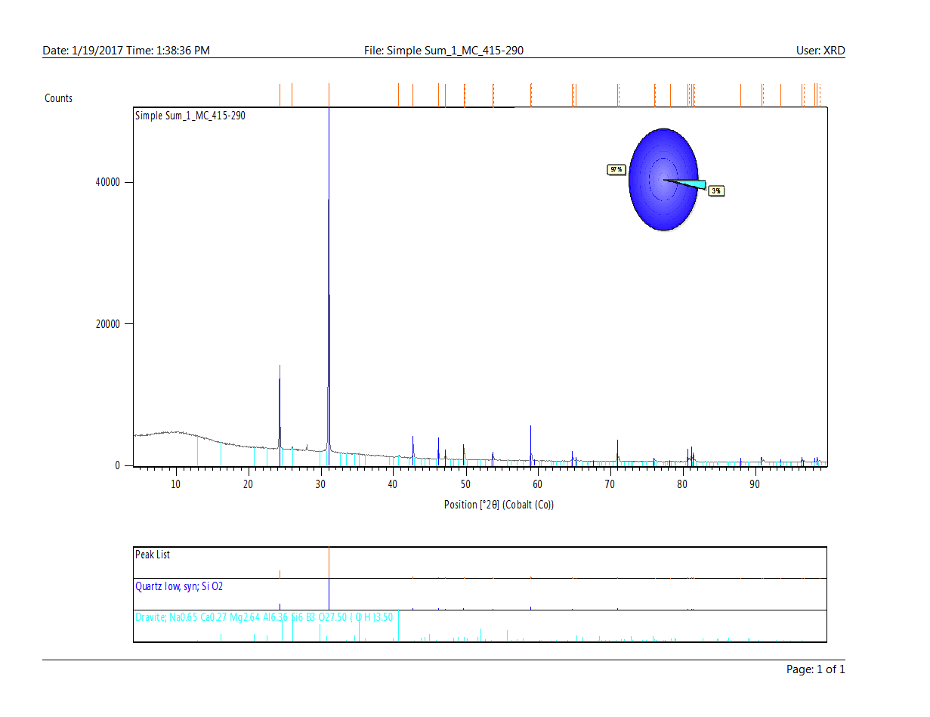
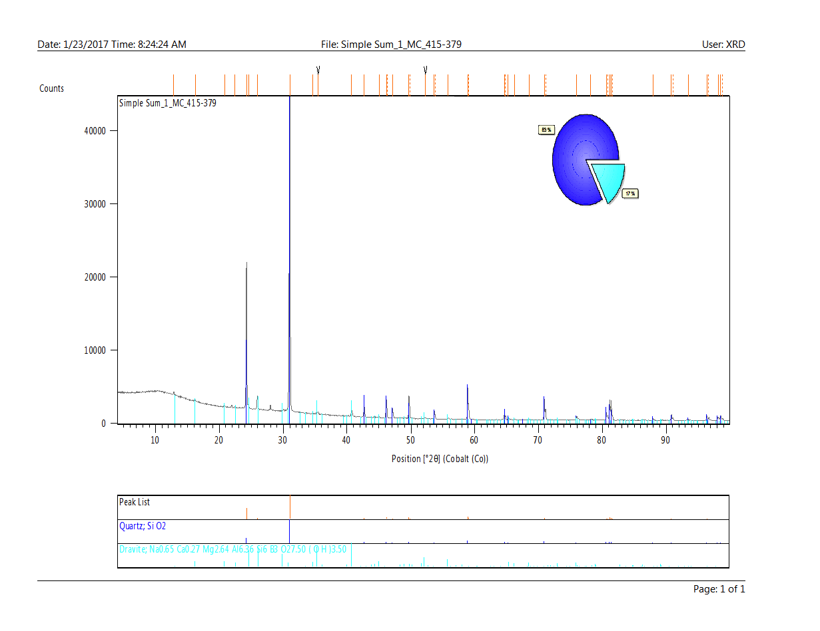
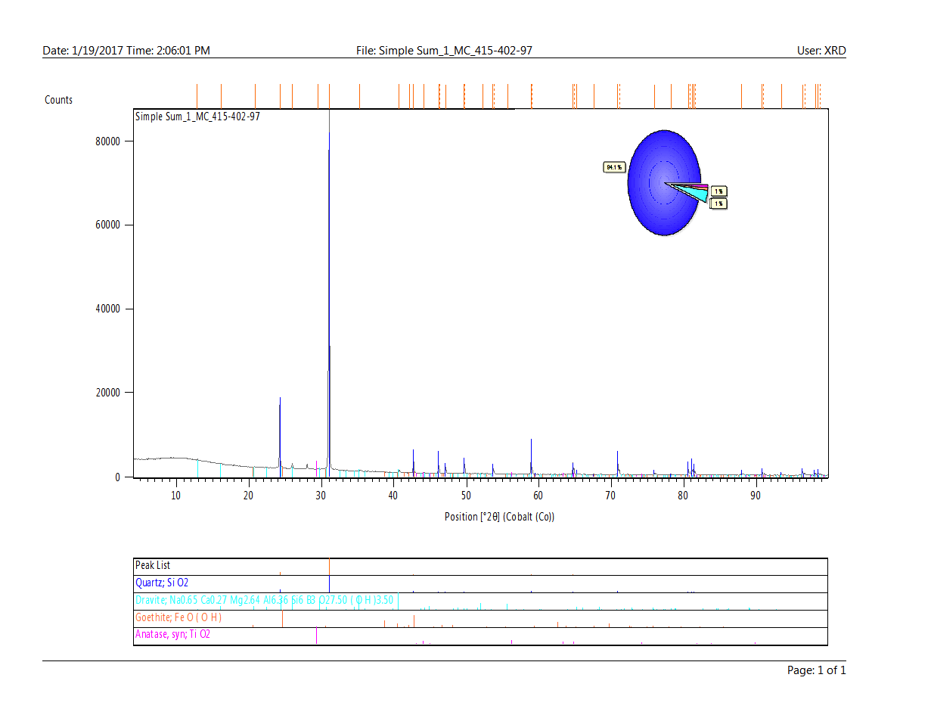
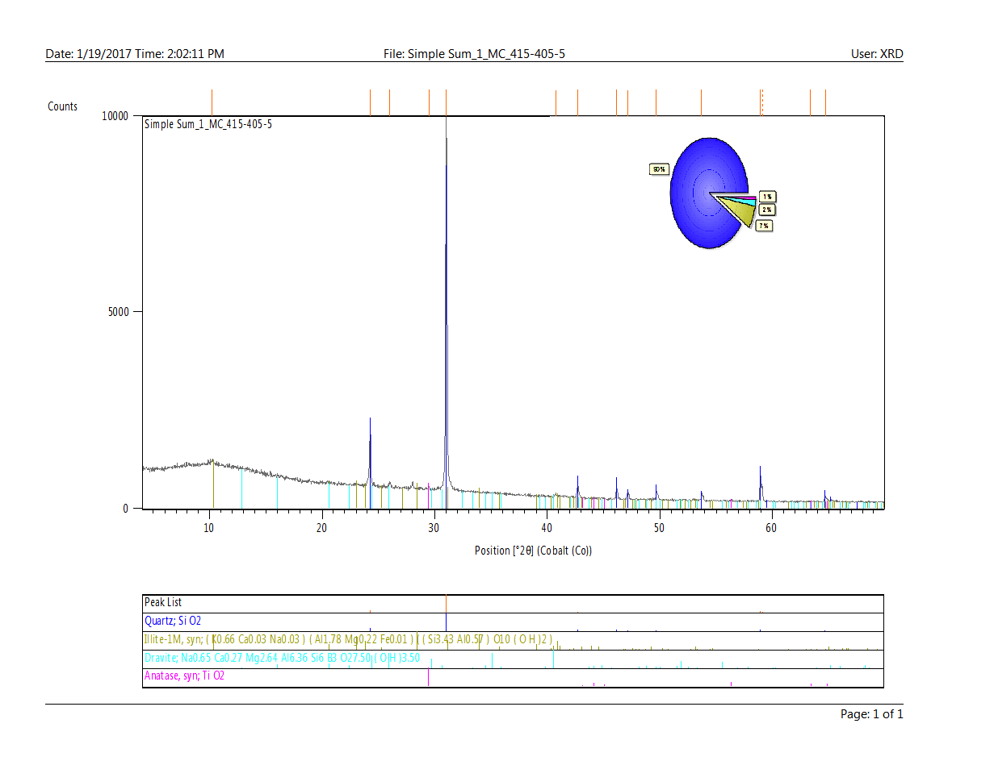

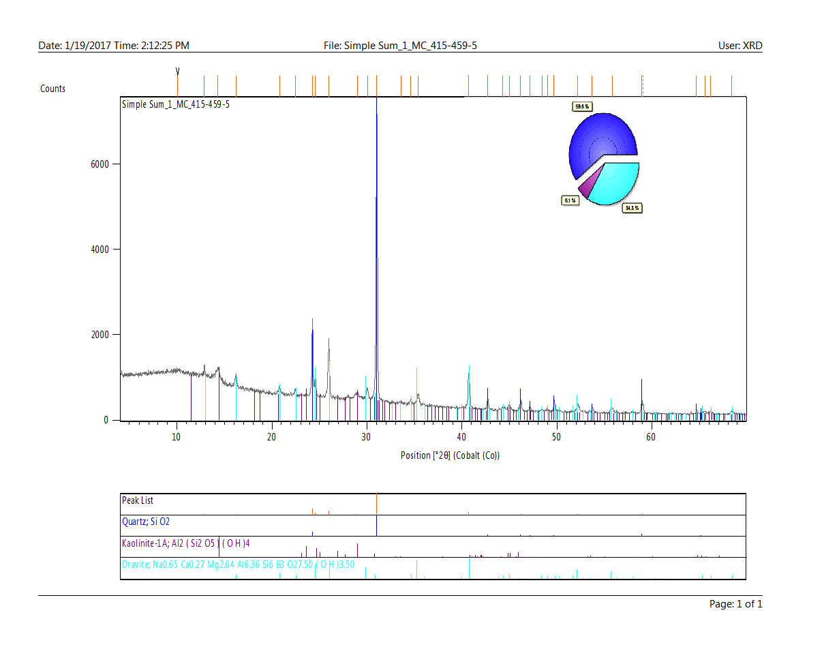
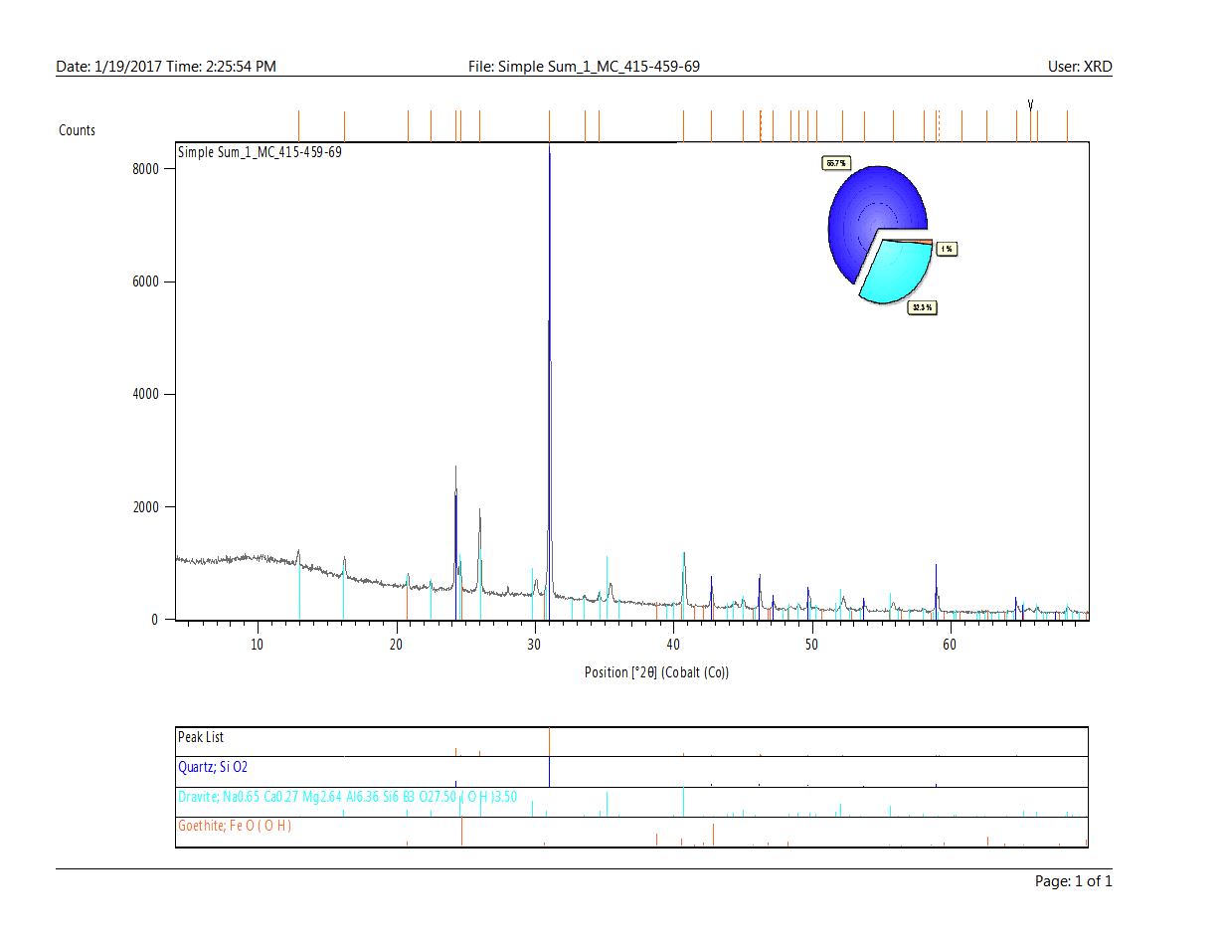

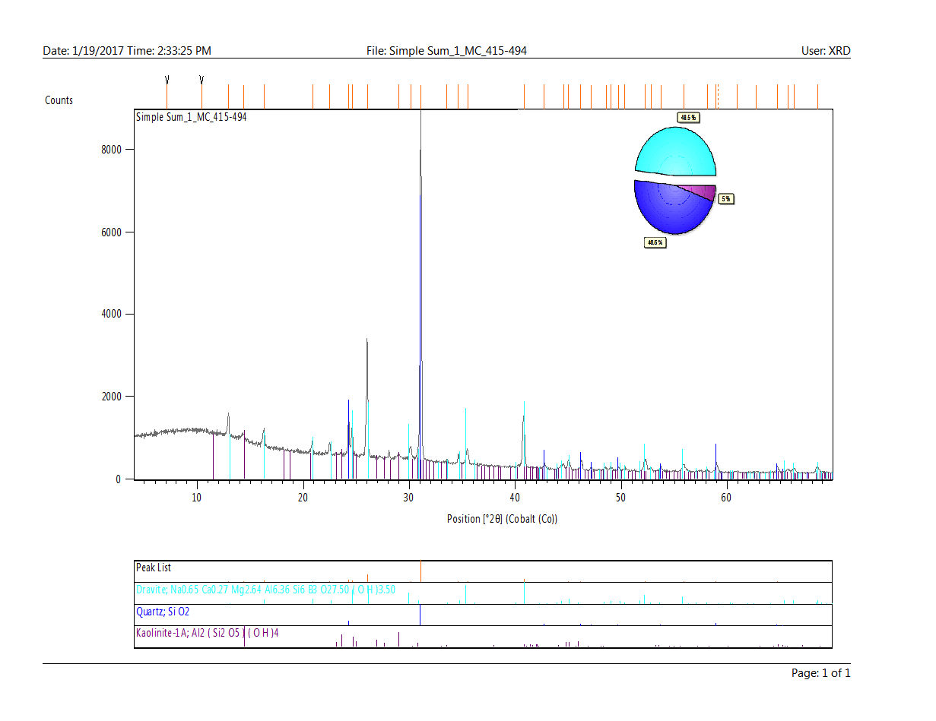
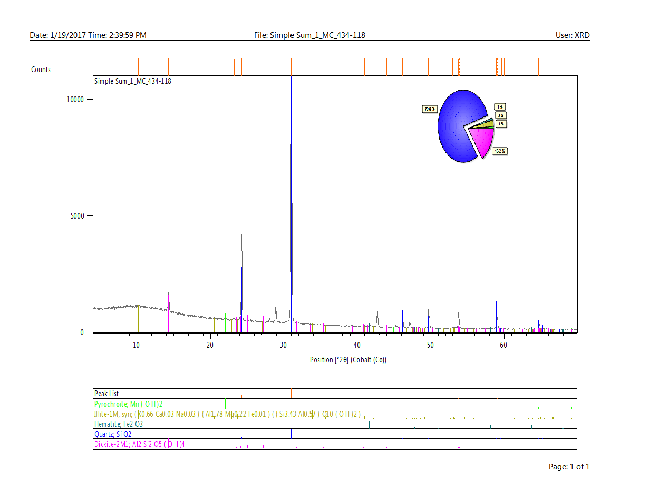
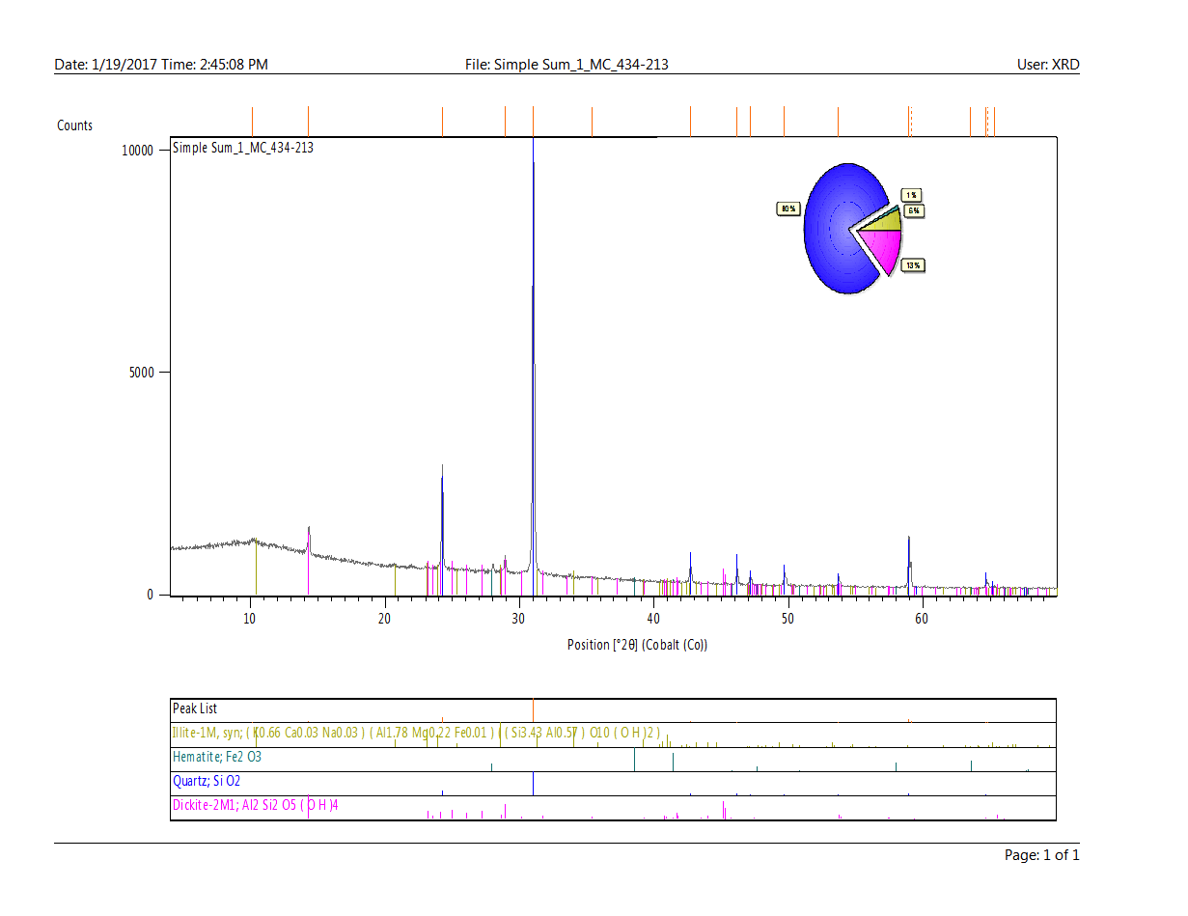
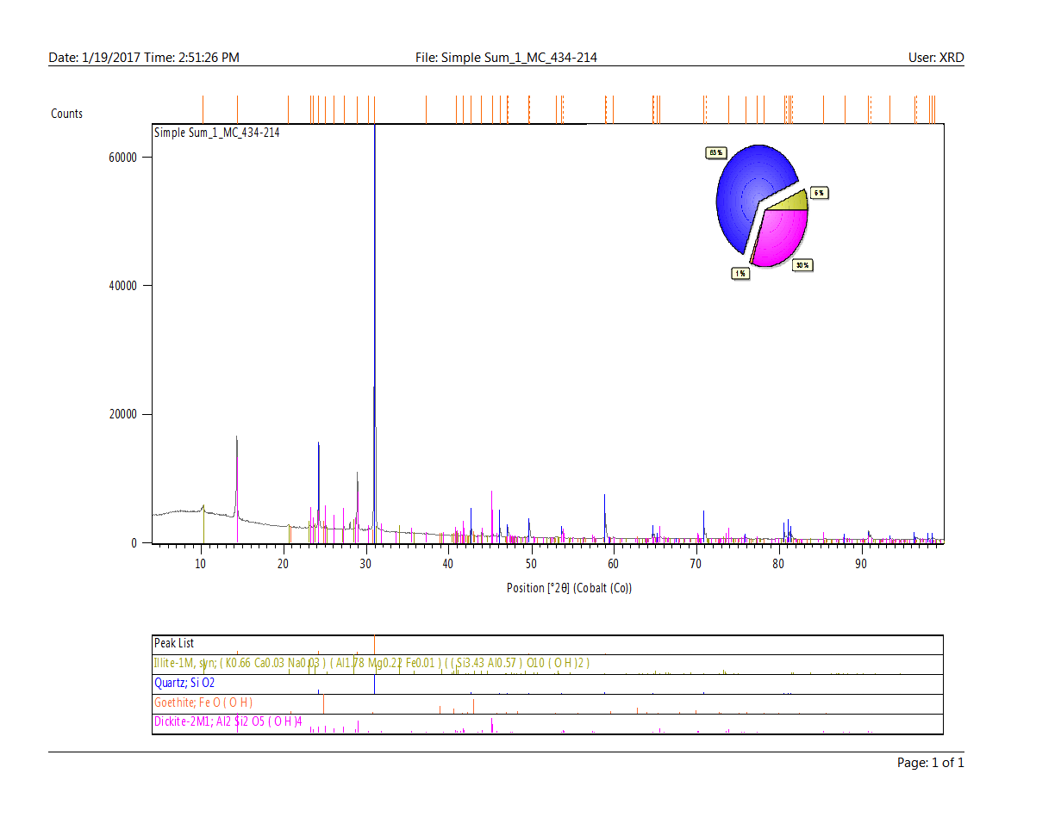

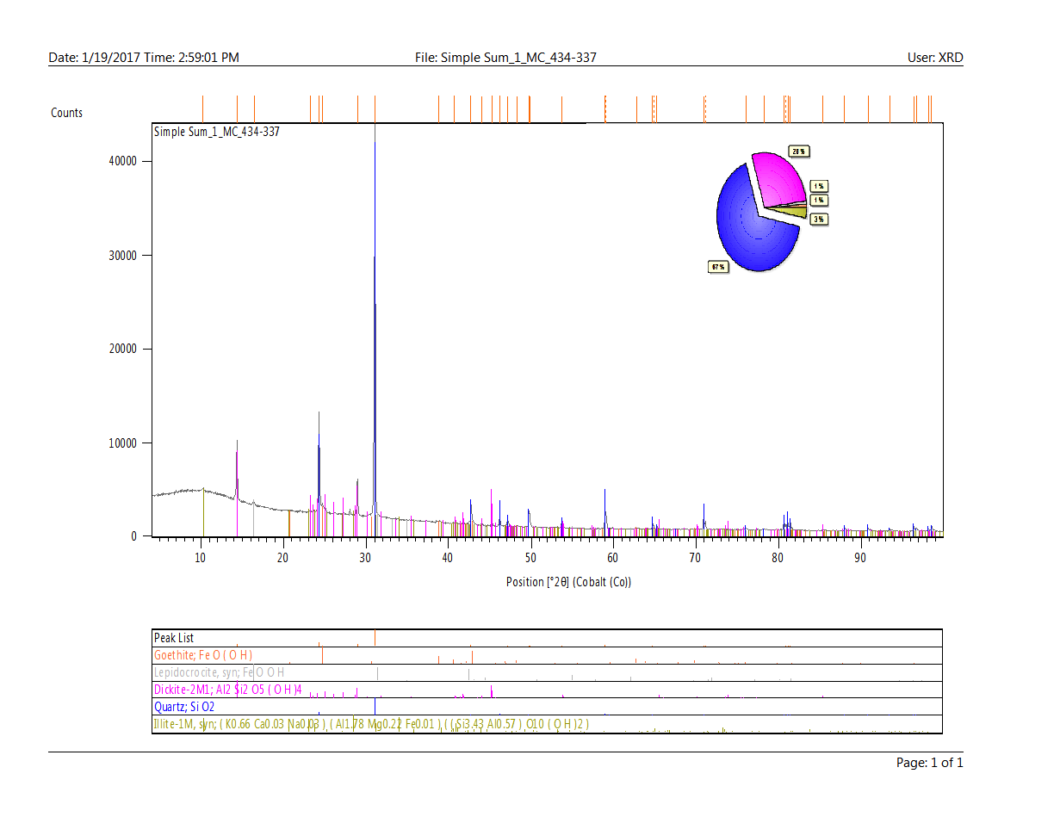
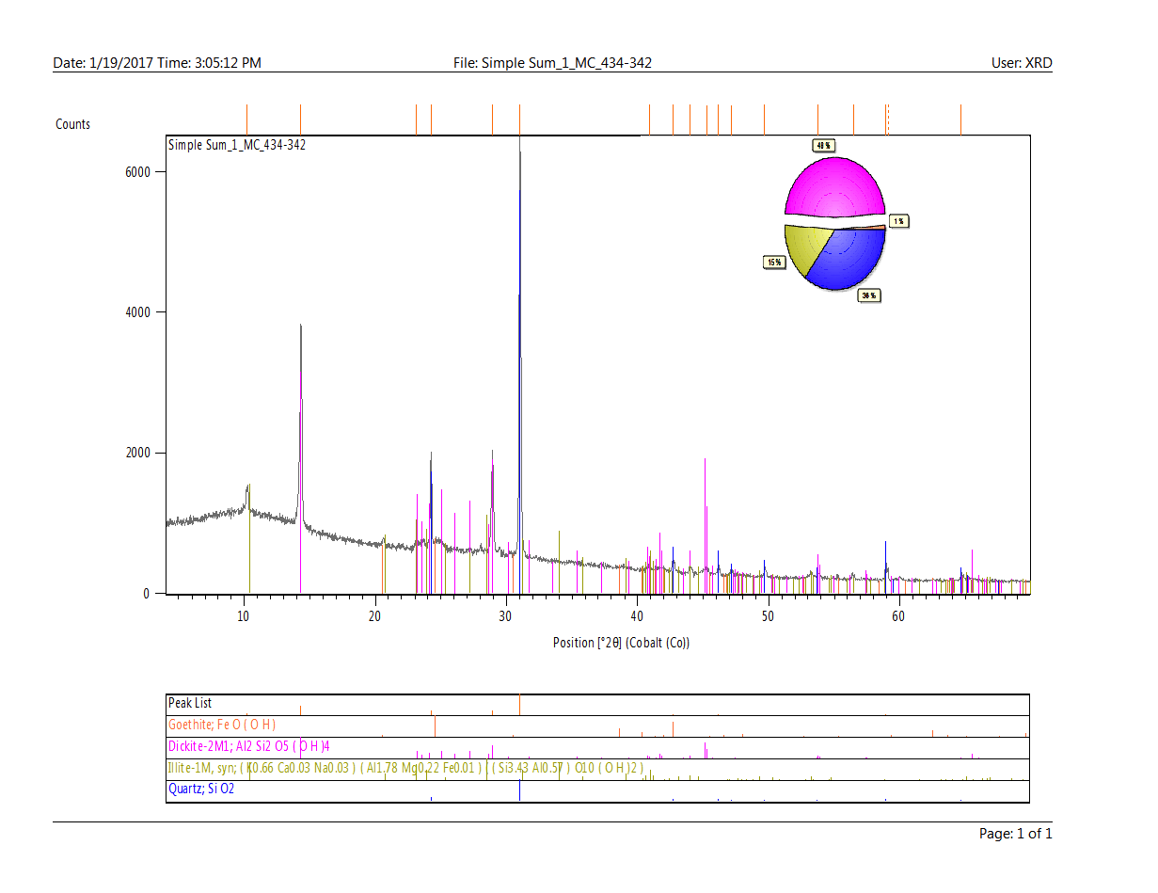

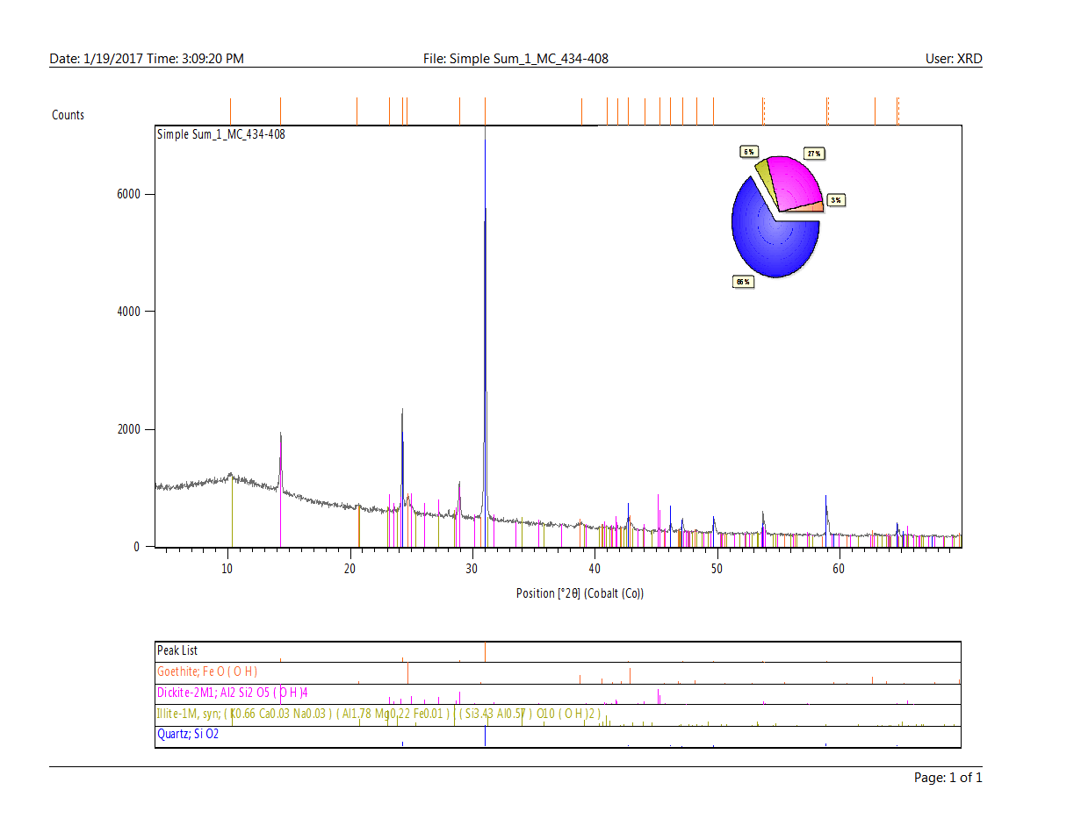
XRD Spectra: McArthur River Fracture Coatings (<100 m)
