REACTION RIMS ON ILMENITE AND CHROMITE: IMPLICATIONS FOR VOLATILE BEHAVIOUR AND CRYSTALLISATION CONDITIONS OF KIMBERLITE MAGMA

LYDIA FAIRHURST§, AND YANA FEDORTCHOUK
Department of Earth and Environmental Sciences, Halifax, NS, CAN

INGRID CHINN
De Beers Group, Johannesburg, Gauteng, ZA

PHILIPPE NORMANDEAU
Northwest Territories Geological Survey, Yellowknife, NT, CAN

MICHAEL POWELL
Department of Earth and Environmental Sciences, Halifax, NS, CAN

§Corresponding author e-mail address: lydiafairhurst@dal.ca

SUPPLEMENTARY MATERIAL
NOTES ON EXPERIMENTAL PROCEDURE

The choice of capsule material was contingent upon the specific temperature conditions of the experiment and the implementation of an inner graphite liner. Given that all of our initial compositions contained Fe, the utilisation of a platinum (Pt) capsule was only viable in experiments that incorporated the graphite liner. This was done to mitigate any potential loss of Fe. Conversely, for experiments that did not involve the use of a graphite liner, high-temperature conditions exceeding approximately 1000 °C (subject to pressure) mandated the use of an AuPd capsule, while low-temperature experiments relied on an Au capsule. The capsules were welded using the three-corner crimp technique or the "ash-can" design (Sneeringer & Watson 1985) with a Lampert PUK 3 welder in micro mode, with the output power set at 12-18% depending on the capsule material. The capsules were weighed before and after welding to check for any loss of H₂O. The welded capsules were inserted into a MgO ceramic and fitted inside a graphite furnace, which was surrounded by a Pyrex-NaCl sleeve of ¾" assembly (Fig. 1A). The assembly was stored at 100 °C for more than 12 hours. The pressure calibration was performed using diopside melting at 1 GPa and 1530 °C. Temperature calibration was achieved by measuring the thickness of spinel growth between the Al₂O₃ thermocouple sleeve and the MgO rod (Watson et al. 2002). Temperature was monitored using a Eurotherm controller with a W₉₅Re₅-W₇₄Re₂₆ thermocouple. Pressure and temperature readings were accurate within ± 0.1 GPa and ± 20 °C, respectively.

Sneeringer, M.A. & Watson, E.B. (1985) Milk cartons and ash cans: two unconventional welding techniques. American Mineralogist 70, 200-201.
Watson, E., Wark, D., Price, J. & Van Orman, J. (2002) Mapping the thermal structure of solid-media pressure assemblies. Contributions to Mineralogy and Petrology 142, 640-652.

SUPPLEMENTARY FIGURES
Ilm
MUM
Ant
Ant

SUPPLEMENTARY FIG 1. Representative laser raman spectra of anatase from CK-A.

Cr
Fe³⁺
Mag
MUM
Chr
Al
Al
Mag
MUM
Chr
MUM
Mag
Chr
A.
B.
C.
D.
CK-A rim
CK-A macrocryst
CK-A groundmass
MVK rim
MVK macrocryst
MVK groundmass
CK-B macrocryst
CK-B groundmass
AK15 rim
AK15 macrocryst
AK15 groundmass
Rim on ilmenite
in experiments
Pre-experiment
lamellae in ilmenite

SUPPLEMENTARY FIG 2 Composition of spinel-group minerals in Orapa samples and in experiments. Ilmenite from natural samples includes spinel macrocrysts, reaction rim phases on ilmenite macrocrysts and groundmass spinel. Experimental data includes spinel reaction rims on ilmenite spheres and pre-experimental spinel lamellae on ilmenite spheres. (A) Ternary Fe³⁺-Al-Cr diagram and plots of Fe²⁺/(Fe²⁺+Mg) versus (B) Cr/(Cr+Al), (B) Fe³⁺/(Fe³⁺+Al+Cr), (D) Ti/(Ti+Al+Cr). Spinel group fields from Roeder & Schulze (2008).

RIM
Wt.%
RIM
CORE
A.
C.
B.
MVK
Mean
AK15
CK-A
CK-A rim
CK-A groundmass
CK-B macrocryst
Post-experiment
MVK rim
MVK macrocryst
MVK groundmass
Pre-experiment
AK15 rim
AK15 macrocryst

SUPPLEMENTARY FIG 3 (A) Composition of ilmenite from Orapa samples and experiments. In key, macrocryst refers to macrocryst profiles and rim specifically refers to analyses in outermost rim of the macrocryst. Experimental data includes ilmenite pre-experiment and post-experiment. All values right of the empirical line in (A) are considered kimberlitic ilmenite (Schulze et al. 1995). (B) Groundmass ilmenite composition including the mean value and (C) mean macrocryst profiles including mean groundmass value.

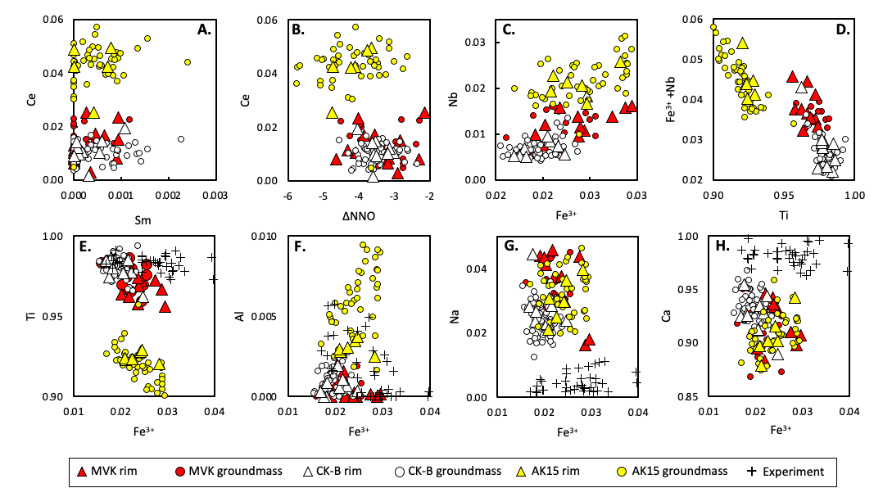

SUPPLEMENTARY FIG 4 (A-D) Trace element content of perovskite in natural samples and (B) comparison with ΔNNO. (E-H) Major element content of natural and experimental samples. Experimental samples refer to perovskite reaction rims found in ilmenite spheres.

PC231 RB705-2
PC231 RB707
PC232 RB707
PC233 RB705-2
PC235 RB705-2
PC235 RB707
PC239 RB705-2
PC239 RB707T
PC252 RB707T
PC252 RB705-2
PC254 RB707T
PC254 RB705-2
PC241 RB707T
PC241 RB705-2
PC258 RB707

SUPPLEMENTARY FIG 5 Estimated run temperature and fO₂ estimates compared to the actual run conditions.

